Translanguaging as Multimodality: Encouraging Multilingual Students’ Full Use of Resources in Online Writing Centers

by Karen Barto, PhD

Introduction [slides 1-2]

Hi. I'm Karen Barto, from the Writing Skills Improvement Program at the University of Arizona. My pronouns are she/her. I have long, wavy, brown hair, glasses, white skin, and colorful clothing on today. Before beginning the presentation, I'd like to read you the university's land acknowledgment statement. At the University of Arizona, we respectfully acknowledge that we are on the land and territories of Indigenous peoples. Today, Arizona is home to 22 federally recognized tribes, with Tucson being home to the O'Odham and the Yaqui. Committed to diversity and inclusion, the university strives to build sustainable relationships with sovereign Native Nations and Indigenous communities through education offerings, partnerships, and community service. Today's presentation also relates to diversity and inclusion. It's titled, "Translanguaging as multimodality: Encouraging multilingual students' full use of linguistic resources in online writing centers."

Today we'll talk about translanguaging, a definition and some background, translanguaging as multimodality, and translanguaging practices in online writing centers.

Translanguaging [slide 3]
Translanguaging is a theory, approach, or set of practices that validates the full use of a multilingual person's linguistic resources. It's been applied in many educational contexts, including writing instruction and writing centers, both brick-and-mortar and online, and it can encourage writers to use any or all of their languages in the writing process.

Learning, Writing, and Translanguaging [slide 4]
Learning and writing are intricately linked with each other and with translanguaging. We know that it's harder to learn in a second language, which many of our multilingual students are doing. But we also know that using all languages known can facilitate complex and deeper learning, and learning and academic writing are intimately paired. We use writing to show what we've already learned, but we also learn through writing. Thus, translanguaging and writing can facilitate and improve learning for multilinguals.

Translanguaging as Multimodality: [slide 5]
Translanguaging has been called complementary to multimodality, as it can be used in different modes, like written or audio visual, but it also may be seen as multimodal itself, where different languages may represent different modes. Choice of language or languages in the writing process becomes another element of multimodality.

Online Tools can Facilitate Translanguaging Practices: [slide 6]
Online tools can facilitate translanguaging practices. They do this by replicating in-person interactions and by making certain processes possible in multiple languages. So, specific translanguaging practices include annotating readings to identify key ideas, drafting by typing, or drafting by dictating and for speech to be transcribed. Now, all of these practices can be used by monolingual speakers as well, but the fact that they can be effectively used with multiple languages makes them translanguaging practices in those cases.

Annotating Readings [slide 7]
Annotating readings, for example, can be done in different software, such as Adobe, or reference management software like Zotero, and it can be done in different languages. This may require multiple keyboards, but that's an easy matter of installation. The image on the right of the slide here shows a research article with some text highlighted, and a sticky note icon, along with a text box under this stickynote icon that's showing the kinds of notes you can take in different languages. This one shows commentary in French, idea in Turkish, and English comment. And I've enlargened the menu for the different keyboard languages, so that you can see it's very easy to select one, then a different one, if you want to switch between languages.

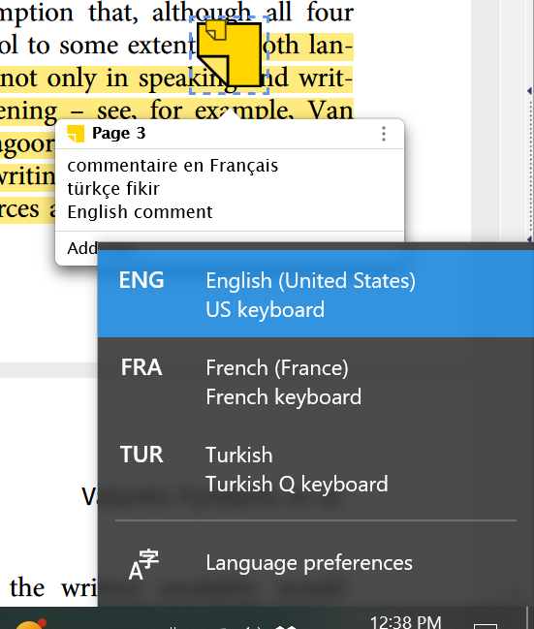

Drafting in Multiple Languages [slide 8]
Drafting in multiple languages is also very helpful. You can use just standard word processingtools to do it, Word, Word Online, Google Docs, etc. But allowing yourself to use more than one language can let you get the ideas down more efficiently and more quickly, if you're not kind of wrestling with yourself to pick one language and stick to it. So, you may just use one keyboard and render other languages somewhat imperfectly, that is, without the correct accents or some specific writing symbols. Or you may switch between keyboards when producing words from different languages, though this may get distracting. Another option is to draft in one language at a time, choosing the appropriate keyboard first each time.

Dictating for Transcriptions [slide 9]
Dictating for transcription is another practice that's very helpful for both monolingual and multilingual users, as it provides remedy against writer's block and perfectionism, and it's just a very natural way to generate ideas. But, it can be especially helpful, again, for multilingual
students. For example, a Zoom Meeting between a Deaf student, an interpreter, and the online writing center personnel could allow for writing center personnel to transcribe the voiced speech by the interpreter and then share that transcription with the student as a draft. For those who speak by voice, you can enable voice typing in Google Docs or the Transcribe function in Word. There are many languages available, and the system understands accented speech. It understands my English and French Well, that's not a surprise; I speak both of those well. But, it also understands my Lao, my Turkish, my Mandarin, and I'm not strong in any of those languages. However, the voice typing and transcribe functions are not good for code mixing. The system tries to understand in whatever language you have it set to. And so, if you speak a different language than that one, it is not able to adapt and figure out what language you're trying to speak and render that correctly. You get kind of a lot of nonsense for any words that are from a language that is not the one you have it set to.

Practicalities of Translanguaging Practices: [slide 10]
So, there are some practical considerations. Of course, you may be concerned, "What if I don't speak a lot of languages? What if I don't speak the same languages as the people I'm working with?" That doesn't matter. You don't need to speak the same languages, or even be multilingual, to support your multilingual clients' use of translanguaging practices. Some training for personnel is advised, however, and can include basic understanding of language acquisition and social aspects of multilingualism, as well as introduction of translanguaging strategies and practices, and practice with tech tools' multilingual capabilities.

Affect and Agency in Translanguaging Practices: [slide 11]
Affect and agency are really important considerations in translanguaging practices, too. Some clients may have a surprised or a doubtful or emotional reaction to hearing about translanguaging practices as an option in their writing. This can be due to some rather overarching cultural ideas in English-speaking cultures, such as the monolingual mindset, whether in English or in foreign languages. There's a tendency to think that code mixing is not a good idea, and there is a large tendency in the US, especially, to still view multilingualism as a deficit, which is unfortunate and inaccurate. However, regardless of how our clients respond to translanguaging practices that we introduce, we should remember that they should be the ones making their own decisions about whether or not to employ those practices. So, if they do continue to feel doubtful or uncomfortable, because they have the sense that it's better not to mix languages, or that they think they really need to focus on English only, that is absolutely their decision, and we should not pressure in any way. However, there can be very positive emotional reactions to learning about translanguaging practices, such as students who I have met who were 30 years and older, had multiple degrees from Hispanic serving institutions, in fact and felt for the first time at our center that their Spanish was a valuable language and valued knowledge in their lives, in their education, and in their scholarship. That, to me, is very important, to emphasize and to give students the opportunity to be validated in their multilingualism.

Conclusion: [slide 12]
In conclusion, translanguaging practices in online writing centers can validate multilingual expression and experience. They may help level the playing field by tapping in to multiple knowledges for learning and writing. They can be used with a variety of standard technology and regardless of what languages writing center personnel speak. And, finally, they address our motto at the Writing Skills Improvement Program, which is "Respect, Rapport, Relationship." We want our students to know always that we respect and acknowledge and appreciate their knowledge, their languages, and their experiences. Thank you.

Note: The presentation document includes three slides of references, included here as a single list.
References
- Cenoz, J. & Gorter, D. (2020). Pedagogical translanguaging: An introduction. System, 92, 102269.
- Cummins, J. (2007). Rethinking monolingual instructional strategies in multilingual classrooms. The Canadian Journal of Applied Linguistics, 10(2), 221–240.
- Cummins, J. (2019). The Emergence of translanguaging pedagogy: A dialogue between theory and practice. Journal of Multilingual Education Research, 9, 19-36.
- García, O., & Li, W.(2014). Translanguaging: Language, bilingualism and education. New York, NY: Palgrave Macmillan.
- Lambert, W. E., & Tucker, G. R. (1972). Bilingual education of children: The St. Lambert experiment. Rowley, MA: Newbury House.
- Li, W. (2018). Translanguaging as a Practical Theory of Language. Applied Linguistics, 39(1), 9–30.
- Kagwesage, A.M. (2013). Coping with English as Language of Instruction in Higher Education in Rwanda. International Journal of Higher Education, 2(2), 1-12.
- Mora, R. A., Tian, Z., & Harman, R. (2022). Translanguaging and multimodality as flow, agency, and a new sense of advocacy in and from the Global South. Pedagogies: An International Journal, 17(4), 271-281.
- Ngo, P.L.H. (2021). Translanguaging Practices in EMI Settings from the Perspective of Student Agency: An Example from Vietnamese Higher Education. In W. Tsou & W. Baker (Eds.), English-Medium Instruction Translanguaging Practices in Asia: Theories, Frameworks and Implementation in Higher Education. Springer.
- Swain, M. & Lapkin, S. (1995). Problems in output and the cognitive processes they generate: a step toward second language learning. Applied Linguistics, 16(3), 371-91.
- Velasco, P. & García, O. (2014). Translanguaging and the writing of bilingual learners. Bilingual Research Journal, 37(1), 6-23.

Cite This Presentation
Barto, K. A. (2023, April). Translanguaging as Multimodality: Encouraging Multilingual Students’ Full Use of Resources in Online Writing Centers [conference presentation]. Online Writing Centers Association 2023 Conference, online. Online Writing Centers Association.

