Activity 2: PORCH TREASURE
(An application of Sue Mendelsohn’s “Metacommentary”)

DESCRIPTION:
This actionable anti-racism group training activity is anchored in one interpretation of “metacommentary” presented in Sue Mendelsohn’s, Rhetorical possibilities: reimagining multiliteracy work in writing centers.

TEXT:
Mendelsohn, S. E. (2012). Rhetorical possibilities : reimagining multiliteracy work in writing centers (dissertation). University of Texas.

We know that “metacognition” is thinking about thinking”. Metacommentary, the way Mendelsohn explains the concept, is also an act of reflection; commentary about commentary. “Performing for a writer what the reader (1.) knows, (2.) does not know, (3.) expects, and (4.) wants to learn.” Most importantly: This performance is not only responding to a piece of writing, but saying out loud how and why you are responding as you do.

Using functions of metacommentary as an actionable anti-racism tool in a writing center session means (1.) Creating space and opportunity for change or self-correction. (2.) Invoking a discussion with the student writer about audience/readership.

OBJECTIVE:
- Participants will learn in-session tutorial protocols and extend metacommentary to incorporate the “Porch Treasure” Model element of Kinship.
Kinship: The deprioritization/erasure of the “white gaze” allows for a unique meaning-making space that is generative and community-specific. And, recursivity of our way of telling can be reinforcing and fortifying in this story space.
Elements of the “Porch Treasure” Model
- Agency
- Kinship
- Tensions
- Identification

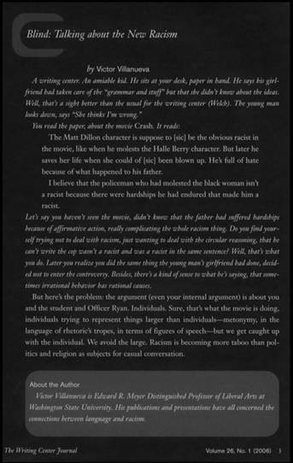
PART I: Read the following as an interested reader/a tutor/ writing center specialist. Read the student writing (non-italicized) out loud.

PART II: As the interested reader/a tutor/writing center specialist, use the following instructions and line of inquiry to engage the student writer.

- Describe the experiences and thoughts that are invoked for you as you read the selection.
- Describe which parts of writing, expressions inspired this feedback. Which words or writer choices support this commentary?
- Different readers have community-specific ideas that we should honor. How might (different audiences) interpret this?
- So as an interested reader, I received this in this way: XXXXX. Did you mean it that way?
- Let’s explore some of the ways that this might be resolved that you can align your intent more with your expression.

(End of Activity)

