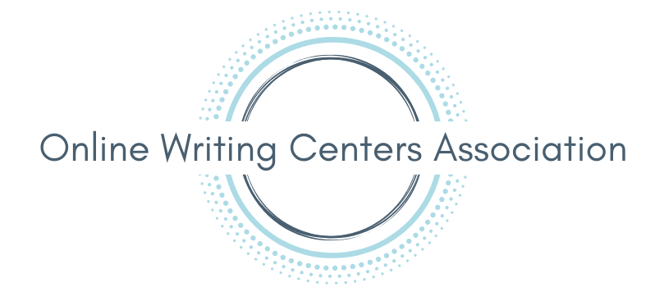

Guide for Video Statements for the Executive Board
______________________________________________________________________

Introduction
This guide is intended for applicants for the OWCA Executive Board who wish to submit a video statement (2-3 minutes long). This guide will help you to upload your video statement to YouTube and create edited closed captions for your statement.
Please note: screenshots in this guide have been reused from our guide for asynchronous conference presenters, due to time restrictions. However, the steps you will follow are the same.

Before Recording
The OWCA suggests that you write a transcript for your video statement before recording and read from your transcript while recording. This will make it much easier for you to add edited captions at the end.

How to Record Your Statement
You can use any program you’d like to record your statement. Some easy-to-use programs for recording include Zoom, Screencast-O-Matic, and Microsoft PowerPoint. Here are some resources:
- How to record with Zoom
- How to record with Screencast-O-Matic
- How to record with PowerPoint

How to Prepare Your Transcript for Captions
After you’ve finalized the transcript for your statement and recorded your video, you will save your transcript as a Plain Text file. Follow these steps:
- Go to the “File” tab
- Click “Save As” in the left menu
- Select “Plain Text (.txt)” from the drop-down menu
- Click “Save”
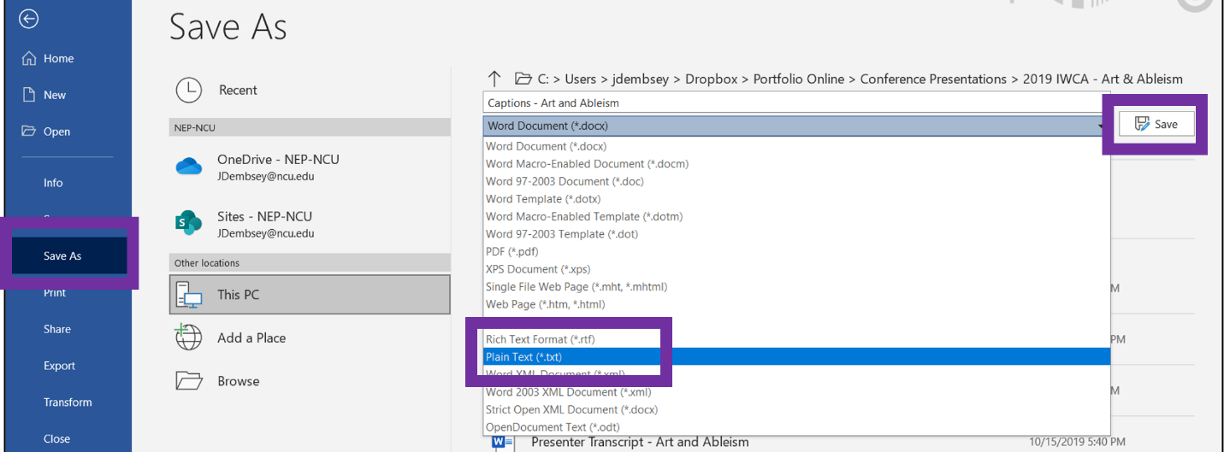
- Click “OK” in the pop-up window.
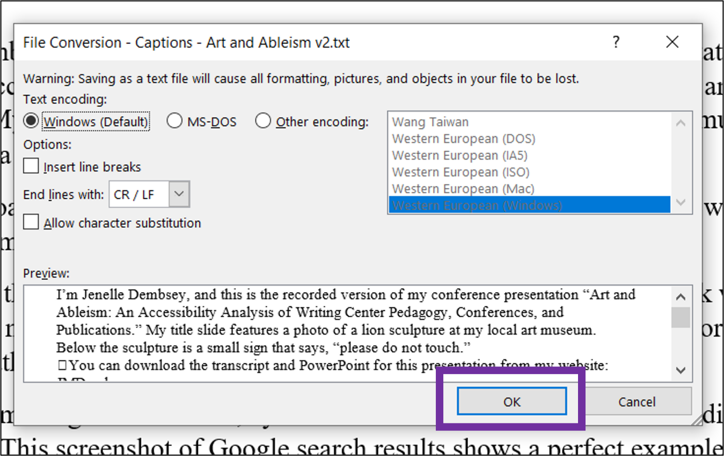
After completing these steps, you will be ready to upload your video and your transcript into YouTube.

How to Upload a Video and Transcript in YouTube
To upload your video and transcript in YouTube, follow these steps:
- Login to YouTube
- In the top right menu, click the camcorder and select “Upload video” from the drop-down menu
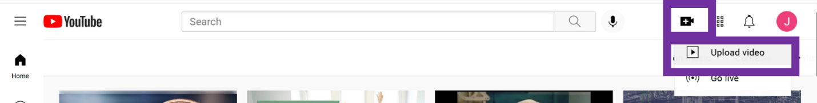
- Drag and drop your video file into the pop-up window.
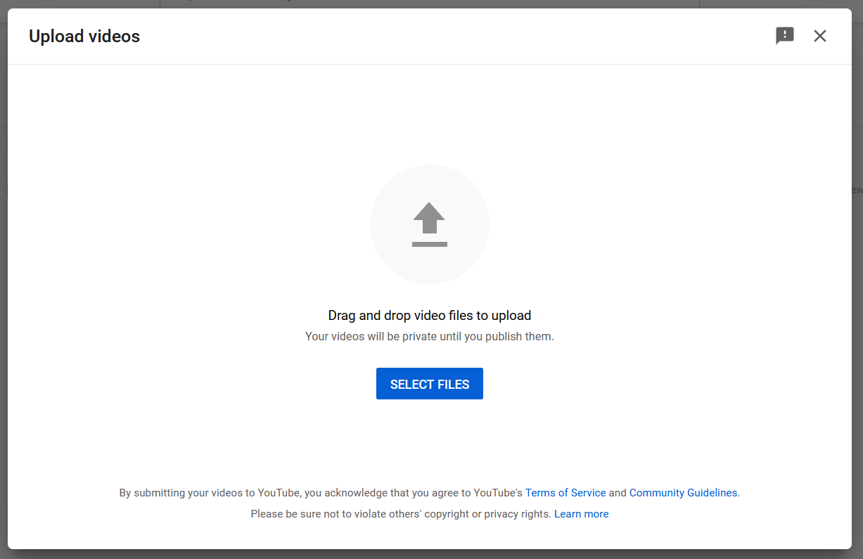

- After YouTube has accepted your video file, a pop-up window will appear. Under “Details,” type in the title of your video.
- Select “Next" in the bottom right corner.
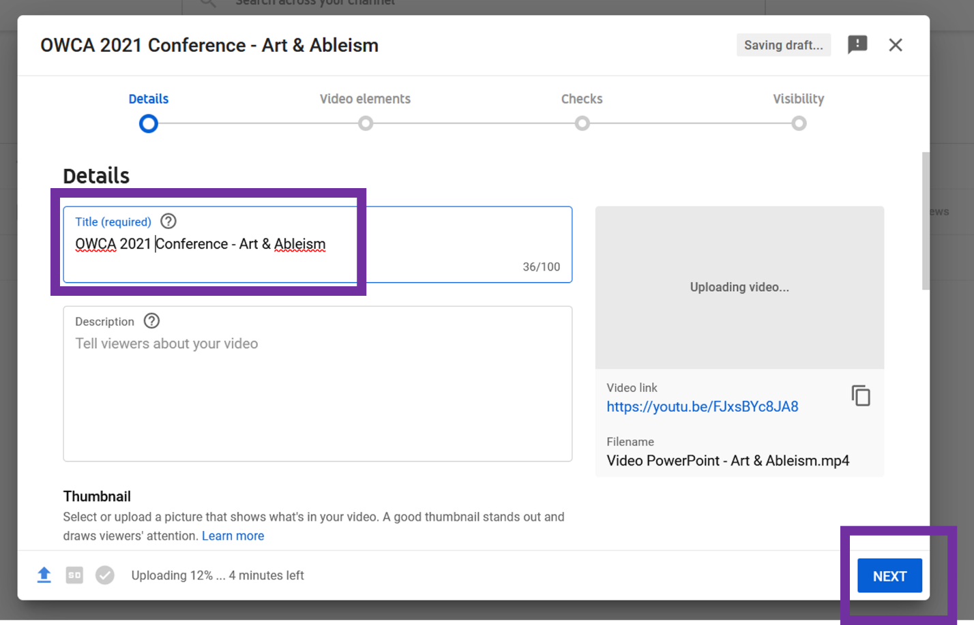

- Under “Video Elements,” find the box for “Add subtitles” and select “Add” on the right side of the box
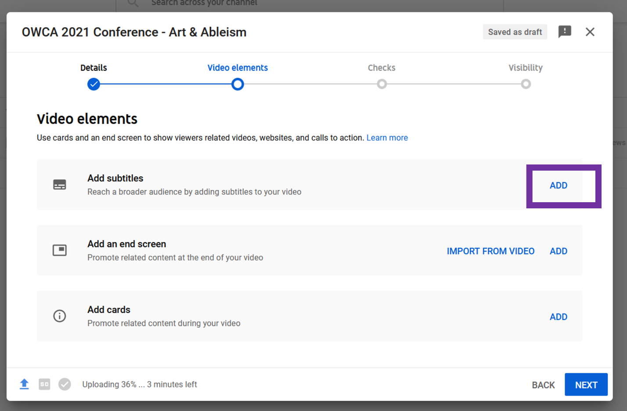
- Select “Upload file.”
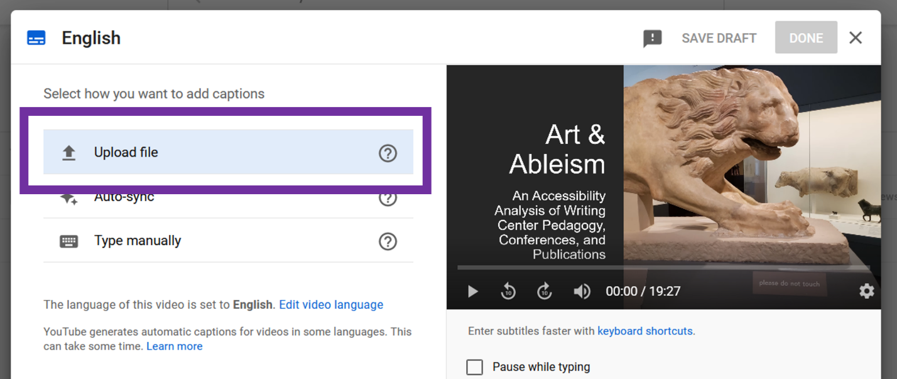

- A pop-up box will appear for your subtitle file type. Select “without timing.”
- Select “Continue.”
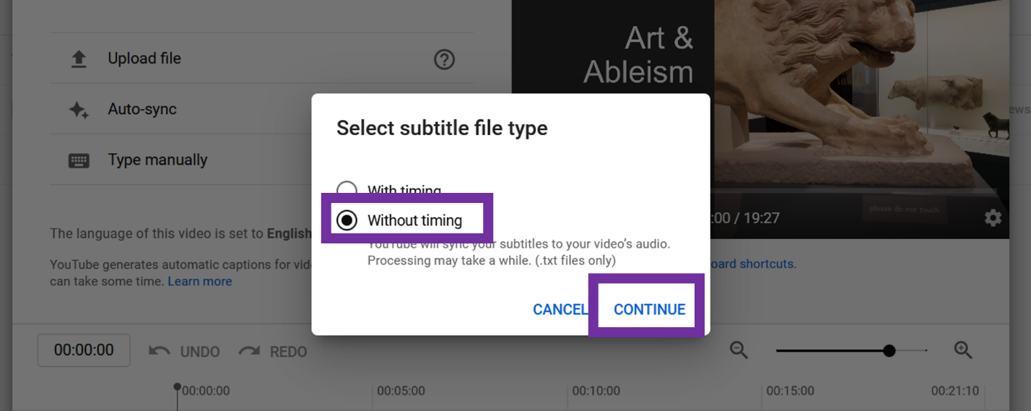
- A pop-up window will appear for you to select your file. Select the .txt file for your transcript that you created earlier.
- Click "Open."
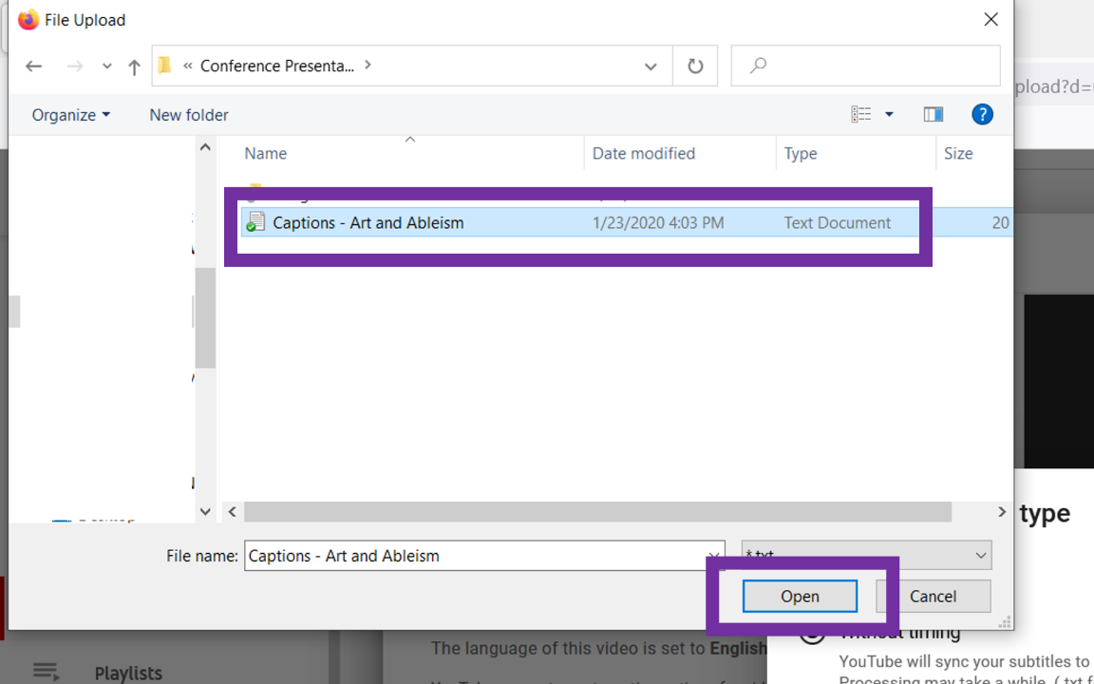

- You will be taken back to the “Video Elements” screen. Click “Next" in the bottom right corner.
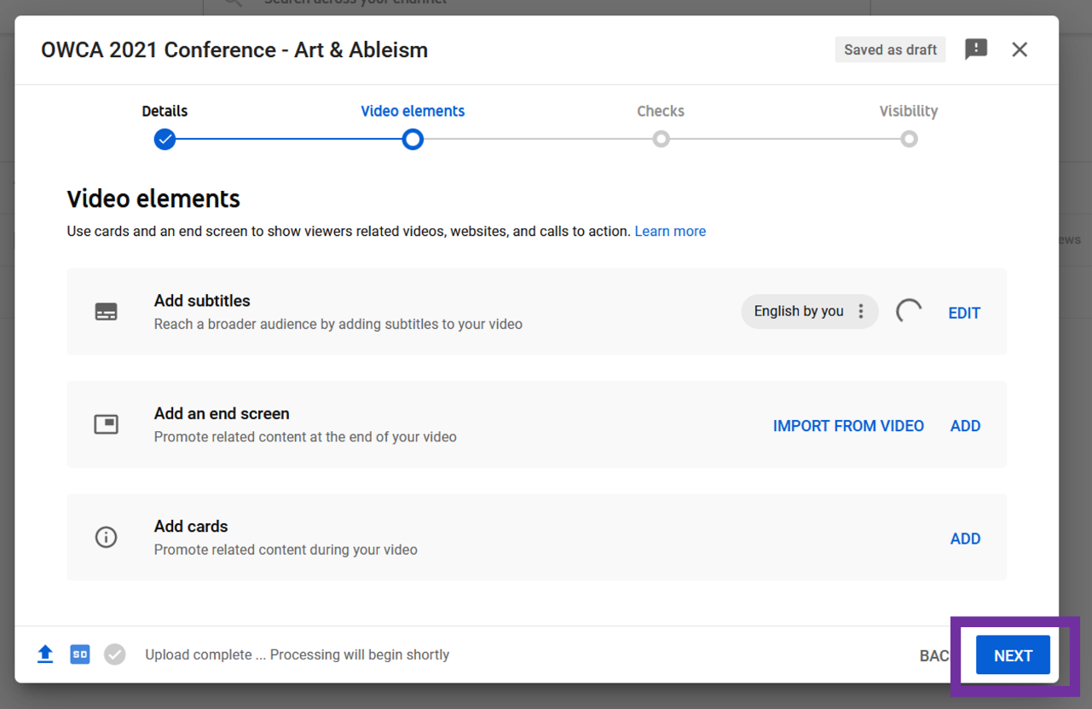
- Click “Next” again.
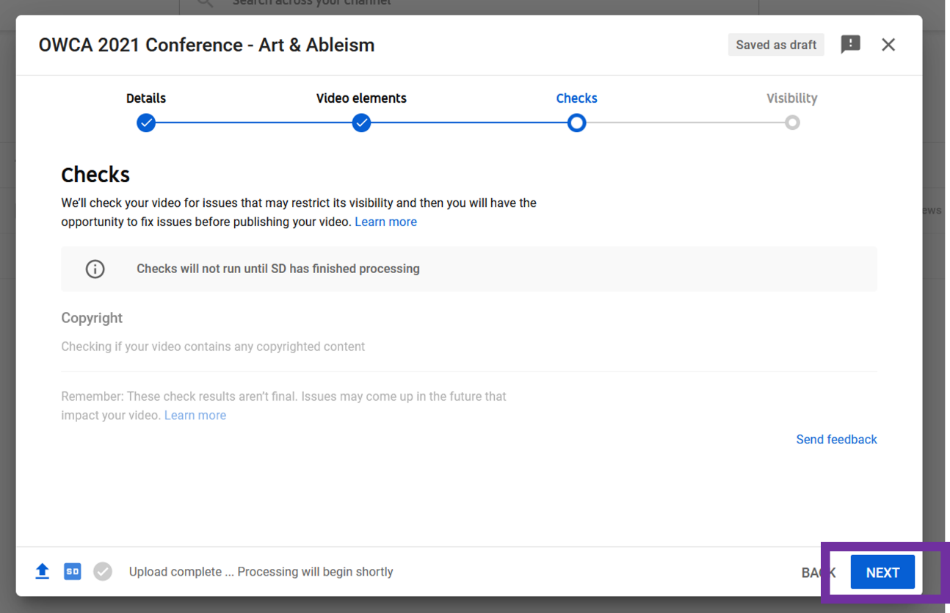
- Under “Visibility,” select “Unlisted.”
- Click “Save" in the bottom right corner.
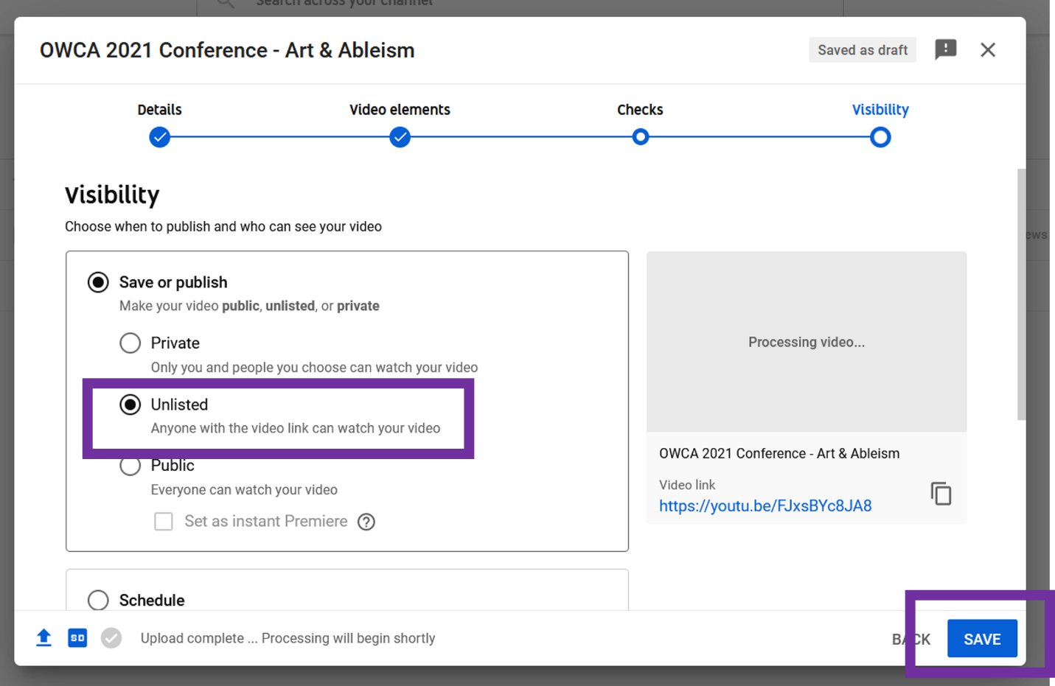
- YouTube will confirm that your video is processing. Click “Close."
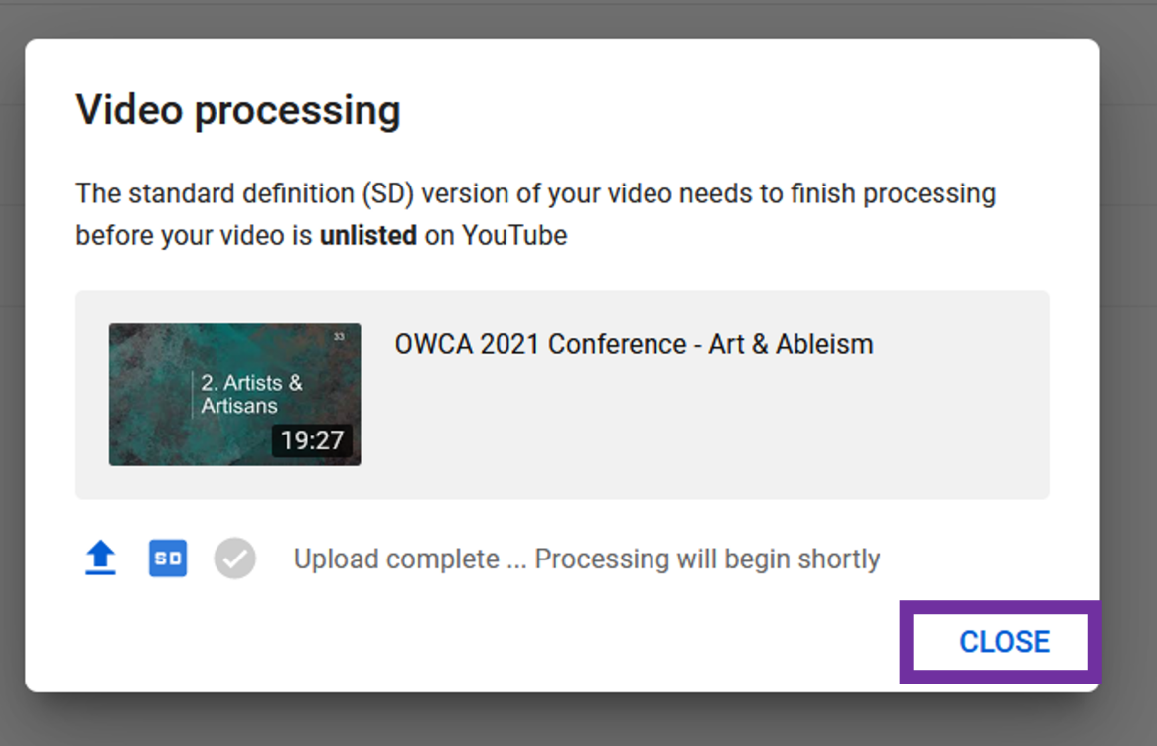

How to Check Captions for Accuracy
You should give YouTube a few hours to finish processing your video and creating captions from your transcript. Before submitting your video statement to the OWCA, please watch your video and double-check that the captions are correct. Follow these steps:
- Click the 3 horizontal lines in the top left corner of YouTube’s site
- Select “Your videos” from the menu.
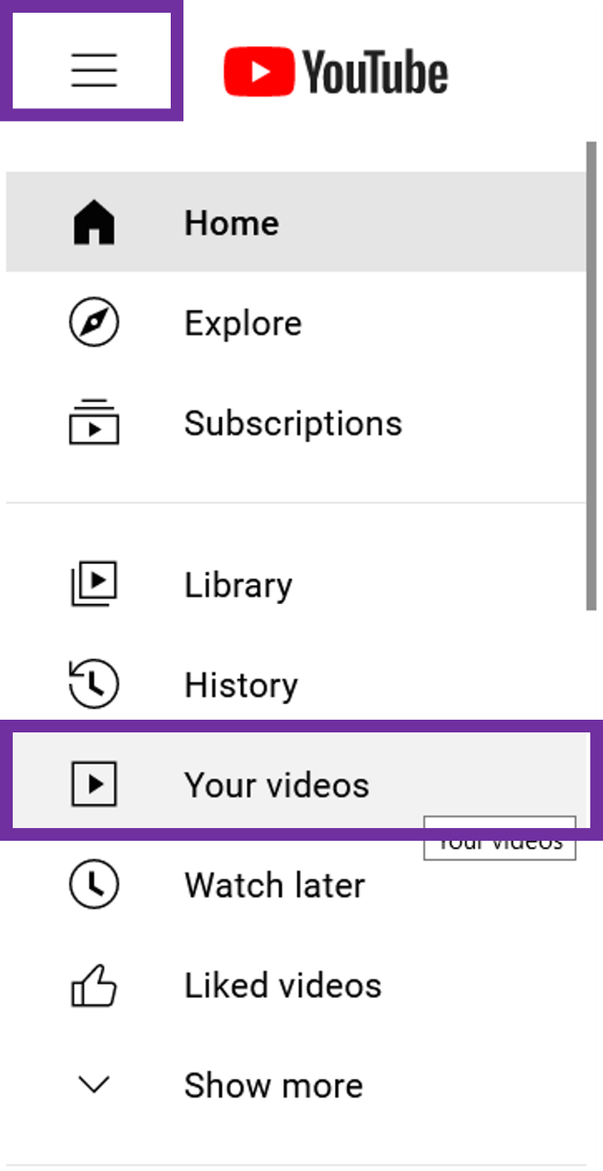
- YouTube will list all of the videos posted to your account. Hover your cursor over your video statement and click the YouTube icon.
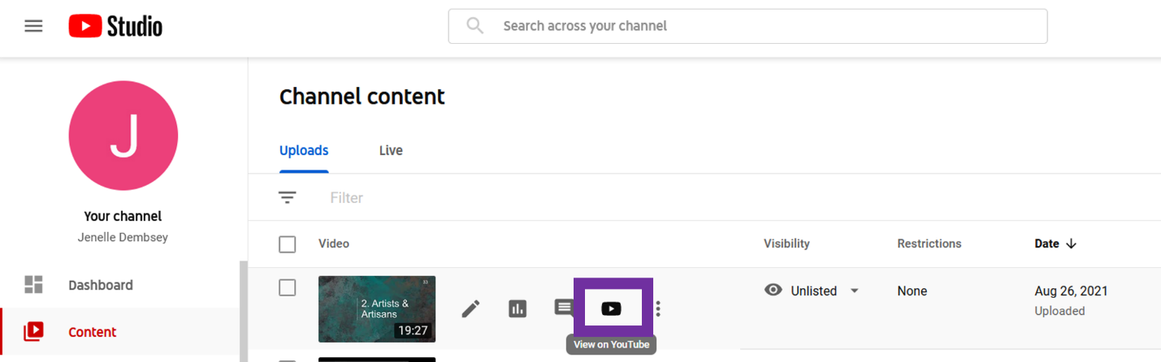
- Your YouTube video will open in a new tab. Select the “CC” icon in the play menu of your video and watch the captions at the bottom as your video plays. Please check that the wording and timing of the captions match what you are saying in your statement.
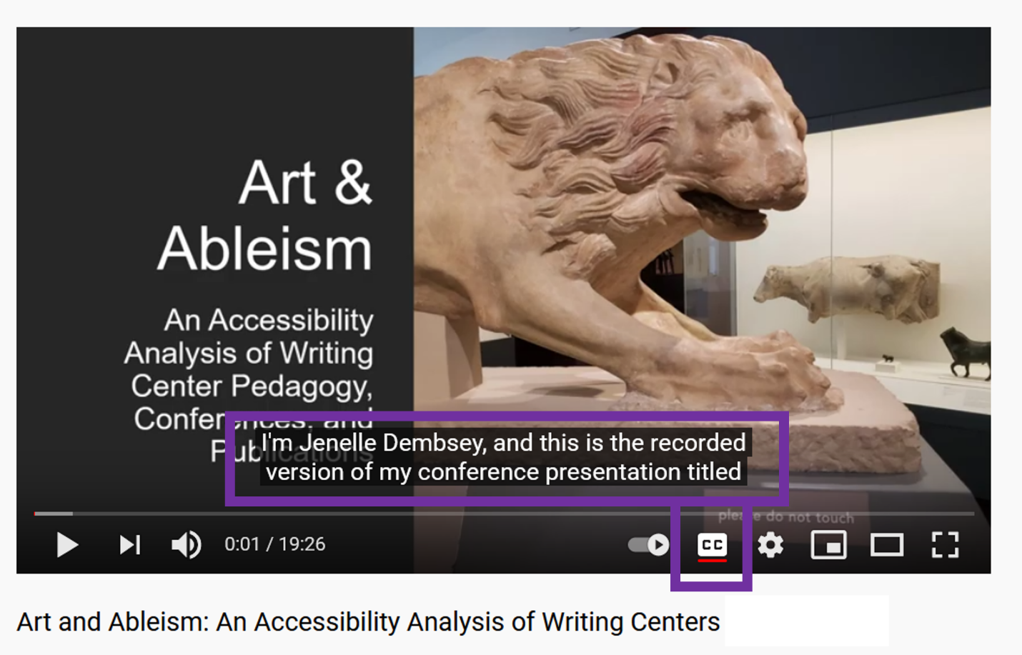

If you notice an error in the captions, you can edit them by following these steps:
- Go back to the “Your Videos” page
- Hover your cursor over your video statement and click the pencil icon for “Details.” You can edit other details about your video here as well, including the title, thumbnail, and visibility.
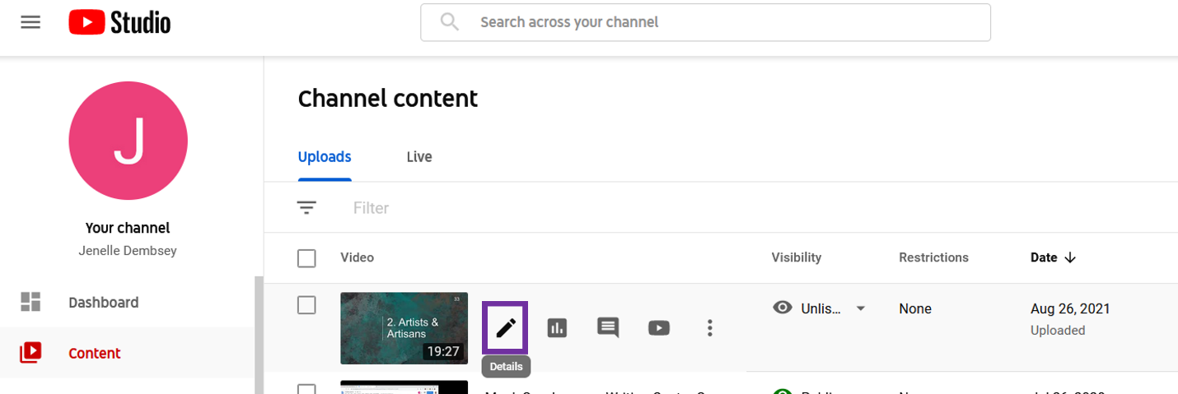
- Scroll down and click the pencil icon next to “Subtitles” on the right.
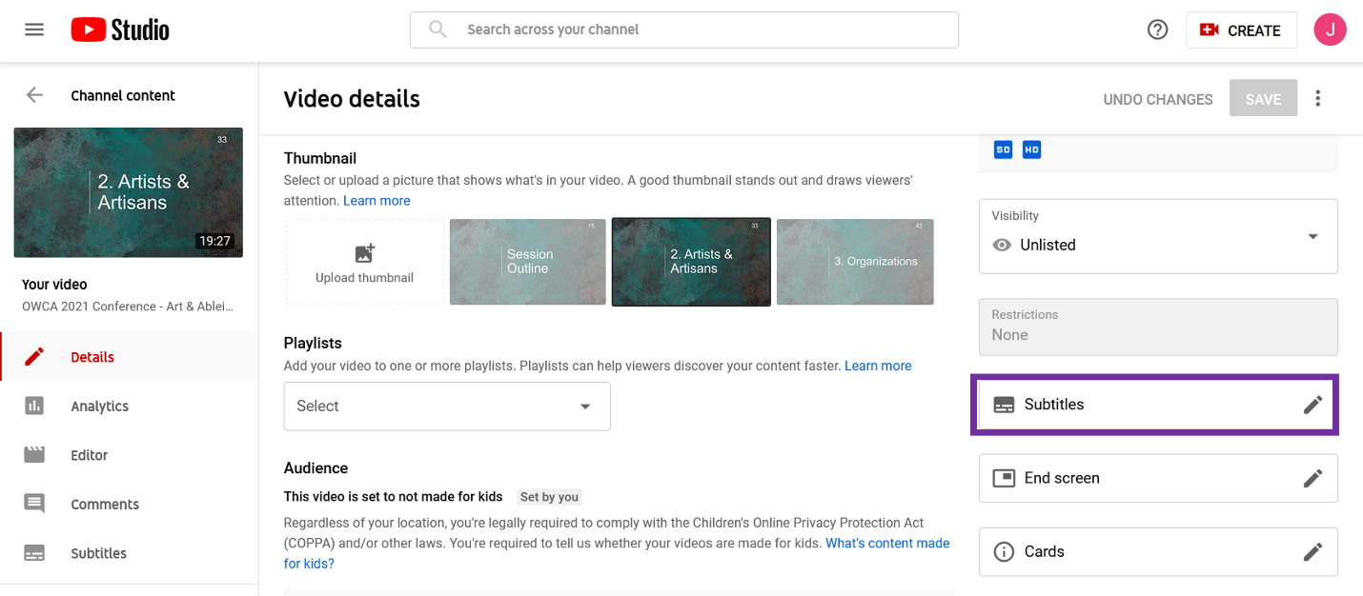

- A pop-up window will appear for the captions. From this screen, you can edit any errors in the text, add in new text for missing captions, and change the timing of the captions.
- When you’ve finished editing the captions, click “Done” in the upper right corner of the pop-up.
