Introduction to Digital Accessibility Principles

by J. M. Dembsey (jmdembsey@gmail.com)

Introduction [slides 1-2]
Hello, everyone! Thank you for being here today to learn about digital accessibility principles. My name is Jenelle Dembsey, and my pronouns are “she, her, hers.” I am a white woman with long brown hair, and I’m wearing a black t-shirt. My Zoom background is the opening gates to Jurassic Park. I’m a big fan of dinosaurs, and you will notice that in some of the examples in this presentation.
Before I begin the presentation, I just want to establish how you can follow along with me today. All materials for today’s talk are available online for you to download. You can download them directly off of the OWCA website at OnlineWritingCenters.org or off of my personal website at JMDembsey.com. The moderators will place both of those links in the chat for you.
The following materials are available for you to download:
- The PowerPoint slides
- A full transcript for the presentation
- A worksheet with Exercises 1-5
- An example inaccessible document for Exercise 6
- Answer keys for all the exercises
You are welcome to use these materials to follow along with me today. You can also share them with colleagues and modify them for use within your own writing centers.
As you engage with this presentation, I encourage you to ask questions in the chat. There will also be plenty of opportunities for you to respond to exercises in the chat as well. And of course, you are welcome to get up, move around, and do whatever you need to best focus and take in the information today.

Agenda [slide 3]
Here is our agenda for today’s webinar. We will:
- Briefly overview the terms “accessibility” and “digital accessibility”
- Discuss 5 introductory digital accessibility principles. Those principles are:
  - Headings
  - Vertical lists
  - Descriptive hyperlinks
  - Alternative text
  - Image descriptions
- Give 10 minutes for you to take a break and practice revising an inaccessible document in Microsoft Word
- Discuss the revisions you made in the practice document and what you learned today
- Have Q&A
There is, of course, a lot more to accessibility then I will have time to discuss in today’s webinar, but I hope that this will be a helpful starting point for many of you on digital accessibility.

Overview of Accessibility [slides 4-11]
Let’s get started with a brief overview of accessibility. I want to start out by just posing a question and seeing where we are in the room. And my question is: what does the word “accessibility” mean to you? Please take a minute or two to answer in the chat.
As we can see in the chat, the word “accessibility” can mean different things to different people. But there are two things that are really important to remember when thinking about accessibility:
- Accessibility must center disability and disabled people. Often times, accessibility is discussed too broadly as a matter of simply reaching more people, without considering that those people have different needs, abilities, and disabilities. So if there’s one thing that you take away today, I hope it is the understanding that you cannot talk about accessibility without talking about disabled people, and you cannot work towards accessibility without including and designing for disabled people.
- Accessibility is a continuous process. Access is not something that we just achieve and then never have to think about again. Access is something we need to constantly reflect on and improve upon: we always have more to learn.
So on the topic of continuous learning, I have a challenge for each of you in the audience. I challenge you to note other accessibility principles and practices that I apply while giving this presentation. And to think about how you and your colleagues can begin applying some of those principles in your everyday work. We will discuss what you noticed towards the end of this webinar.

Digital Accessibility [slides 9-11]
Because we are the Online Writing Centers Association, we are focused on digital accessibility in this webinar. When I say digital accessibility, I’m talking about designing digital documents, spaces, and services that can be navigated by disabled people. A few examples include:
- Written content and visuals that can be read by screenreaders, text-to-speech software, or similar programs
- Spaces that can be navigated by keyboard keys, instead of a mouse
- Transcripts and captions for audio or video content
- Visual explanations of complex processes or information
- High contrast of color in images and presentations
- Information that is not conveyed only in color
The principles we will discuss today are primarily for disabled people who are blind or have vision impairments and are using screenreaders or text-to-speech software to read digital content. But these same principles can also make digital spaces more accessible to other disabled people and non-disabled people as well.
The basic principles that we will discuss today are relevant in many digital contexts, including:
- Presentation materials for conferences, webinars, or workshops
- Online feedback that you provide to writers
- Handouts, templates, and resources that you share with writers
- Handbooks, training materials, and other internal documents for your staff
- Meeting agendas that you share with your colleagues
- Emails that you send everyday
- Websites for your department, organization, or event
- Any classes, modules, or posts in your learning management system (LMS)
- Your scheduling system for appointments and events
- Any posts on social media
Basically, anything that you are creating digitally should apply these principles, when the technology platform allows.
All of the principles we will discuss today can be applied in Microsoft Word, and I will show you how to apply these principles in Word for Microsoft 365 on the PC. If you are using a MAC or another version of Word, there are many online resources that can help you apply these digital accessibility principles in those platforms. Let’s get started.

Principle 1: Headings [slides 12-26]
The first accessibility principle we will discuss is headings. If you have a writing background, you’re likely already familiar with the concept of using headings. Headings are helpful for adding white space and organizing the sections of your text. But did you know that there are accessible and inaccessible ways of using headings?

How Do I Make Headings Accessible? [slide 13]
Adding headings actually involves more than just bolding text or increasing the size of the text. To make a heading accessible, you have to tag each heading as being a heading within the program that you are using. Tagging headings allows screenreaders and text-to-speech software to:
- Recognize that there are headings in the document
- Read off all the headings in the document to the user
- Allow the user to skip directly to the sections they need. If no headings are tagged, the user would have to read through every paragraph to figure out where information is.

How Do I Number Headings? [slide 14]
When you are tagging headings, you are basically assigning them a heading number, so that screenreaders can understand the hierarchal structure in your document. Heading numbers should always be used in numerical order:
- Heading 1 (H1) is the title of your document, and the title should be the only Heading 1 in your document. Just a warning that Microsoft Word provides a style for "Title," but you should not use that. You should use Heading 1 instead.
- Heading 2 (H2) is any main heading after your title.
- Heading 3 (H3) is any sub-heading under a Heading 2.
- Heading 4 (H4) is any sub-heading under a Heading 3. And so on.

How Do I Tag Headings in Microsoft Word? [slides 15-17]
Now I’ll show you how to tag headings in Microsoft Word. To tag headings in Microsoft Word, you will:
- Select the text you want to tag as a heading
- Select the appropriate heading number under the “Styles” panel. The “Styles” panel is under the main “Home” tab, as shown in the screenshot here.
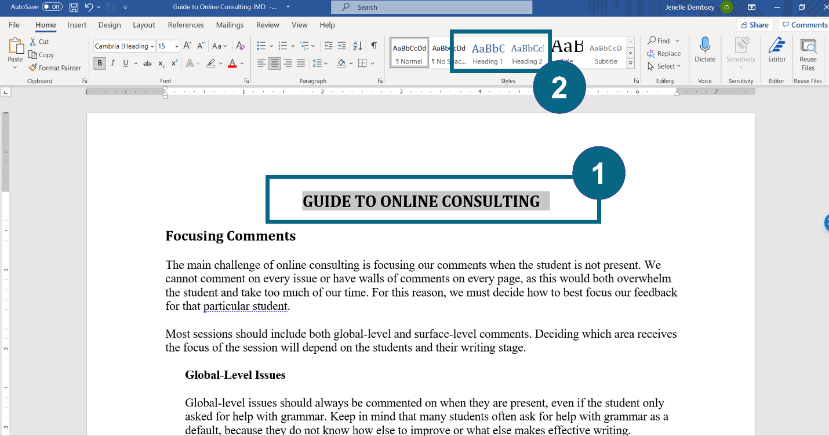
Microsoft Word has default formatting for their heading styles. You can kind of see in the screenshot here that their default formatting is blue. You can change this formatting very easily to make your headings look however you want.
If you want to update the formatting of your headings in Microsoft Word, you will:
- Format the text the way you want and then select the text.
- Right-click on the appropriate heading number in the “Styles” panel
- Select “Update Heading to Match Selection” from the drop-down menu
That action will both tag that text as a heading and apply that formatting to all other headings with the same heading number.
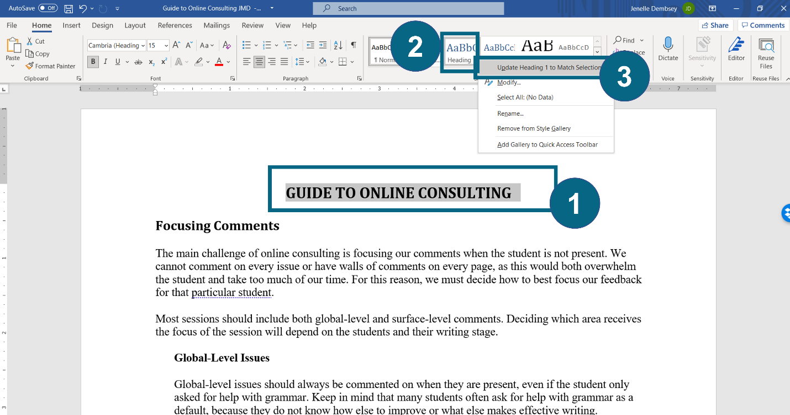

Headings Example 1 [slide 18]
Now let’s look at some examples of correctly numbered headings. This first example is a screenshot of an online consulting guide in Microsoft Word. The title of the document is “Guide to Online Consulting,” and it is tagged as a Heading 1. It is the only Heading 1 in the document. The next main heading is “Focusing Comments” and that is tagged as Heading 2. Then, under “Focusing Comments,” there is a sub-heading for “Global-Level Issues,” and that is a Heading 3.
One way to check if something is tagged as a heading is to put your cursor on it and check if one of the heading styles is selected. So in this screenshot, the cursor is on the title of the document, and “Heading 1” is selected in the Styles panel at the top of the document.
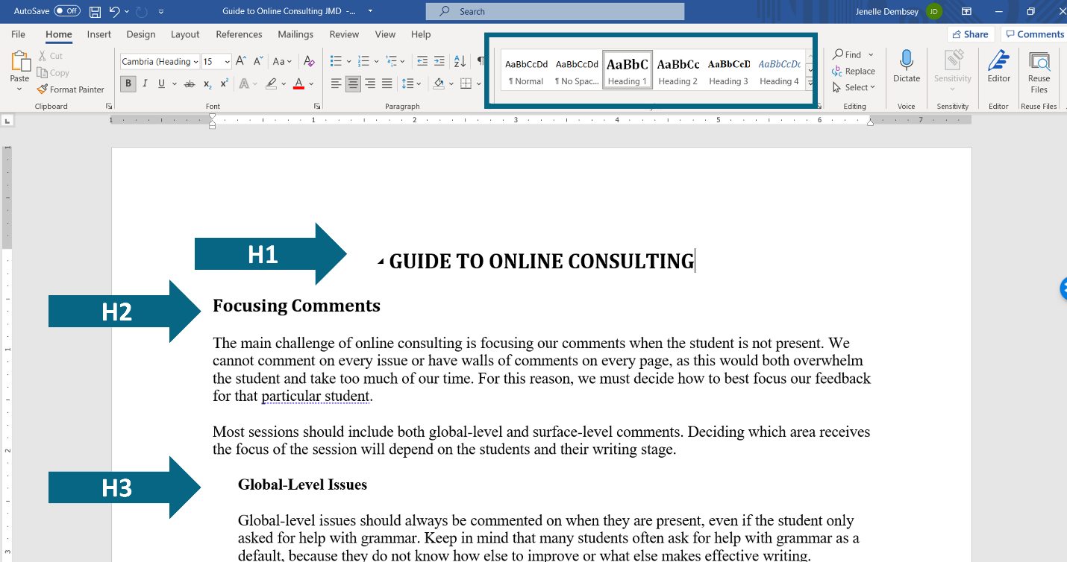

Headings Example 2 [slide 19]
The second example is of headings on a website. This is a screenshot of the “Webinars” page on the OWCA website. The title of the webpage is “Webinars” and so that is Heading 1. Then, there are several main headings on the page for “ASL Interpretation and Recording,” “Guidelines for Participating,” and “Upcoming Webinars.” And these are all Heading 2s.
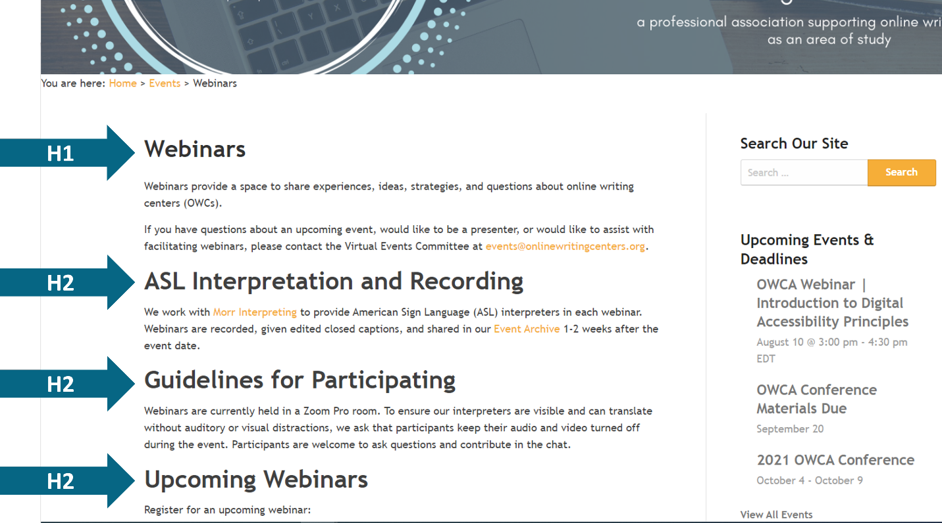

Practice with Headings [slides 20-26]
Now we will practice what you’ve learned. These are Exercises 1.1, 1.2, and 1.3 in the worksheet. I’m going to share some screenshots, and I’ll ask you to tell me what is inaccessible about the headings in each screenshot. Please place your answers in the chat.

Exercise 1.1 [slide 21]
Exercise 1.1 is a screenshot of a document in Microsoft Word. The title of the document is “Submitting Your IRB Application,” and it is centered and bolded. Then there are three sub-headings regarding when to start the IRB application, how to submit, and what happens after submission. These sub-headings are bolded and left-aligned. The cursor is currently placed on the title of the document, and “Normal” is selected in the Styles panel at the top.
What is not accessible about the headings in this document?
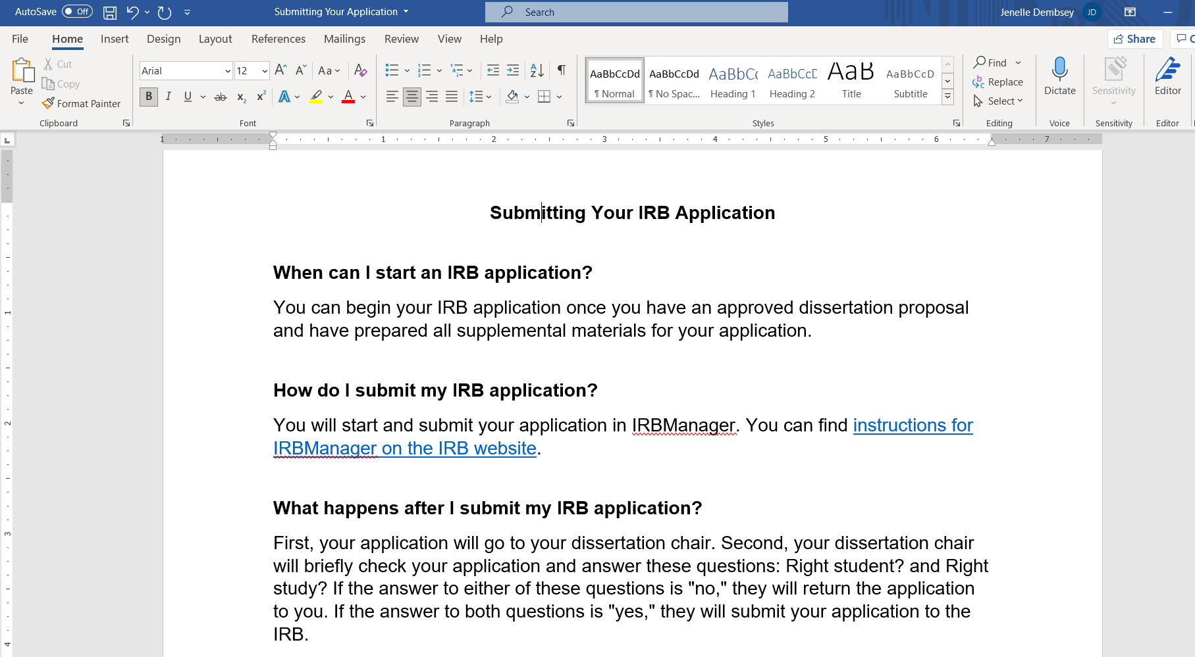

Webinar Chat Responses
Shan Overton: Title not tagged H1
Jess Shubert (she/her): Title not formatted as a heading
Alex Johnson: Based on where the cursor is, the title is not marked as Heading 1
Glynis Benbow-Niemier: not tagged
Felicia Karas (she/hers): the headings aren't tagged appropriately
Presenter [Responding to Chat]: Yup, some of you already got it. The title is not formatted as a heading based on where the cursor is; nothing with normal being selected means it's not marked as a heading. So yes, you all got it. None of the headings are tagged as being headings. Excellent.

Exercise 1.1 (answer) [slide 22]
The headings are not tagged as headings, because the heading styles are not being used in this document. The cursor is placed on the title, but none of the heading styles are selected at the top. The format of the heading styles (blue text) also does not match the format of the “headings” in the document (black text).
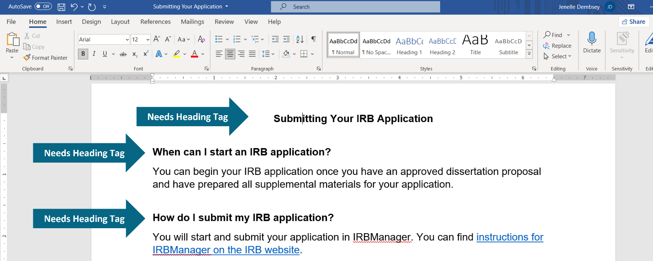

Exercise 1.2 [slide 23]
Exercise 1.2 is the same document as before in Microsoft Word, but the headings have now been tagged as headings. The title has been tagged using the “Title” style and the following headings are tagged as Heading 1s.
What is not accessible about the headings in this document?

Webinar Chat Responses
Mike Dvoracek: Should be Heading 1
Mimi Loughlin: The title is not tagged as a heading, and neither are any of these headings
Janice Lark: Title heading is incorrect
Jess Shubert (she/her): The title is formatted as a title instead of heading 1
Bethany Bibb (she/her/hers): Title isn't tagged as H1
Felicia Karas (she/hers): title should be H1 and the others should be H2
Shan Overton: Don’t use Title!
Robin Clark: “Title” should be H1, “H1” should be “H2”
Alex Johnson: The “title” shouldn’t be tagged as Title
Robert George: Title should be heading 1; others heading 2
Valerie Balester: Headings can't all be H1
Glynis Benbow-Niemier: there are multiple H1s
Bethany Bibb (she/her/hers): Main headings should be H2
Janice Lark: Title is heading 1; others should be tagged as heading 2
Presenter [responding to chat]: Yes, excellent! You guys got it!
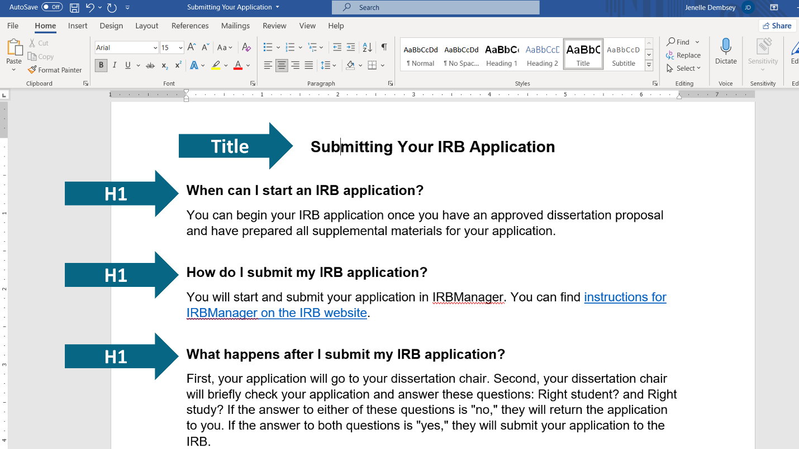

Exercise 1.2 (answer) [slide 24]
The title of the document should be tagged as Heading 1 (H1), not “Title.” The title should also be the only Heading 1 in the document, so the following headings should be tagged as Heading 2s instead.
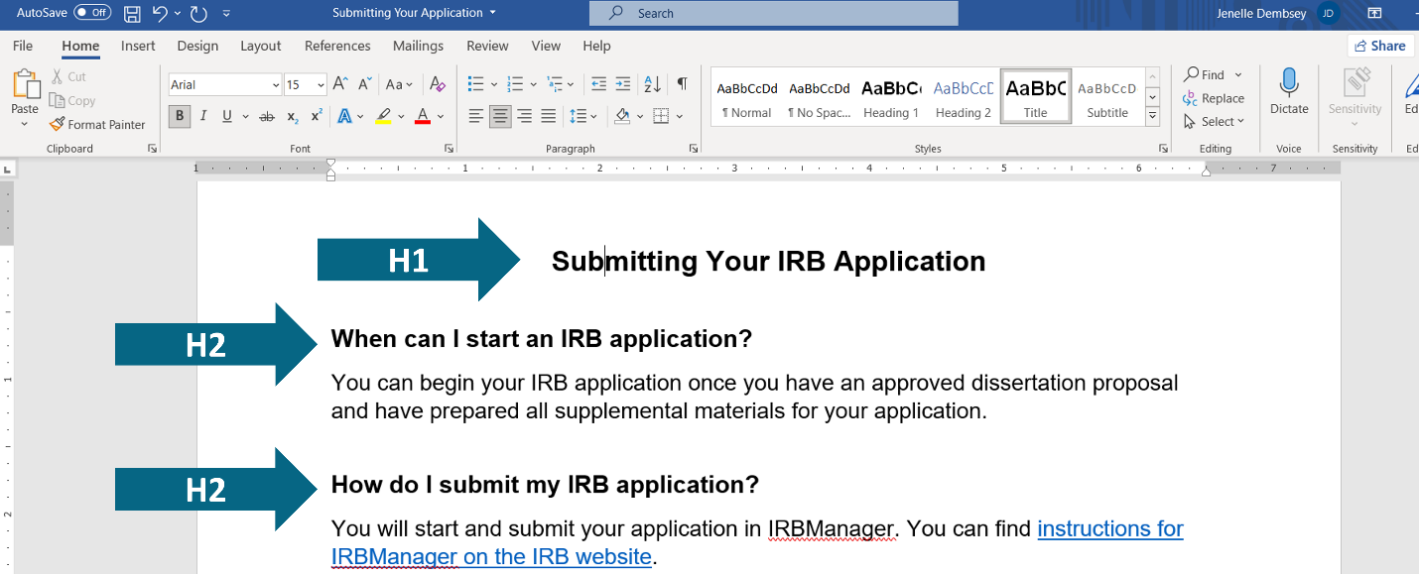

Exercise 1.3 [slide 25]
And the last exercise for headings (Exercise 1.3) is a screenshot of the website for Qualtrics. Qualtrics is a survey-building platform: many of you may know the name because your institutions have a license to it. This is their webpage that conveys their commitment to inclusivity. The title of the page is a direct quotation, “Qualtrics will be a force for good,” and the title is tagged as a Heading 1. Right underneath the Heading 1 is the attribution for that quotation, “Ryan Smith, Co-Founder,” which is tagged as a Heading 3.
What is not accessible about the headings on this webpage?

Webinar Chat Responses
Valerie Balester: Headings are our of order (1, 2, not 1,3)
Jess Shubert (she/her): There's an H3 without an H2, which will interfere with navigation
Robert George: h3 should be h2
Felicia Karas (she/hers): headings are out of order
Janice Lark: incorrect order
Jenny Staben (she, her, hers): Also, how can you know the quote is a quote.
Paula Rawlins (she/her): @Jenny, right!?
Jenny Staben (she, her, hers): :)
Presenter [responding to chat]: Yes. Excellent. Yes, the headings are out of order and there is no Heading 2. Excellent.

Exercise 1.3 (answer) [slide 26]
The headings on this webpage are not used in numerical order. A Heading 1 should be followed by a Heading 2, not a Heading 3. Furthermore, the attribution for that quotation should not be a heading, because the paragraph that follows doesn’t have anything to do with Ryan Smith. Ryan Smith’s name should be just regular text.
This happens quite often on websites where web editors will use heading styles to emphasize regular text that are not headings. They also commonly choose heading styles based on the size/formatting they want, rather than using them in numerical order. But that is incorrect. You would hope that a technology company that claims to be committed to inclusivity would be aware of that, but I digress.

Principle 2: Vertical Lists [slides 27-39]
Our second principle is vertical lists. Again, you may already be using vertical lists in your documents. Vertical lists are a great way to group and emphasize information, add white space for readability, and/or clearly convey steps in a process.

How Do I Make Vertical Lists Accessible? [slide 28]
But similar to headings, for vertical lists to be accessible, you have to tag the list as being a list. So instead of manually typing out numbers or hyphens, you would use the formatting options that automatically number or bullet the vertical list for you. This allows screenreaders and text-to-speech software to recognize there is a list in the document and to let users skip between items in the list.
You should use bulleted lists when the order of the list items does not matter. And you should use numbered lists when the order of items does matter, such as when readers need to follow steps in a specific order.

Vertical List Example 1 [slide 29]
This first example has vertical numbered lists in Microsoft Word. This is our consent letter template for the IRB application, and we require researchers to use vertical numbered lists to emphasize who is eligible to participate in their study and what activities the participants will be asked to do. Numbered lists are used because potential participants have to meet all of the eligibility criteria, which are listed in order from most broad to most specific, and participants will be asked to complete the research activities in a specific order as well.
Similar to headings, you can test if a list is formatted correctly by placing your cursor on the list and seeing if the lists icon is highlighted at the top of the page, under the “Home” tab. In this example the cursor is placed on one of the lists and then the numbered list option is highlighted up at the top. You’ll also notice that the lists are completely aligned in terms of spacing. Lists that aren’t tagged as lists will often have odd spacing and/or misalignment.
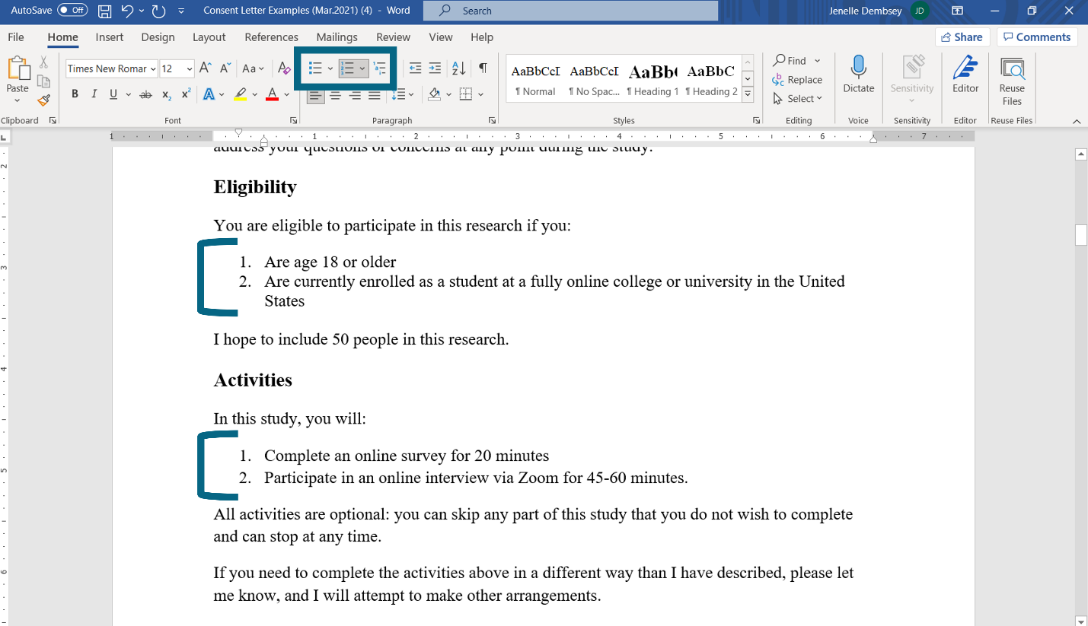

Vertical List Example 2 [slide 30]
Here is another example that has a vertical bulleted list in Microsoft Word. This screenshot is from our handbook for writing session facilitators. This list tells facilitators the main things they will need to do when leading writing sessions, such as invite questions, be direct, and be honest when they don’t know something. These strategies don’t need to be applied in a specific order, so a bulleted list is appropriate.
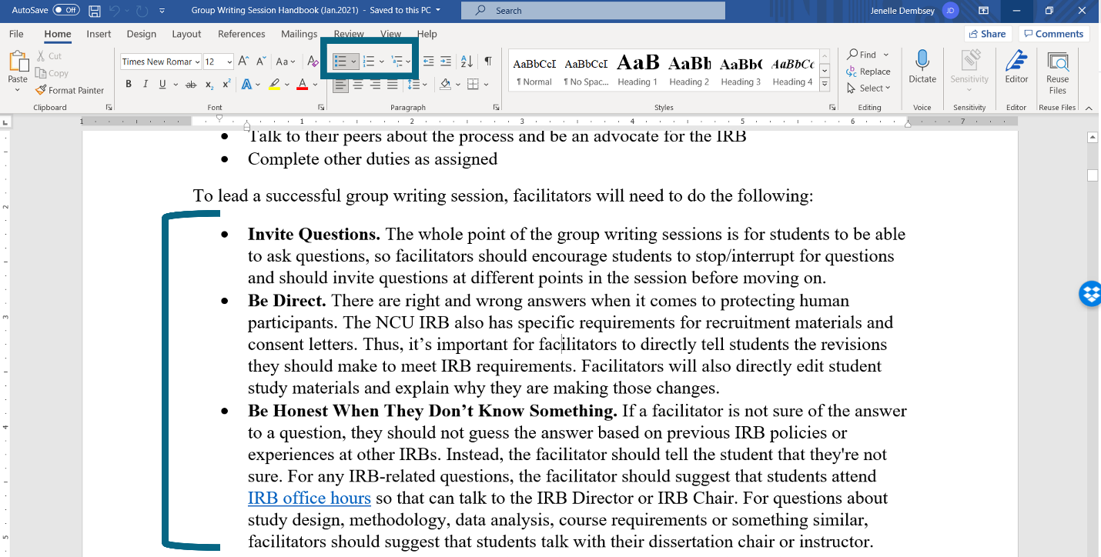

How Do I Tag Vertical Lists in Microsoft Word? [slides 31-32]
Tagging lists in Microsoft Word is really simple: it’s only two steps. You will just:
- Select the text you want to tag as a list
- Select the bulleted or numbered list icon in the "Paragraph" panel under the "Home" tab.
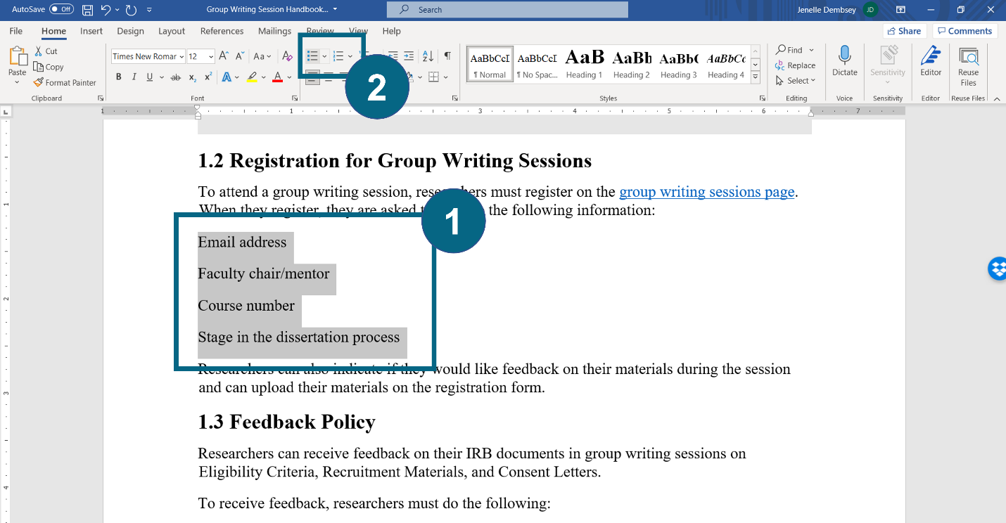

Practice with Vertical Lists [slides 33-39]
Now let’s practice with Exercises 2.1, 2.2, and 2.3 in the worksheet. In the following exercises, I’ll ask you to tell me how you would add or update vertical lists to be more accessible. Like last time, please place your answers in the chat.

Exercise 2.1 [slide 34]
Exercise 2.1 is a paragraph that describes the suggested order for attending IRB group writing sessions. It reads:
“Before submitting your IRB application, we recommend attending our IRB group writing sessions. We recommend attending the session on Eligibility Criteria first. Next, you should attend the session on Recruitment Materials, followed by the session on Consent Letters. After you’ve attended the previous 3 sessions, you will have enough context to attend the last session on the Introduction to the IRB application.”
How would you revise this paragraph to be more accessible?

Webinar Chat Responses
Shan Overton: Numbered list
Beth Sheofsky: Use 1, 2, 3
Felicia Karas (she/hers): revise to be a numbered list
Janice Lark: number the items in correct order
Elyse Pelzer: Break these steps up into a numbered list
Josh Leonard: I would revise by separating the activities into a numbered list
Jess Shubert (she/her): I'd put each sentence as items in a numbered list
Paula Rawlins (she/her): a list of sessions to attend in the suggested order
Jasara Hines: number list
A. P. Lamberti: Begin each item in the numbered list with a verb, since the list involves instructions.
Presenter [responding to chat]: Some of you are already saying a numbered list, use one two three, and break those steps up into a numbered list in the suggested order. Yes. Excellent.

Exercise 2.1 (answer) [slide 35]
We can revise the previous paragraph by adding a vertical numbered list to more clearly indicate the suggested order of IRB group writing sessions and significantly cut down on words. The revised version reads:
Revised: “Before submitting your IRB application, we recommend attending our IRB group writing sessions in the following order:
- Eligibility Criteria
- Recruitment Materials
- Consent Letters
- Introduction to IRB Application”

Exercise 2.2 [slide 36]
Exercise 2.2 is an advertisement for open writing center appointments. The appointment times are listed vertically with one or two hyphens. It reads:
“Stuck on a writing assignment? The online writing center can help! The following appointment times are still open this week:
- Monday at 10am
- Tuesday at 8am and 2pm
-- Wednesday at 4pm
- Thursday at 6pm”
What is inaccessible about this list?

Webinar Chat Responses
Shan Overton: Yikes!
Robert George: Needs formal bullets
Margaret Hernandez: bullets
Alex Johnson: Needs to be made into a true bullet
Janice Lark: do not use manually inserted hyphens
Duane Theobald: Bullets
Bethany Bibb (she/her/hers): regular bullets
Robin Clark: Hyphens should be replaced with a bulleted list
Mimi Loughlin: not in bullet points
Beth Sheofsky: Should be bullet points. Do not use hyphens
Shan Overton: Bullets
Paula Rawlins (she/her): use the bullets!
Elyse Pelzer: Messy hyphens!
Josh Leonard: Not a list
Allison Kranek: Doesn’t use bullets or numbers (and also uses them inconsistently)
Jess Shubert (she/her): Use the automatically formatted bulleted list instead of those hyphens!
Presenter [responding to chat]: Yep. No manually inserted hyphens and they're not tagged as a list. Yes, excellent.

Exercise 2.2 (answer) [slide 37]
The original list was not tagged as a list. We can tell this because the items in the list had odd spacing. One item had two hyphens while the others had only one hyphen. We can easily revise this by tagging the list as a bulleted list. It automatically aligns the items in the list and gives them all just one bulleted point.
Revised: “Stuck on a writing assignment? The online writing center can help! The following appointment times are still open this week:
- Monday at 10am
- Tuesday at 8am and 2pm
- Wednesday 4pm
- Thursday at 6pm”

Exercise 2.3 [slide 38]
And then the last example (Exercise 2.3) is from a tutor training handbook, and it describes how new tutors will learn to do online consulting. The training activities are listed in a bulleted list. It reads:
“New tutors will learn online consulting in the following stages:
- Observe a recorded synchronous consultation
- Attend a mock consultation as the writer
- Lead mock consultations as the tutor
- Be scheduled for live online appointments and be observed until no longer necessary”
What is inaccessible about this list?

Webinar Chat Responses
Shan Overton: Numbered list needed — because stages
Janice Lark: use numbers instead for stages
Jenny Staben (she, her, hers): Should be a numbered list.
Bethany Bibb (she/her/hers): This should be a numbered list.
Catkin O'Grady (they/them): Last sentence is super long compared to the others.
Mimi Loughlin: should be 1,2,3
Robin Clark: Should be in numerical order rather than bullets
Beth Sheofsky: should be in order Use a numbered list
Felicia Karas (she/hers): should be numbered
Glynis Benbow-Niemier: should be numbered
Josh Leonard: Shouldn't it be numbered because it should be done in a specific order
JeffV: numbered list
Robert George: Need sequence
Jasara Hines: if this is a series of events, this needs to be numbered
Presenter [responding to chat]: Yep. As you guys indicate in the chat it should be numbered.

Exercise 2.3 (answer) [slide 39]
The training activities are obviously scaffolded and they’re going take place in a specific order, so a numbered vertical list is needed instead of a bulleted list.
Revised: “New tutors will learn online consulting in the following stages:
- Observe a recorded synchronous consultation
- Attend a mock consultation as the writer
- Lead mock consultations as the tutor
- Be scheduled for live online appointments and be observed until no longer necessary”

Principle 3: Descriptive Hyperlinks [slides 40-56]
The third accessibility principle we will discuss is descriptive hyperlinks. So now we get into more advanced things. All right.

What Is a Descriptive Hyperlink? [slide 41]
We have two terms to define here:
- A hyperlink is any link that a user can click to go to a webpage or website, a document for download, or even another heading in the same document. Hyperlinks are almost always formatted to stand out from the rest of the text. They are commonly underlined and bright blue.
- A descriptive hyperlink is a hyperlink that is placed on a specific word or phrase that describes where the link will lead the user.

How Do I Write Descriptive Hyperlinks? [slide 42]
There are two things to consider when writing descriptive hyperlinks.
First, you have to place the link on an actual word or phrase. In other words, don’t just paste the entire URL into your document. URLs are not actual words, and some of them are quite long and complicated. So if you paste a URL into a document, a screenreader will just read the entire thing letter by letter, which is both annoying and unhelpful to the user as to where that link goes and whether or not they should click it.
Second, you should place the hyperlink on a specific word or phrase that both clarifies where the link will take the user and makes sense completely out of context. Screenreaders can read off all of the hyperlinks in a document, without their surrounding text.

Descriptive Hyperlinks Example 1 [slides 43-44]
Let’s look at some examples. This first example is a screenshot of our IRB handbook for student researchers. This screenshot is of “Section 5: Services and Support,” where we describe the different writing services that are available to our students. On this page in our handbook, we have 4 descriptive hyperlinks that are bright blue and underlined and are written to make sense completely out of context.
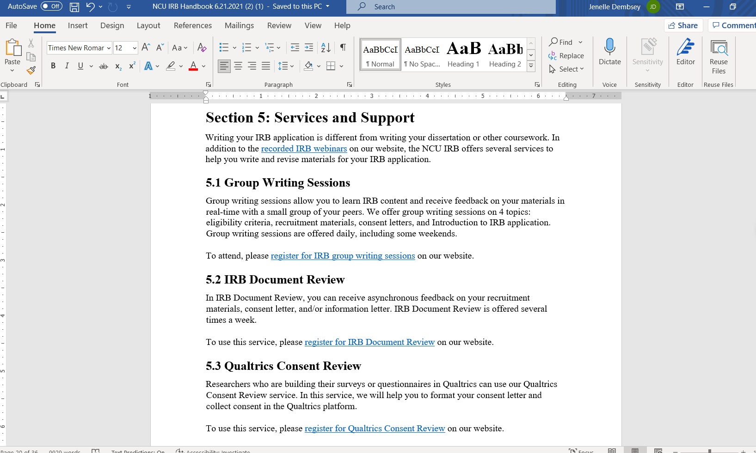
To show you what I mean, let’s remove all of the surrounding context. In this new screenshot, I’ve removed all of the surrounding headings and paragraph text, so only the hyperlinks remain, just like if a screenreader were reading them off.
The first descriptive hyperlink is “recorded IRB webinars.” Even with no context, you understand that the link will take you to recordings of webinars from the IRB.
The second descriptive hyperlink is “register for IRB group writing sessions.” We know we can click on this link to register for that specific service. The same goes for the following two descriptive hyperlinks for “register for IRB Document Review” and “register for Qualtrics Consent Review.”
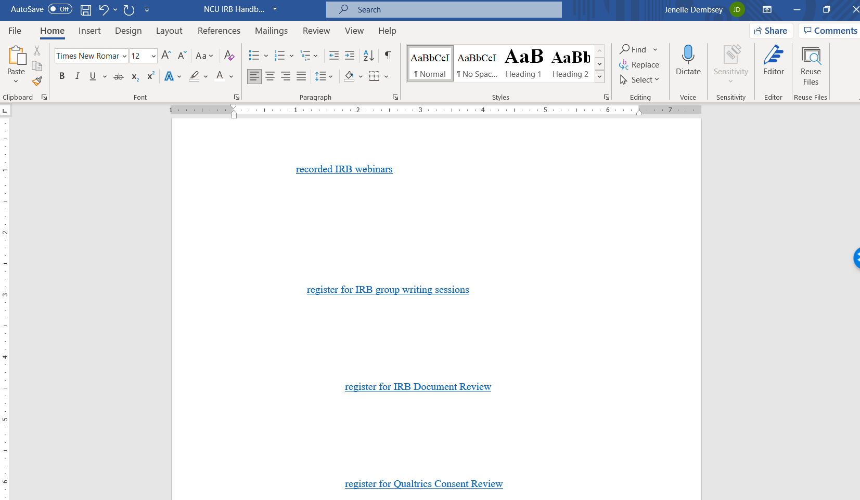

Descriptive Hyperlink Example 2 [slides 45-46]
Here is another example of hyperlinks on a webpage. This is the “Handbook and Newsletters” page on our IRB website. We have a lot of links on this page, indicated in dark blue, for people to download handbooks, student guides, all of our newsletters, and our metrics.
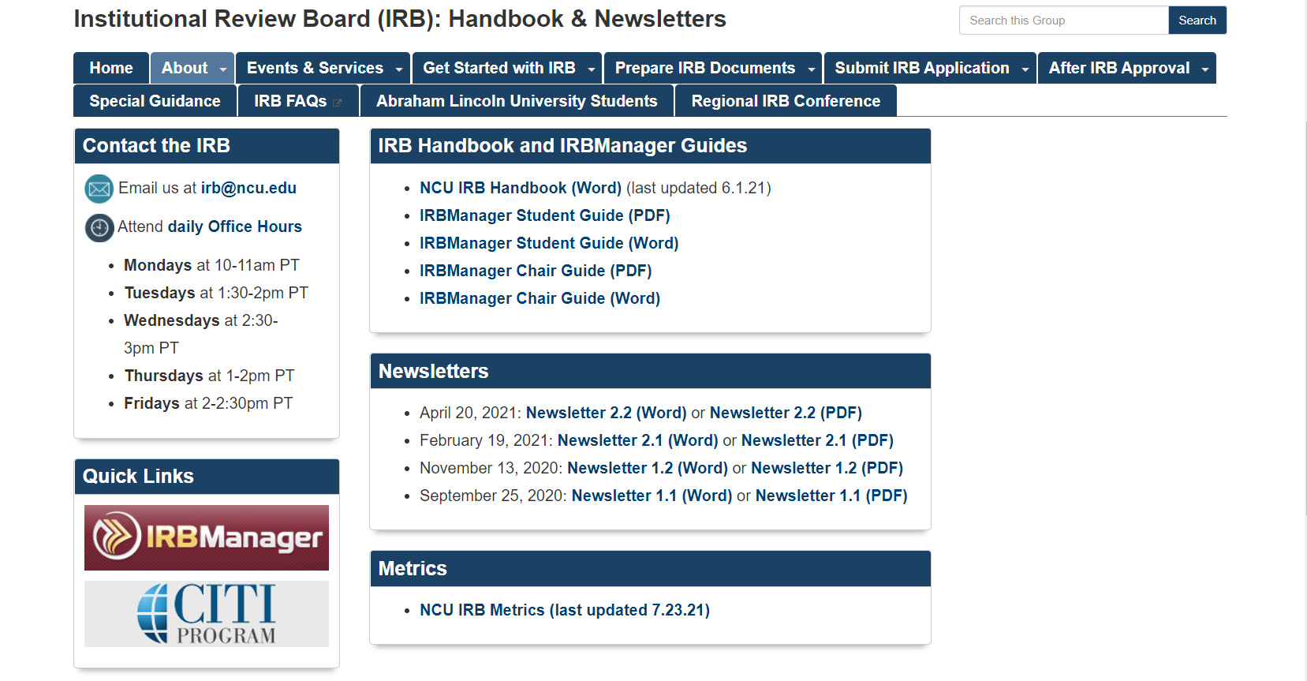
Let’s remove all of the context and surrounding information again so we can consider the hyperlinks on their own. Without the surrounding context, you can still clearly tell which link will let you download which document, whether that be the IRB handbook, the IRBManager student guide, or the IRBManager chair guide. We also have 4 newsletters, and we include the issue and volume numbers in the descriptive hyperlinks so they can be differentiated from each other.
And when a document is offered in multiple formats (such as a Word document and a PDF), we include the file type within the descriptive hyperlink as well so users can choose which type of document they want.
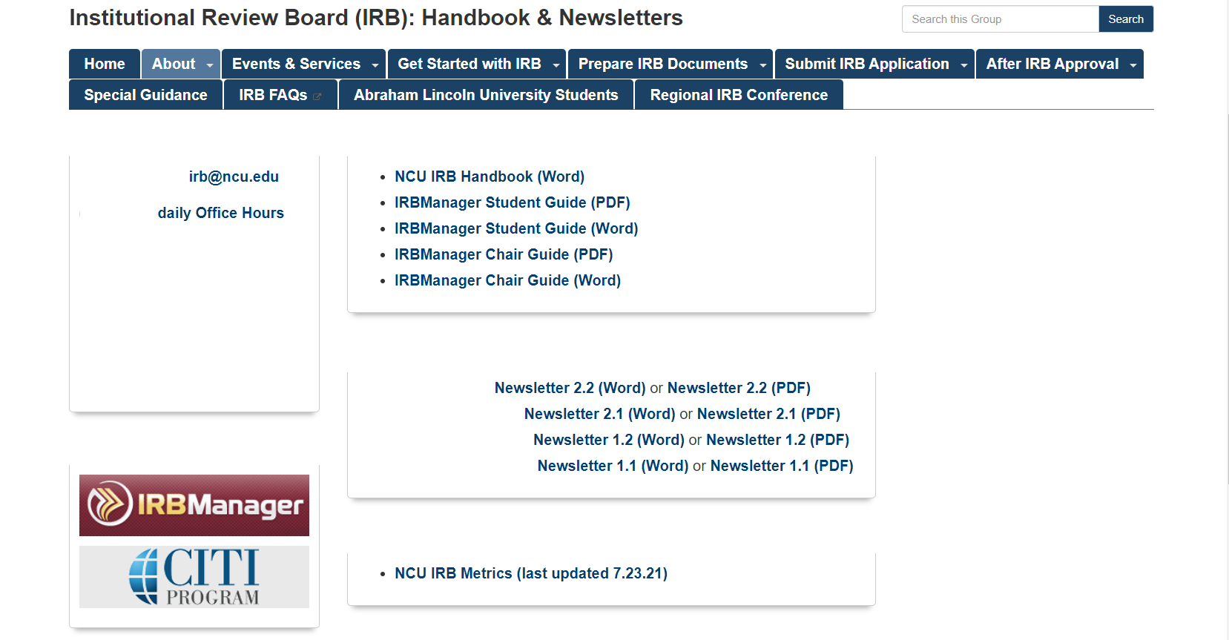

How Do I Format Descriptive Hyperlinks in Microsoft Word? [slides 47-49]
Adding descriptive hyperlinks in Microsoft Word involves 5 steps. To add a descriptive hyperlink in Microsoft Word, you will:
- Select the text that you want to link
- Right-click and select “Link” from the drop-down menu. A pop-up box will then appear.
- In the pop-up box, you're going to select “Existing File or Web Page” on the left side of the pop-up box
- Paste the URL into the “Address” box
- Click “OK”
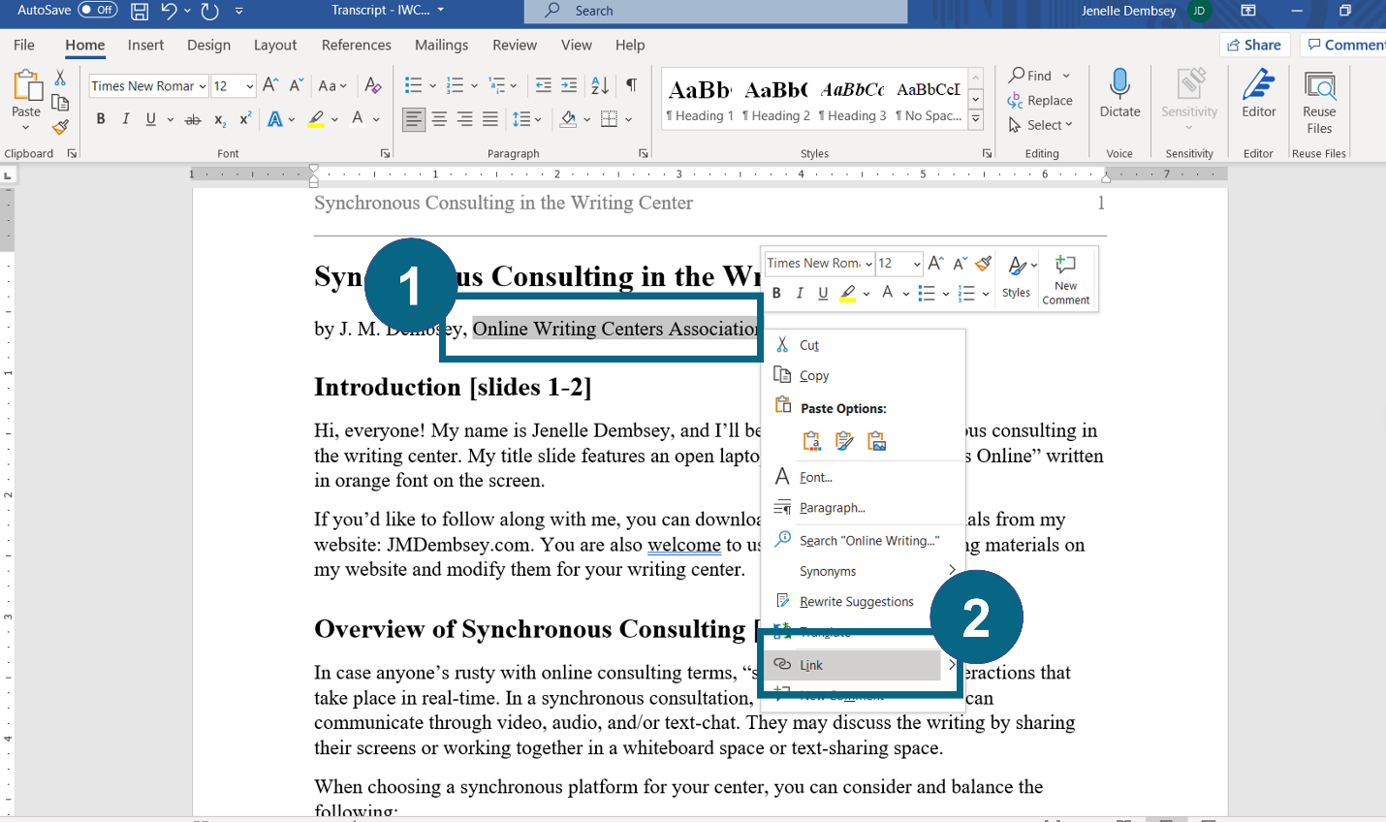
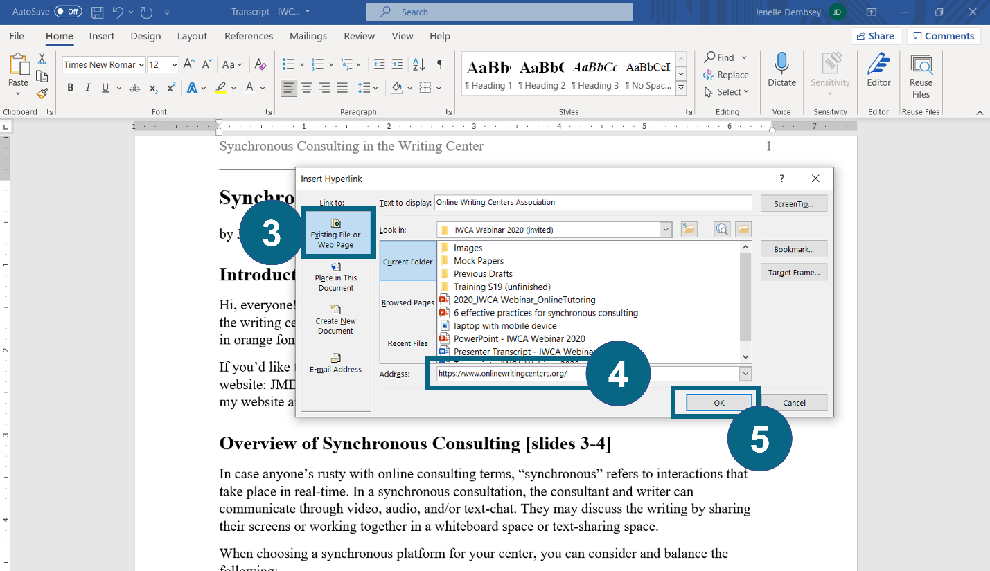

Practice with Descriptive Hyperlinks [slides 50-56]
Now let’s do some practice with descriptive hyperlinks. These are Exercises 3.1, 3.2, and 3.3 in the worksheet. I will provide some example sentences with hyperlinks, and I’ll ask you to tell me what is inaccessible about the hyperlink and how you could fix it. Please type your responses in the chat.

Exercise 3.1 [slide 51]
Exercise 3.1 is a sentence that reads: “Click here to schedule an appointment with the CMU writing center!” “Click here” is the hyperlink.
What is inaccessible about this hyperlink? How would you revise to fix it?

Webinar Chat Responses
Shan Overton: Click here is not descriptive
Robert George: Not descriptive
Jess Shubert (she/her): Doesn't make sense out of context
Robin Clark: “Schedule an appointment” should be the hyperlink
Mimi Loughlin: not descriptive of where the link will lead someone
Josh Leonard: Does not define where "here" leads to
Janice Lark: Click here should be identified
Paula Rawlins (she/her): Get rid of "click here." Instead, you could make the phrase "schedule an appointment" the hyperlink and just say "Schedule an appointment with the CMU Writing Center."
Jenny Staben (she, her, hers): Not descriptive
A. P. Lamberti: Does this link lead to a webpage, a PDF form, or...?
Valerie Balester: Click here is ambiguous. Need text to explain
Bethany Bibb (she/her/hers): There's no description. "Schedule an appointment" should be hyperlinked.
Bethany Bibb (she/her/hers): Is it incorrect to just hyperlink "appointment" in the above example?
Presenter [responding to chat]: Yes, it's not descriptive. There you go, Robin got it. "Schedule an appointment" should be the hyperlink. Yes

Exercise 3.1 (answer) [slide 52]
“Click here” does not convey any information about where the link will take users and is not clear outside of context. The link should tell users it will take them to the schedule for the writing center.
So we could revise this sentence to be: “Schedule an appointment with the writing center!” and place the hyperlink on all of those words.

Exercise 3.2 [slide 53]
Exercise 3.2 reads: “You can download my transcript here.” “My transcript” is the hyperlink.
What is inaccessible about this hyperlink? How would you revise it?

Webinar Chat Responses
Presenter [Responding to chat]: Somebody asked in the previous example would it be incorrect to just hyperlink schedule an appointment. I guess it would depend in context. Because you can schedule appointments for multiple different services and things like that, right. So sometimes your department might link out to another department that you could schedule an appointment with so including what the appointment is for would be an extra level of clarity so that they they understand in context it's for the writing center and not for some other department on campus
Janice Lark: identify the name of the transcript holder
Shan Overton: Whose transcript? What format?
Felicia Karas (she/hers): Point of view (you vs my) is confusing
Josh Leonard: Should it include download as the hyperlink?
Jenny Staben (she, her, hers): More info about transcript (transcript of what)
Alex Johnson: should be “download [name] transcript (pdf)”
Jess Shubert (she/her): "Download" should be included as the linked text to be more descripted, and include the format type
Glynis Benbow-Niemier: not out identifiable of context
Valerie Balester: Describe transcript. Include download.
Mimi Loughlin: should be more specific about the title of transcript and author, otherwise it is unclear
Lauri Barnes: a transcript to what?
Felicia Karas (she/hers): Add in some description of the transcript
Presenter [responding to chat]: Yes okay. So some of you said to add download or to add download and the name of the file transcript to what. There you go! There you go, Lori.

Exercise 3.2 (answer) [slide 54]
“My transcript” does not tell users what the transcript is about or for. And if we really wanted to be specific, we would also tell users what format the file is in (Word, PDF, PPT, etc.)
We could revise this example to be: “You can download my transcript for the OWCA 2021 conference (Word).” And we would place the hyperlink on the words “download my transcript for the OWCA 2021 conference (Word).”

Exercise 3.3 [slide 55]
The last example is: “I’m the Northcentral University IRB Coordinator.” And the hyperlink is on the words “Northcentral University IRB Coordinator.”
What is inaccessible about this hyperlink? How would you revise to fix it?

Webinar Chat Responses
Alex Johnson: We don’t know where this hyperlink is going to take us
Paula Rawlins (she/her): I don't know what this link would take me to...
Shan Overton: Put in name of person?
Kate Parsons (she/her): It’s not clear what you’re linking to. Bio? Contact info?
Josh Leonard: Who is "I'm" and define where it leads to
Robin Clark: Not sure what this would lead to...
Glynis Benbow-Niemier: Where does it go? Is it a link to send an email?
Elyse Pelzer: Doesn't seem to go to a website or page
Bethany Bibb (she/her/hers): I don't know why this is hyperlinked or why I would need to visit it.
Janice Lark: what is the source of the link?
Beth Sheofsky: Link to email?
Presenter [responding to chat]: Yeah, there you go. Where is this link going to take us, right? What are we linking to?

Exercise 3.3 (answer) [slide 56]
So it is highly unlikely that a webpage is dedicated to one specific position in the IRB. It is more likely that the link leads to the IRB department website, so the hyperlink needs to be placed on the name of the department, rather than on the job title.
We should revise to: “I’m the Coordinator for the Northcentral University IRB” and place the hyperlink on “Northcentral University IRB,” so we know it goes to their department website.

Principle 4: Alternative Text [slides 57-74]
The fourth digital accessibility principle we will discuss is alternative text.

What Is Alternative Text? [slide 58]
Alternative text is also called “alt text” and is a textual description of an image that appears behind-the-scenes. So when a screenreader or text-to-speech software is reading through a document, and it comes upon an image, it will read off whatever the alternative text is for that image.

How Do I Add Alt Text in Microsoft Word? [slide 59-62]
Let’s look quickly at how to add alt text in Microsoft Word.
Remember how I promised you dinosaur images? Well, here you go. Here is one of our IRB newsletters, and we have a section for “Research Tips with Research Raptor.” I came up with that, if you can't tell. And there is a picture of me in a dinosaur head sitting at my desk. Robert is saying "Yay" in the chat because Robert works with me everyday. He loves that I love dinosaurs.
There are two ways that you can add alternative text to this picture in Microsoft Word. Option 1 is to do the following:
- Right-click on the image
- Select “Edit Alt Text” from the drop-down menu
- And add the alt text in the box that appears on the right side. In this example, the alt text I added states “Jenelle wearing a brown dinosaur head at her desk.”
I agree Allison; Research Raptor is brilliant!
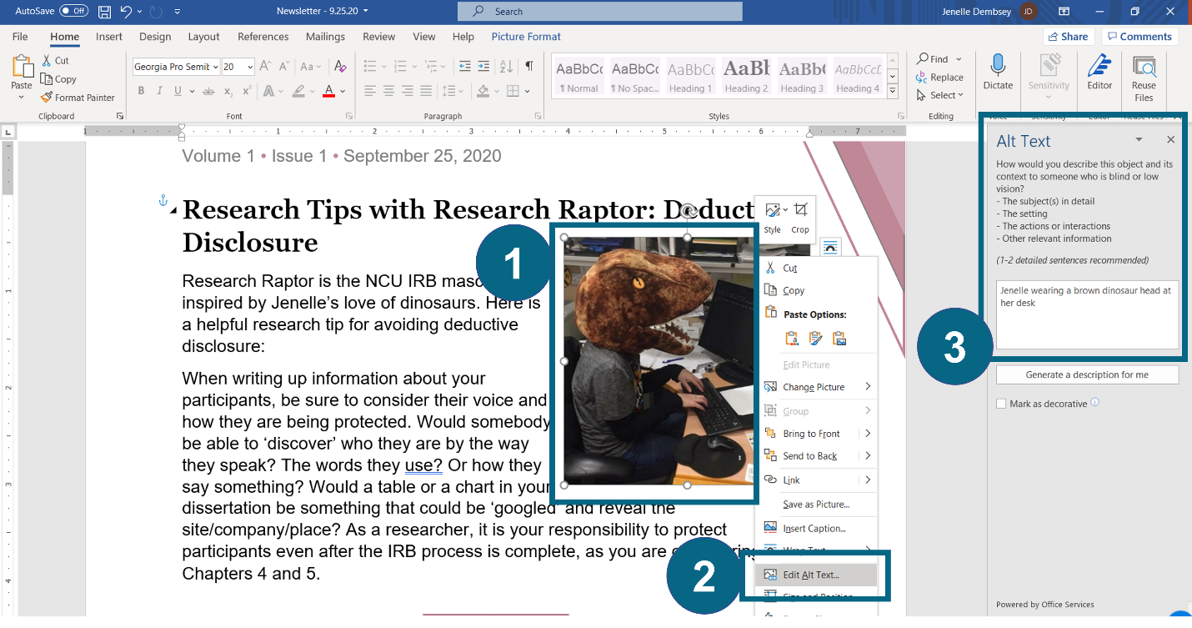
Option 2 for adding alternative text is to do the following:
- Select the image
- Go to the “Picture Format” tab at the top
- Click “Alt Text”
- Add the alt text in the box that appears on the right side.
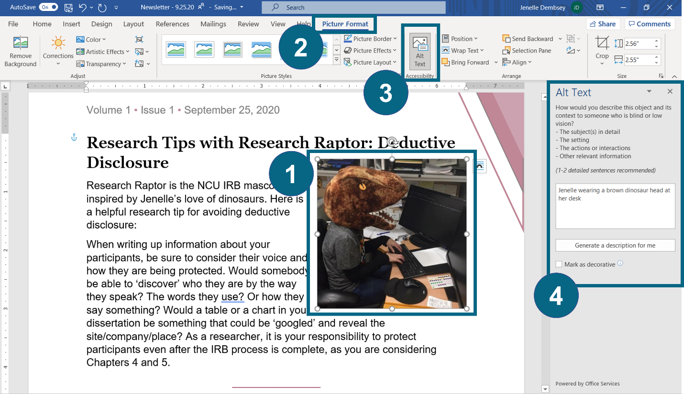
This alt text box also provides you the option to indicate images that are decorative. Usually, decorative images are shapes or lines that might add color to a document but don’t convey any information or context.
In this example, there is a maroon triangle design in the upper right corner of the newsletter. It’s there to make the newsletter look better visually, but it doesn’t convey anything. So in the alt text box on the right side, we can check the box for “Mark as decorative.” This indicates to screenreaders that the image does not convey anything, and the user is not missing out on any information.
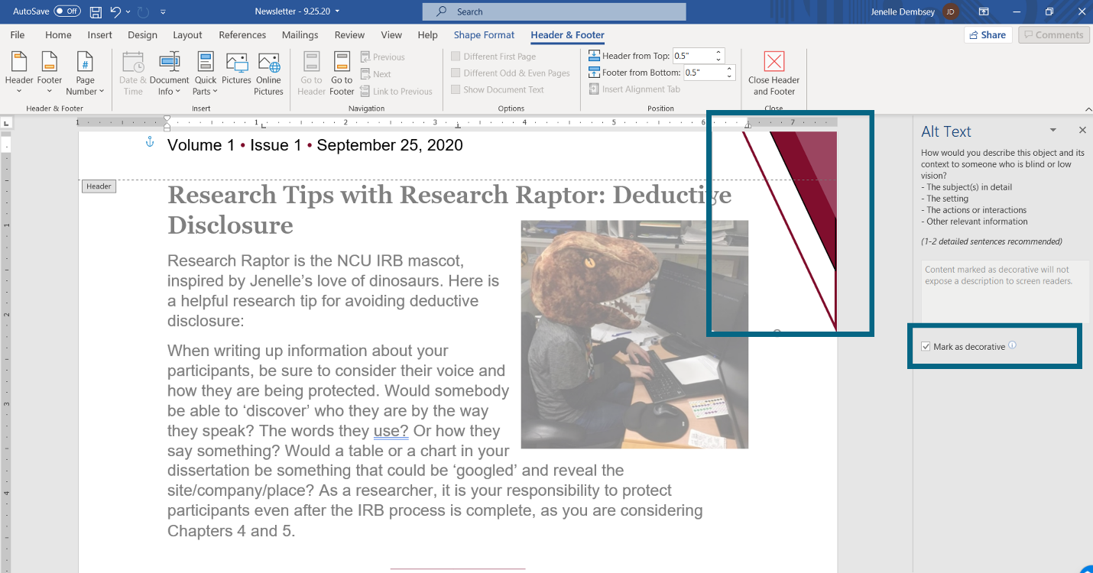

How Do I Write Alternative Text? [slide 63]
The trickiest part with alternative text is knowing how to write them in a way that is both concise and meaningful. And this all depends on context.
Here are some tips for writing alternative text:
- Do not begin with phrases like “image of,” “photo of,” or “screenshot of.” The screenreader will already indicate the image when reading off alternative text, so it is redundant to also include it as part of the alternative text.
- Describe the parts of the image that are relevant in context. Think about why you chose the image and what is relevant to you when you look at it.
- Type out any relevant words that appear on the image.
- If the image acts as a link, describe where the link will take users.
- Use phrases when possible and no more than 2 full sentences. If more than 2 full sentences are needed to describe the image, then put the phrase “Description in text” in the alt text box and write an image description within the main text instead. (We will discuss image descriptions in the next section.)
Here are some examples of alternative text.

Alt Text Example 1 [slide 64]
This first example is a drawn image of a woman in a red shirt who is staring at a laptop screen. She has question marks around her head, is holding her hand to her head, and is holding her glasses in her hands.
This image is being used in a handout about avoiding confusing language, and it does not act as a link. So, in this context, the only detail that is relevant is that this person is confused. So the alt text is only a short phrase:
Alt text: “Confused woman”
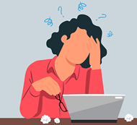

Alt Text Example 2 [slide 65]
In this second example, we have a light blue circle and inside the circle is a downward-facing arrow. This kind of arrow is commonly used to indicate that something can be downloaded.
The image is appearing on a PowerPoint slide about how attendees can download the materials for that presentation. So the only detail about the image that is relevant is that it is a download arrow. The image also acts as a link to the presenter’s online portfolio. So the alt text would be:
Alt text: “Download arrow. Links to Jenelle’s online portfolio.”

Alt Text Example 3 [slide 66]
This third example is the website banner for the OWCA. It appears at the top of every page on the OWCA website. It is not a link, but the image includes words that are relevant in context.
So we will start the alt text by telling the user what the main image or background is. And then we will write out all of the text that appears on top of the image. I was trained to include the word “Text,” to indicate that the following words appear on the image itself. So the alt text would be:
Alt text: “Laptop and agenda notebook. Text: Online Writing Centers Association (OWCA). A professional association supporting online writing centers as an area of study.”
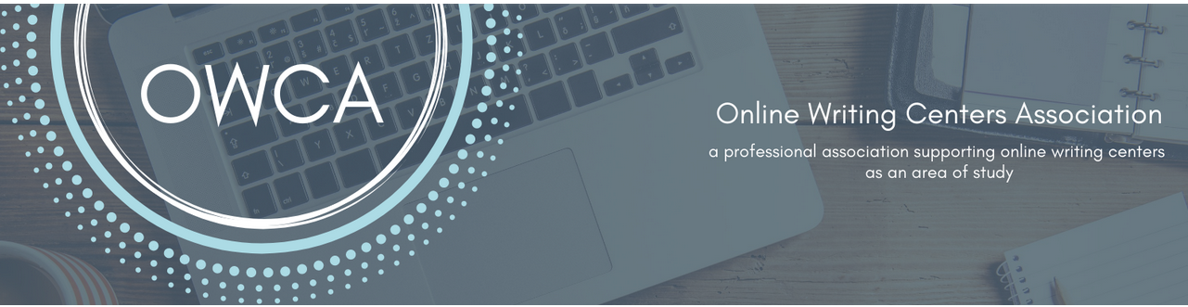

Alt Text Example 4 [slide 67]
Our last example is a yellow post-it note that looks stuck to a wall with a pin. It has the words “SAVE THE DATE” in all red caps.
This image appears in an online list of upcoming writing center events. The image is also a link to the event registration page. So the alt text will need to establish what the main image is, what text it has, and what it links to.
Alt text: “Post-it note. Text: Save the date. Links to writing center event registration.”

Practice with Alternative Text [slides 68-74]
Alright, let’s practice writing some alternative text. These are Exercises 4.1, 4.2, and 4.3 in the worksheet. I will provide some example images, and you can write out the alternative text in the chat. There are multiple correct ways that you can write alt text for any given image.

Exercise 4.1 [slide 69]
Exercise 4.1 is a photograph of a day planner or calendar that is open on a desk. Some days are filled in, and some days are blank.
The image is being used in the background of a PowerPoint presentation on accessible everyday practices.
How would you write the alt text for this image?
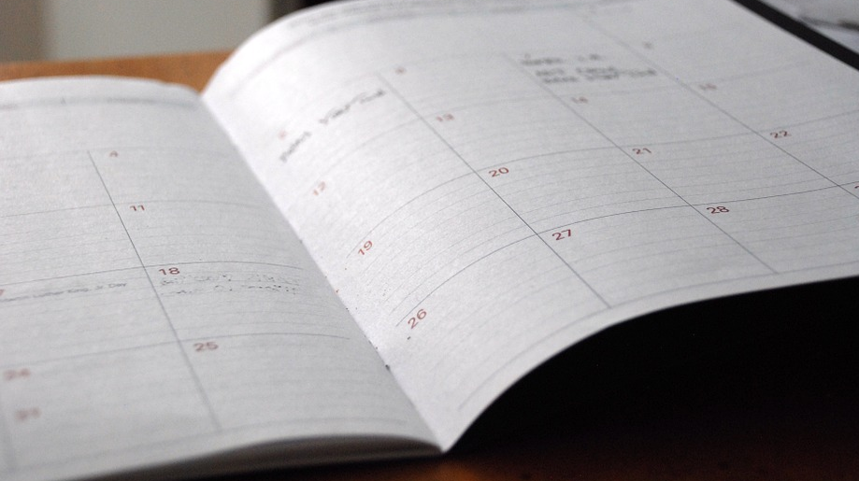

Webinar Chat Responses
Robert George: Dayplanner on desk
Alex Johnson: Open planner
Shan Overton: Open calendar on desk.
Josh Leonard: Day planner open on a desk
Margaret Hernandez: Dayplanner opened on a desk
Jenny Staben (she, her, hers): Open planner
Bethany Bibb (she/her/hers): Alt text: planner open on a desk
Jess Shubert (she/her): "Day planner"
Presenter [responding to chat]: “Open Calendar on a desk.” “Day planner opened on a desk.” “Open Planner.” Yeah. Mine is closest to Jenny’s. So I don’t even mention the text in my alt text because that’s not the part that is important, right?

Exercise 4.1 (answer) [slide 70]
If the presentation is on everyday practices, then the only relevant detail in this image is that it’s an open day planner. So the alt text would be:
Alt Text: “Open day planner”

Exercise 4.2 [slide 71]
Exercise 4.2 is a photograph of train tracks in the woods. The photo is a low-angle close-up of the tracks, and the word “START” appears in white in all caps on the first wooden plank of the tracks. The word “START” looks 3D and appears to be actual letters that were placed on the tracks in the photograph.
This image is being used on the IRB website and is acting as a link to a page called “Getting Started with the IRB.”
How would you write the alt text for this image?

Webinar Chat Responses
Shan Overton: Train tracks in woods. Text: START. Links to IRB website.
Josh Leonard: Train tracks with the word "start"---can you use quotations in Alt Text?
Kate Parsons (she/her): Train track close up. Text: Start. Links to IRB Getting started page.
Valerie Balester: Railroad tracks pointing way forward Text: Start
Jess Shubert (she/her): Train tracks with white letters spelling "START." Links to IRB website.
Valerie Balester: Links: IRB web site
Alex Johnson: train tracks with the word start placed on them. Links to IRB About website.
Janice Lark: railroad tracks Text: Start hyperlink to start
Glynis Benbow-Niemier: Train tracks leading away. Text: Start with link to IRB web site
Presenter [responding to chat]: Shan, yours is really close and good. Train tracks and woods. Text: START. Links to IRB website.
Josh I believe, I use quotations in alt text so I think that you can use quotations in alt text. I think they do prefer punctuation just like when you're writing sentences. Punctuation just adds extra clarity and it helps the screen reader to know when to pause and things like that, so punctuation is good.
All right Alex mine is kind of close to yours.

Exercise 4.2 (answer) [slide 72]
So again there's multiple ways that we could have written this because the word "START" looks like it's actually placed on the tracks I chose to just write out the word "START" on train tracks rather than beginning with the word text but that's just me. I think either one would have been fine.
Alt Text: “The word “start” on train tracks. Links to page about getting started with IRB.”

Exercise 4.3 [slide 73]
This is the last exercise for alternative text (Exercise 4.3). This is a screenshot of 5 people in Zoom, and they are dressed in pirate gear, with the exception of me and my dinosaur head. You can tell I have a consistent theme.
This screenshot is meant to be humorous, and it is from a pirate-themed webinar. The image is appearing in a newsletter under a section titled “In Case You Missed It.” Readers of the newsletter will know the individuals in the image.
How would you write the alt text for this image?
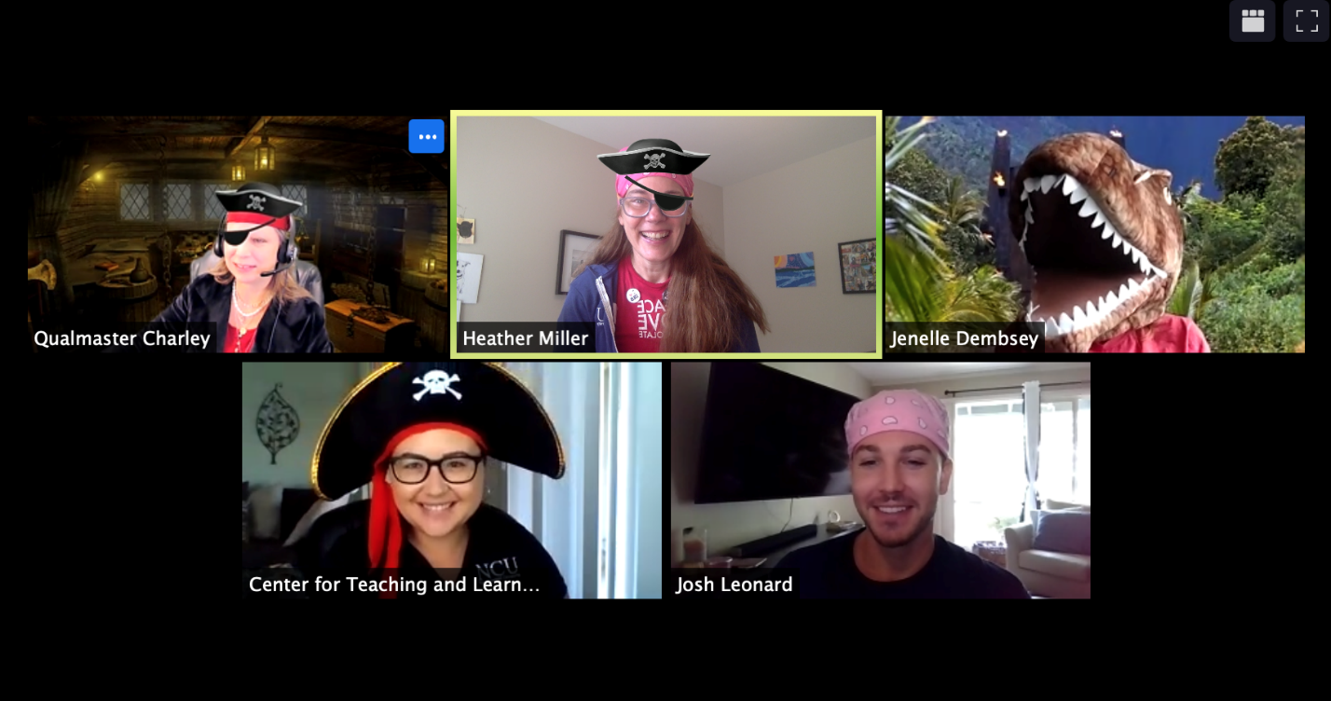

Webinar Chat Responses:
Josh Leonard: 😆
Robert George: Irb staff in pirate costumes
Shan Overton: Screenshot of Zoom screen with five people in pirate costumes.
Josh Leonard: Webinar hosts dressed in pirate attire
Janice Lark: collection of presenters dressed as pirates along with a dinosaur
Alex Johnson: Zoom screenshot of users wearing pirate filters. Users include Charley, Heather, Jenelle, Josh, and [other person]. Jenelle is in a dinosaur costume.
Presenter [responding in chat]: So, I’m going to disagree with all of you.
Paula Rawlins (she/her): I would consider a description in text!

Exercise 4.3 (answer) [slide 74]
This image is too detailed to be described in only 1-2 sentences in the alt text. If you were to describe it with only 1-2 sentences, you would be cutting out a lot of the humorous details, and then someone who cannot see the image is not getting to enjoy the same humor as someone who can see the image. In addition, even people who can see the image would benefit from an explanation of what they are looking at. There is a lot going on in this image, and context is needed for all readers.
So our alt text would be:
Alt Text: “Description in text.”
This indicates to the user with a screenreader that the description of the image appears within the main text. And then we would write out an image description within the main text. Which leads us to our last digital accessibility principle.

Principle 5: Image Descriptions [slides 75-89]
Our fifth and last digital accessibility principle is image descriptions.

What Is an Image Description? [slide 76]
An image description is a description of an image that appears within the main text, instead of behind-the-scenes. You have options for where to place image description within the main text, including within a paragraph near the image, on its own directly above the image, or on its own directly below the image. Which place you choose will depend on the context, the layout of the document, or even your citation style.

When Do I Use Image Descriptions? [slide 77]
You should use image descriptions if any of the following are true:
- The image has too many relevant words or details to be described in only 1-2 sentences in the alt text.
- Clarity and context are needed for all readers.
- You are sharing a flowchart, graph, table, or other complicated visual. Tables and graphs, even when created in Microsoft Word, sometimes don’t work well with screenreaders, so providing an image description makes sure that the same information is conveyed to everyone.
- The technology platform doesn’t allow for alternative text. For example, some email and social media platforms don’t have options for adding alternative text.

How Do I Write Image Descriptions? [slide 78]
When writing image descriptions, keep the following in mind:
- Include details that are relevant in that context, just like when you’re writing alternative text. Think about why you are sharing the image or visual, and what it is that you want people to notice.
- Remember to write “Description in text” in the alternative text box (if the platform you’re using allows you to). This informs anyone using a screenreader that they can find the description when reading through the main text.

Image Description Example 1 [slide 79]
Our first example is the Zoom screenshot from our earlier discussion on alternative text. As a reminder, this image is a humorous screenshot from a webinar where the presenters dressed up as pirates. The image appears in a newsletter in a section titled “In Case You Missed It.” Readers will know the people in the image.
There are a lot of humorous details in this image, so we would provide the following image description:
Image description: “Screenshot of 5 presenters in Zoom. Top left: Charlene Sutton (with the Zoom name Qualmaster Charley) with a pirate ship background, pirate jacket, and pirate hat/eye patch. Top center: Heather Miller in a pink bandana, pirate hat, and eye patch. Top right: Jenelle Dembsey in a brown T.Rex head, with a Zoom background of the Jurassic Park gate. Bottom left: Nicole Kitchens with a pirate hat. Bottom right: Josh Leonard in a pink bandana.”

Image Description Example 2 [slide 80]
The next example is my family Halloween picture from 2020 that is also being shared in a newsletter. The audience knows only me. An image description is needed because there are other people that the audience doesn’t know in the picture. Our faces are also all covered, so you can’t even tell that I’m in the picture or which one I am. So we would provide the following image description for all readers:
Image Description: “Jenelle’s family on Halloween in 2020. From left to right: Jenelle’s partner, Mason, in a brown T.rex head. Jenelle’s dog, Jack-Jack, in a T.rex hat and body suit. Jenelle in an inflatable brown T.rex costume.”
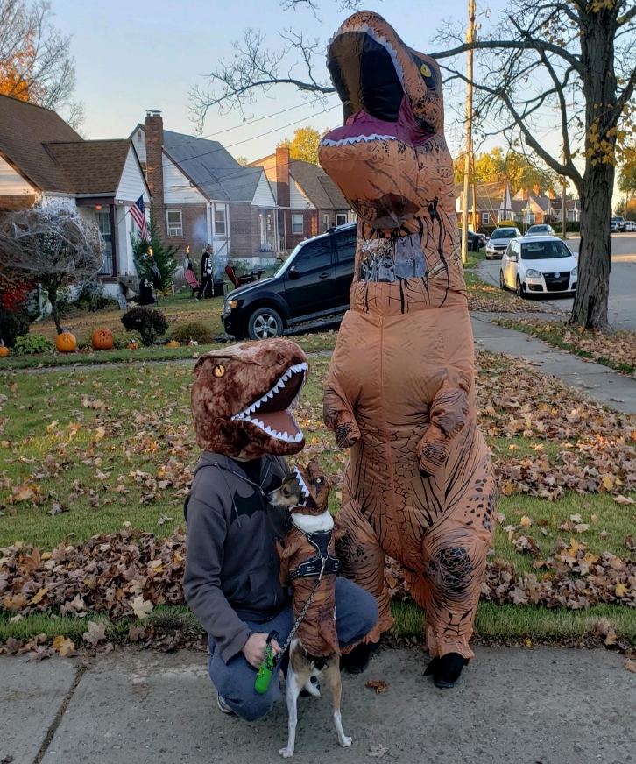

Image Description Example 3 [slide 81]
Our third example is the digital flyer that we created to advertise this webinar on Facebook. An image description is needed here because social media does not make it easy to provide alternative text. There is also too much information in this flyer to be put into alternative text anyway.
So in the body of our social media post, we would type out all of the same details about the event that appear within the flyer. The flyer also includes a picture, so at the end of the post we include a brief description for that picture. So our social media post reads:
“The OWCA is hosting a webinar titled “Introduction to Digital Accessibility Principles,” led by J.M. Dembsey, OWCA President. The webinar will be on Tuesday, August 10, from 3-4:30pm EST.
Image description: Man working at computer.”
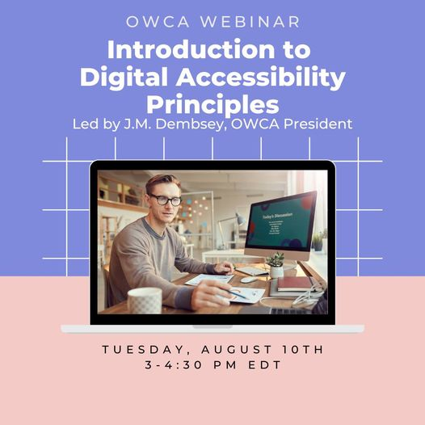

Image Description Example 4 [slide 82]
Our fourth and last example is a flowchart that describes the process for dissertation chairs to review their students’ IRB applications. This flowchart provides a helpful visual to explain a complicated process. But that process cannot be described in 1-2 sentences in the alt text, so an image description is needed. The image description would read:
Image description: “Flowchart for the dissertation chair review process for IRB applications. After the student submits their IRB application, the chair will review. The chair will then check to answer two questions: right student? Right study? If the answer to either is “no,” the chair does not review and sends the application back to the student. If the answer to both is “yes,” the chair submits the application to the IRB.”
You’ll notice that I don’t describe the shapes or arrows that appear in this flowchart, because they aren’t relevant. The process is what is relevant, so I carefully describe that same process in the text.

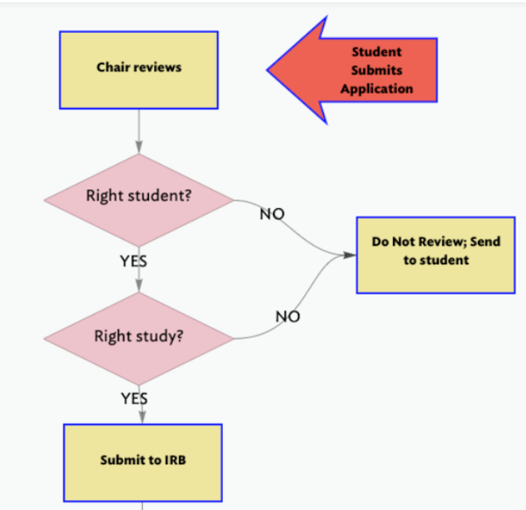

Practice with Image Descriptions [slides 83-89]
Let’s practice writing some image descriptions. These are Exercises 5.1, 5.2, and 5.3 in the worksheet. For each exercise, I’ll put an image on the screen and ask you to write an image description in the chat. Similar to alt text, there are multiple correct ways to write image descriptions.

Exercise 5.1 [slide 84]
Exercise 5.1 is a screenshot of Dory from Finding Nemo. She looks really happy and is staring at a small jellyfish. The image is being used as a meme and the words “Just keep writing…. Just keep writing…” appear on the image. The meme is being shared in a writing group on Facebook.
How would you describe this image?
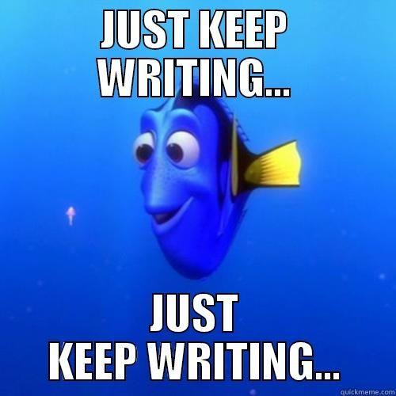

Webinar Chat Responses
Josh Leonard: Dory from Finding Nemo with the text "Just Keep Writing..." ?
Mike Dvoracek: Dory from Finding Nemo. Text: Just keep writing...Just keep writing
Jennifer Wilson: Will you talk a little about where these longer image descriptions go in the main text? How does one signal to sighted readers that this description is not part of the main narrative?
Shan Overton: Image description: Smiling blue fish in background with the words Just Keep Writing repeated twice.
Valerie Balester: Happy Dori from Finding Nemo Text: Just Keep Writing, Just Keep Writing
Alex Johnson: Meme of Dory from Finding Dory. The top and bottom text both read “just keep writing” in the classic meme font.
Jess Shubert (she/her): Meme of Dory from Finding Nemo. Text on top and bottom: "Just keep writing...Just keep writing..."
Presenter [responding to chat]: Yeah, there you go Mike. You got it. Dory from Finding Nemo.
And Jennifer asks if we will talk a little bit more about how these longer image descriptions go in the main text. How does one signal to sighted readers that this description is not part of the main narrative? So, sometimes you can make the description part of the main narrative, right? I have a transcript for this session and I'm describing all the images and they're just part of my regular narrative, my regular paragraphs, as part of the transcript. So it kind of it depends on what you're writing right, whether you feel like describing the image just kind of naturally flows in the paragraphs and the narrative you already have or if you need to have it separated. And if you have it separated, I usually just write the words "Image Description". I actually write those words and bold them so it'll say "Image Description" in bold, colon, and then I write the description and usually it might be like, right underneath the image perhaps, so that they would see the image first then they'd see the image description second and be like
Jennifer Wilson: I'm thinking of a table or figure in an academic document. Thank you for the explanation!
Presenter [responding to chat]: okay you said you're thinking of a table or figure in an academic document so I would do the same exact thing actually. I would have the table or figure and then underneath that I would have, you know, description or image description that then gives all the information, all the data, or whatever I want them to find. I guess, you know, you could also make it part of the narrative as well sometimes you end up emphasizing in the narrative the things you really want people to notice from your graphs or tables anyway. I don't know if that helps. You have options.

Exercise 5.1 (answer) [slide 85]
All that is relevant in this image is that it is Dory from Finding Nemo and the text on the meme that says to keep writing. So we would write the following image description:
Image description: “Dory from Finding Nemo. Text: “Just keep writing… Just keep writing…””

Webinar Chat Responses
Alex: Why is this one not done as alt text?

Presenter [responding]:

Exercise 5.2 [slide 86]
Exercise 5.2 is a screenshot of 4 people in a Zoom room for IRB office hours. There is a notification at the top of the screenshot that says “YOURE A JERK entered the waiting room.” This image is being used as an example in a lesson on checking your Zoom name before you try to enter a public Zoom room. The audience knows the 4 people in the screenshot.
How would you describe this image?
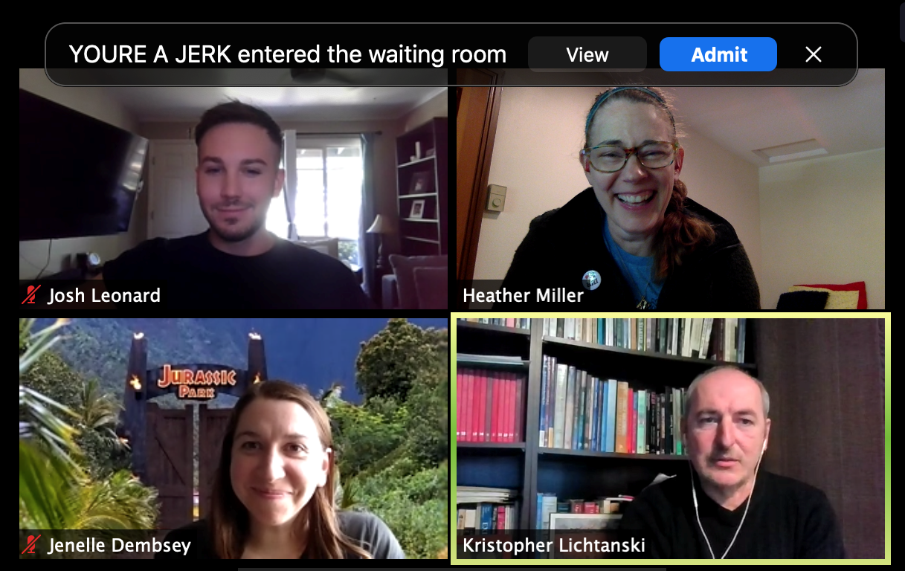

Webinar Chat Responses
Josh Leonard: I am stumped on this one
Shan Overton: Not a clue!
Alex Johnson: A Zoom meeting screenshot showing that “YOURE A JERK entered the waiting room.” then I’d list the 4 people’s names
Janice Lark: Image Description: Writing Center Personnel Josh, Jenelle, Heather, and Kristopher in Zoom Room; Text: You're a Jerk at the top of the frame
Presenter [responding to chat]:

Exercise 5.2 (answer) [slide 87]
Because the audience knows the people in the image, it is relevant to name the 4 people in the image description. It is also important to establish the context for this Zoom call and to point out the notification at the top, which is the focus of the image. So we could write the following description:
Image Description: “Screenshot of Josh, Heather, Jenelle, and Kristopher in a Zoom room for IRB Office Hours. At the top of the screen is a notification that states: “YOURE A JERK entered the waiting room.””

Exercise 5.3 [slide 88]
Exercise 5.3 is a bar graph that shows online writing appointment numbers for January through July 2021. This bar graph is Figure 3 in a metrics report on the online writing center.
How would you describe this visual?
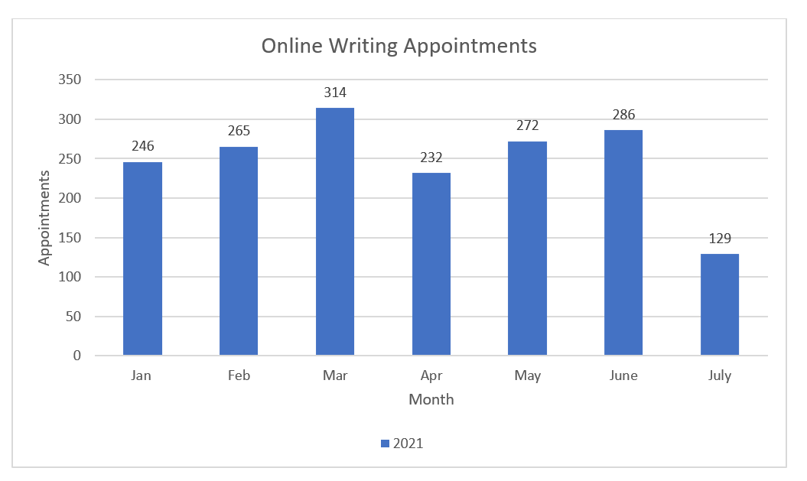

Webinar Chat Responses
Josh Leonard: Bar graph depicting metrics for Online Writing Appointments
Shan Overton: Image Description: Bar graph featuring January through July 2021 for online writing appointments.
Janice Lark: Image Description: Graph showing online writing appointments from January to July 2021
Zayra Carolina Cabañas Zárate: only important data
Mimi Loughlin: Bar Graph showing metrics of Online Writing Appointments. January had 246 appointments...
Alex Johnson: A bar graph showing the appointments per month for online writing center. March and June are the highest and July is the lowest, with almost half the appointments of the others.
Jess Shubert (she/her): Figure 3: bar chart showing appointment numbers for 2021 for each month January through July. [Then list months and numbers]
Glynis Benbow-Niemier: Image Description: Bar graph indicating the number of appointments from January through July with the peaks indicated in July
A. P. Lamberti: Bar chart showing online writing appointments between January and July 2021. March had the largest number of appointments.
Paula Rawlins (she/her): If the table was made correctly, would a screen reader be able to read the bar graph's information?
Paula Rawlins (she/her): (or I guess my question was if screen readers can read tables?)
Josh Leonard: For alt text, in this case, should you include numbers for each month?
Josh Leonard: **as a part of the image description
Presenter [responding to chat]: For tables, yes. For graphs, my understanding is that sometimes creating graphs can be tricky with screen readers because they have so many little parts that are overlapping like all the little text boxes that are there and so my understanding is that they might not read very clearly to screen readers.

Exercise 5.3 (answer) [slide 89]
Because this graph is being shared in a metrics report, the numbers for each month are relevant to the audience. So we would begin by describing the general look of the graph and the data it contains. Then we list out the appointment numbers for each month.
Image description: “Figure 3 is a vertical bar graph with the online writing appointment numbers for January through July of 2021:
- January: 246
- February: 265
- March: 314
- April: 232
- May: 272
- June: 286
- July: 129”

Break + Exercise 6 [slides 90-93]
I’ve just given you a lot of information, so now we will take a 10-minute break and also give you some time to practice applying all of this information in Exercise 6.
You can download Exercise 6 from the OWCA website at OnlineWritingCenters.org or my personal website at JMDembsey.com. The moderators will place both links in the chat.
We will give you 10 minutes to edit this document and apply the 5 digital accessibility principles that we have discussed today. We will now stop the recording, and we will return for discussion in 10 minutes.

Exercise 6 (answers) [slide 92]
So you’ve just spent 10 minutes editing Exercise 6 for digital accessibility. Now I’m going to put Exercise 6 up on my screen and show you how I would revise this document for the 5 digital accessibility principles we discussed today. I’ll go in order starting from the top of the document:
- “How to Design More Accessible Research Studies” is the title and needs to be tagged as a Heading 1.
- “Respect Participants’ Time and Energy” needs to be tagged as a Heading 2.
- Alt text is needed for the icons of data collection methods: “Data collection methods: questionnaire, interview, focus groups, and email review of transcripts.”
- A descriptive hyperlink needs to be moved from “click here” to “Christine Miserandino’s article on ‘The Spoon Theory.’”
- A vertical bulleted list needs to be added in place of the hyphens for the list of daily activities.
- Alt text is needed for the image of spoons: “spoons.”
- “Provide Flexible Options for Participating” needs to be tagged as a Heading 2.
- A descriptive hyperlink needs to be moved from “online survey” to “SurveyMonkey.”
- “Include Image Descriptions with Online Recruitment Materials” needs to be tagged as a Heading 2
- The pasted URL for Canva needs to be deleted, and a descriptive hyperlink needs to be added “Canva.”
- The list of text alternative requirements needs to be tagged as a vertical numbered list.
- Alt text is added for the screenshot of the social media post: “Example online recruitment post on social media. Description in text.”
- An image description is needed for the screenshot of the social media post
  - “Image Description. Post on social media that is advertising a study. The online recruitment flyer has coffee and books and reads: “Take an online survey on learning preferences of students in online higher education.” The social media post reads: “Are you age 18+ and currently enrolled as a student at a fully online college or university? If so, consider participating in a research study on the learning preferences of students in online higher education. Participants will complete an online survey for 20 minutes. To participate in this study, please contact Jenelle at jmdembsey@gmail.com. Thank you! Image description: coffee and books.””
- “Choose Accessible Research Locations” needs to be tagged as a Heading 2.
- Alt text is needed for the photograph of the staircase: “Library staircase. Multiple inaccessible landings and study areas in middle of stairway.”
- “Need Help?” needs to be tagged as a Heading 2.
- The pasted URLs need to be removed, and descriptive hyperlinks need to be added instead for each of the services listed. A vertical bulleted list is also needed for the list of services.

Discussion of Exercise 6 [slide 93]
So how did you do? Did you catch all the revisions? Did you miss anything? Did I miss anything? You can type your response in the chat.

Ending Discussion [slides 94-97]
Earlier in the webinar, I challenged you to pay attention to the other accessibility principles and practices in this presentation. So, what other accessibility practices or principles did you notice? Please type your response in the chat.
Here is a brief list of accessibility practices that I tried to apply today:
- Describing what I look like at the beginning of the presentation
- Telling the audience how they can participate and welcoming stimming
- Providing a transcript and presentation materials for download
- Including all important information on slides
- Verbally describing images
- Displaying discussion prompts and instructions
- Reading aloud comments and questions from the chat
Now, how can you use the principles that you’ve learned in your everyday work and communication? Please type your response in the chat.
What questions do you have?

Q&A
Elyse: If your main student-facing document is an infographic, how would you decide which content should include ALT text and image descriptions?
Presenter: So it's gonna depend on everything that is in your infographic. Sometimes infographics, the whole point of them is that they contain a lot of information right, so you're probably gonna have to use an image description for that. To write out all of the information that you want people to take away from your infographic and so your alt text would be description in text and then you would have the image description that writes out all the information in your infographic. If your infographic is very detailed and there's a lot to it, I mean it depends on the infographic of course.
Josh Leonard: (from Exercise 5.3 answer)--For alt text, in this case, should you include numbers for each month?**as a part of the image description
Presenter: Yes
Josh Leonard: Should there always be two downloadable file options for hyperlinked documents? (ex: both a Word doc, and PDF)?
&
Deciphering between decorative images and images that need description. How does one decipher between the two? At what point does an image become decorative and not descriptive?
Presenter: It depends on what you are sharing. So usually, I stay away from pdfs whenever possible. So, pdfs are historically very difficult for screen readers. They can be very inaccessible so it's not as simple as I format a word doc to be accessible and I save it as a pdf and that means the pdf is accessible. There's stuff that happens in between when it's smushing it to make it into a pdf and I don't even know how to make pdfs accessible, so I try to avoid them at all costs. The only time that I would provide a pdf option is if there's like a lot of images. So, our newsletters, you know we have a lot of images and kind of some design in the newsletters and so for some people it might just be easier for them to view that in a pdf. So that's why we provide that option, but we also provide the Word document option for people who can't use pdfs. Then Josh's other question was deciphering between decorative images and images that need description. How does one decipher between the two and at what point does an image become decorative and not descriptive? That's a great question and my boyfriend Mason had the same question when I was practicing this presentation with him yesterday. How do you tell which images are decorative and to me decorative means the only time that I label anything as being decorative is when it's just a shape it has no words. It depicts nothing. It's just, you know, a nice, like my slides had a whole bunch of like pink circles or like little teal circles and it's just to make it look nicer for people who can see it. So, it's not just a bland white slide but it conveys nothing so I mark all of that as decorative but if it is ever an image, even if it's just like a silly icon or a silly little graphic that you've picked, it's still something, so I would still have alt text for that.
Robin Clark: Should descriptive hyperlinks be colored in a way to stand out on the page? Is coloring them the same as the rest of the text an accessibility no-no? & How can Webmasters (just, like, a normal employee using whatever web software to maintain the site within the larger host site) format headings within webpages to be both aesthetically pleasing for sighted users as well as using the headings for their intended, screen reader purpose? As (I'd guess) this is a larger issue than a one-off situation and employee, what do you think is the best way to address this aesthetics v. accessibility issue on a larger scale?
Presenter: It should be colored a different way to stand on the page. That is, if you're using any kind of program like Microsoft Word or a website they do that automatically so programs like that if you put a hyperlink on it it automatically gives it a color or an underline or something to make it stand out. So yes you would want another color and again the bright blue and the underline is is the most common, almost universal way of indicating a hyperlink. Other colors can be used, but blue bright blue is far more common.
Always go with accessibility over aesthetics. I've run into this problem too. Like I edit our OWCA website and I don't like whenever you use a website they've pretty much already decided here's what the headings look like, here's how big a heading two is, here's how big a heading three is, so like on our OWCA website I hate the size of the heading twos. They're bigger than the heading ones and I don't think that makes any sense. So I think they look bad but that's what's accessible so I'm gonna use that even if I don't think it's aesthetically pleasing, so accessibility over aesthetics always.
Alex Johnson: Does downloading a Word document as a PDF preserve the metadata of the alt text and heading numbers? Or should we just provide a Word doc?
Presenter: So I think that going from word to pdf preserves some of the metadata, but I think that pdfs, to make them accessible you have to do a lot more tagging and again I don't really know how to make pdfs accessible. My training was just to avoid them at all costs if you don't need to have them. So if you have something in Word, I would always just provide the word document version.
Glynnis Benbow-Niemier: It is best practice then to label all images whether decorative or not?
Presenter: So any actual image, yes, but again if it's just like a shape or a line I would say that could be decorative.
Irina: Does the style of an image matter? sticky figure, vector image. etc...in an alt text
Presenter: So usually I don't indicate sticky figures or vector images. From what I've seen, you don't really need to indicate that level of detail. It's just what the image conveys. I don't think that you have to distinguish between that, not to my knowledge.
Josh Leonard: What about GIFs on a website? What would be the best way to describe that for a screen reader?
Presenter: You would describe whatever's happening, right? Whatever the action is or whatever piece of pop culture the GIF is is pulling from, whatever's funny about it, or the text that's appearing in the GIF. So you would write that out of course. If I had an example I would show you, but it'd be, you know whatever reason you're sharing it, right, like what part of it is conveying your emotion or conveying something funny and that's why you're sharing it. So you would just convey that same type of thing in the image description.
Janice Lark: For an asynchronous presentation that features a narrated PowerPoint, should the presenters describe themselves (as you did) at the onset? Does the narrator have to be visible while giving the presentation?
Presenter: It is an accessibility best practice that I've seen a lot of people do, particularly disabled presenters, is to always describe what they look like even if you can't see them. So it just gives you an idea of who is presenting. You know, what are other people seeing or noticing about this person who is presenting. For an asynchronous presentation I would say you could still give a general description. Like I would probably still describe myself in the same way for an asynchronous presentation and I would say that you do not have to be visible while giving the presentation. Whenever I do asynchronous recordings, I never have my my video on because I find it distracting for myself and it blocks some of the content so I would say you shouldn't feel like you have to have your video on in an asynchronous presentation if you don't want to.

Cite This Webinar [slide 98]
Dembsey, J. M. (2021, August). Introduction to digital accessibility principles [webinar]. Online Writing Centers Association.

