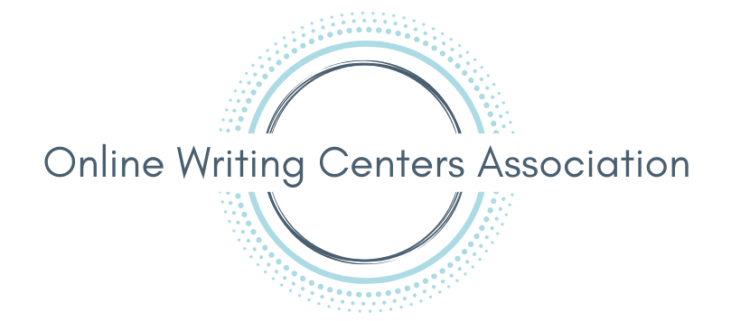

Guide for Asynchronous Recorded Presentations
______________________________________________________________________

Introduction
This guide is intended to help OWCA presenters who proposed an asynchronous presentation. Asynchronous presenters will need to (1) upload their recorded presentation to YouTube and (2) add edited closed captions to their video. This document can be used alongside other guides and examples on the OWCA Accessibility Resources page.

Before Recording
The OWCA suggests that you write your presentation transcript before recording and read from your transcript while recording. This will make it much easier for you to add edited captions at the end.

How to Record Your Presentation
You can use any program you’d like to record your presentation. Some easy-to-use programs for recording include Microsoft PowerPoint, Zoom, and Screencast-O-Matic. Here are some resources:
- How to record a presentation with PowerPoint
- How to record your screen with Zoom
- How to record your screen with Screencast-O-Matic

How to Prepare Your Transcript for Captions
After you’ve finalized the transcript for your presentation, you can then prepare your transcript to be used for captions.

Create an Unformatted Copy of Your Transcript
Captions cannot convey formatting or special characters like bullet points. So you will create a separate version of your transcript that can be used for captions:
- Save a separate copy of your final transcript
- Edit the copy to remove all formatting (title, headings, vertical lists, etc.) and include only the words that you spoke aloud while recording
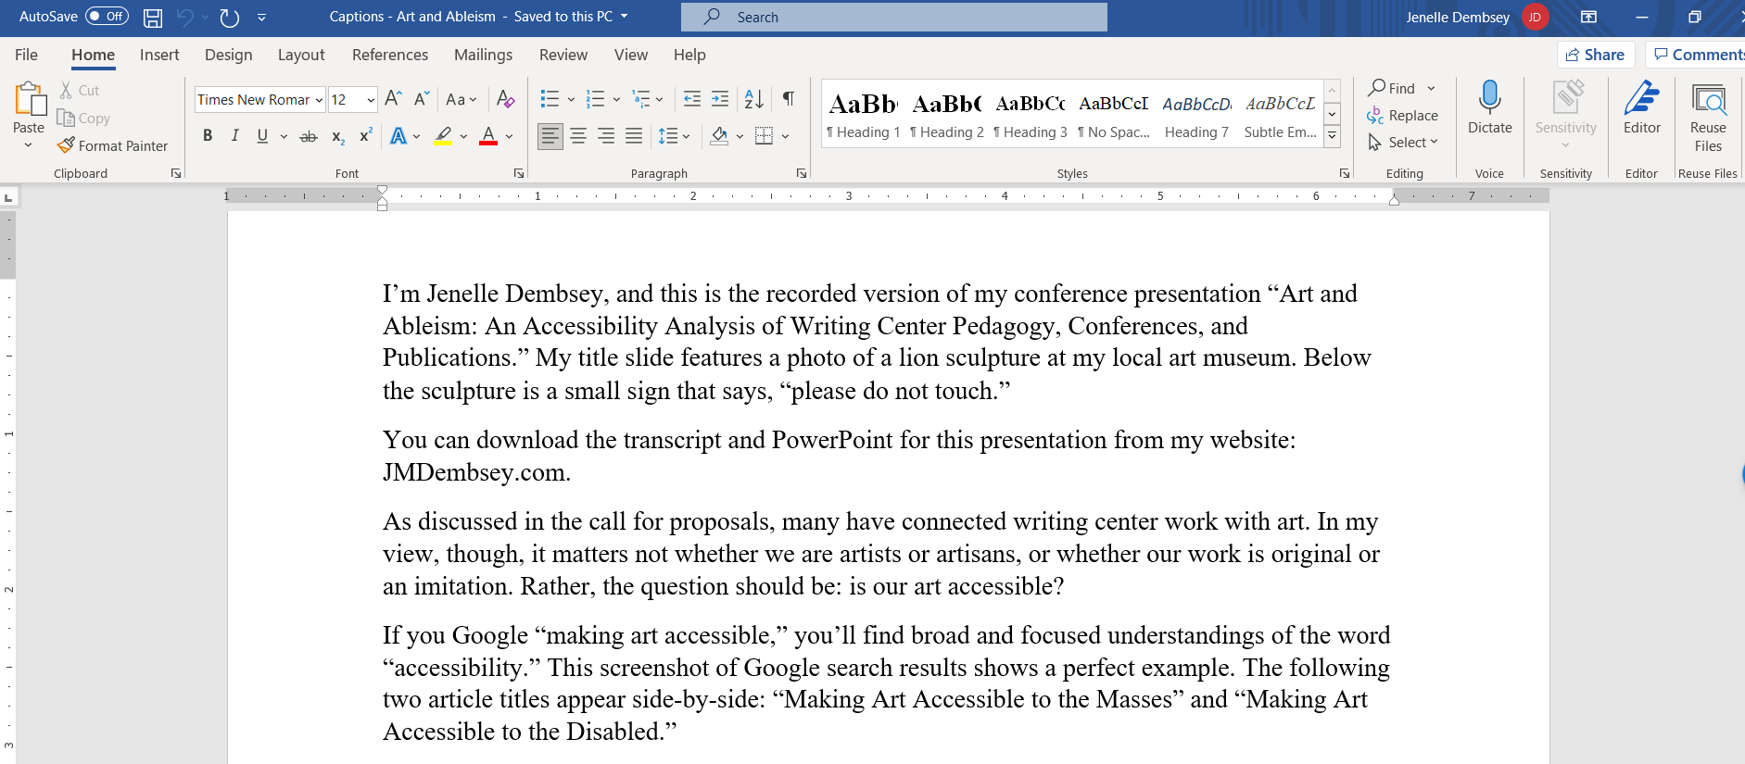

Replace Curly Quotes with Straight Quotes
YouTube will not be able to read the curly quotation marks that Word uses (“). So for your quotation marks to show up in the captions, you'll need to replace any curly quotation marks with straight quotation marks. Word can do this automatically for you. Follow these steps:
- Go to the "File" Tab
- Click "Options" on the bottom left
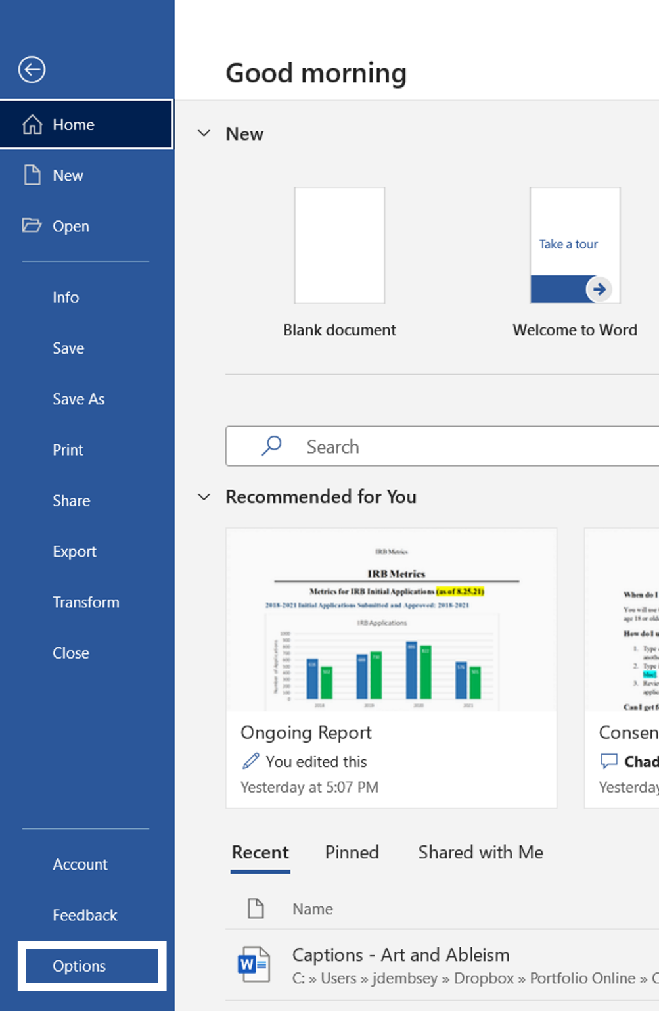

- Click the "Proofing" tab on the left
- Click the button for "Autocorrect Options"
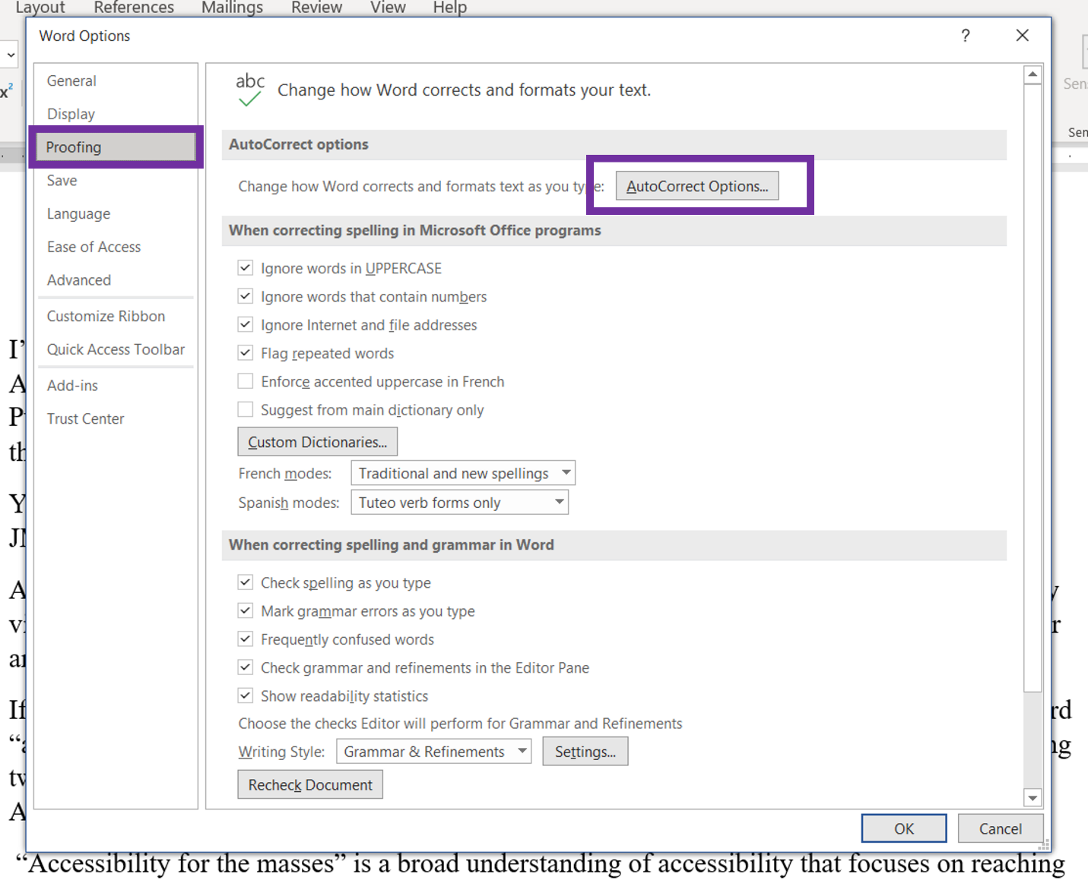

- Click the tab for "AutoFormat As You Type"
- Uncheck the box next to "Straight quotes with smart quotes".
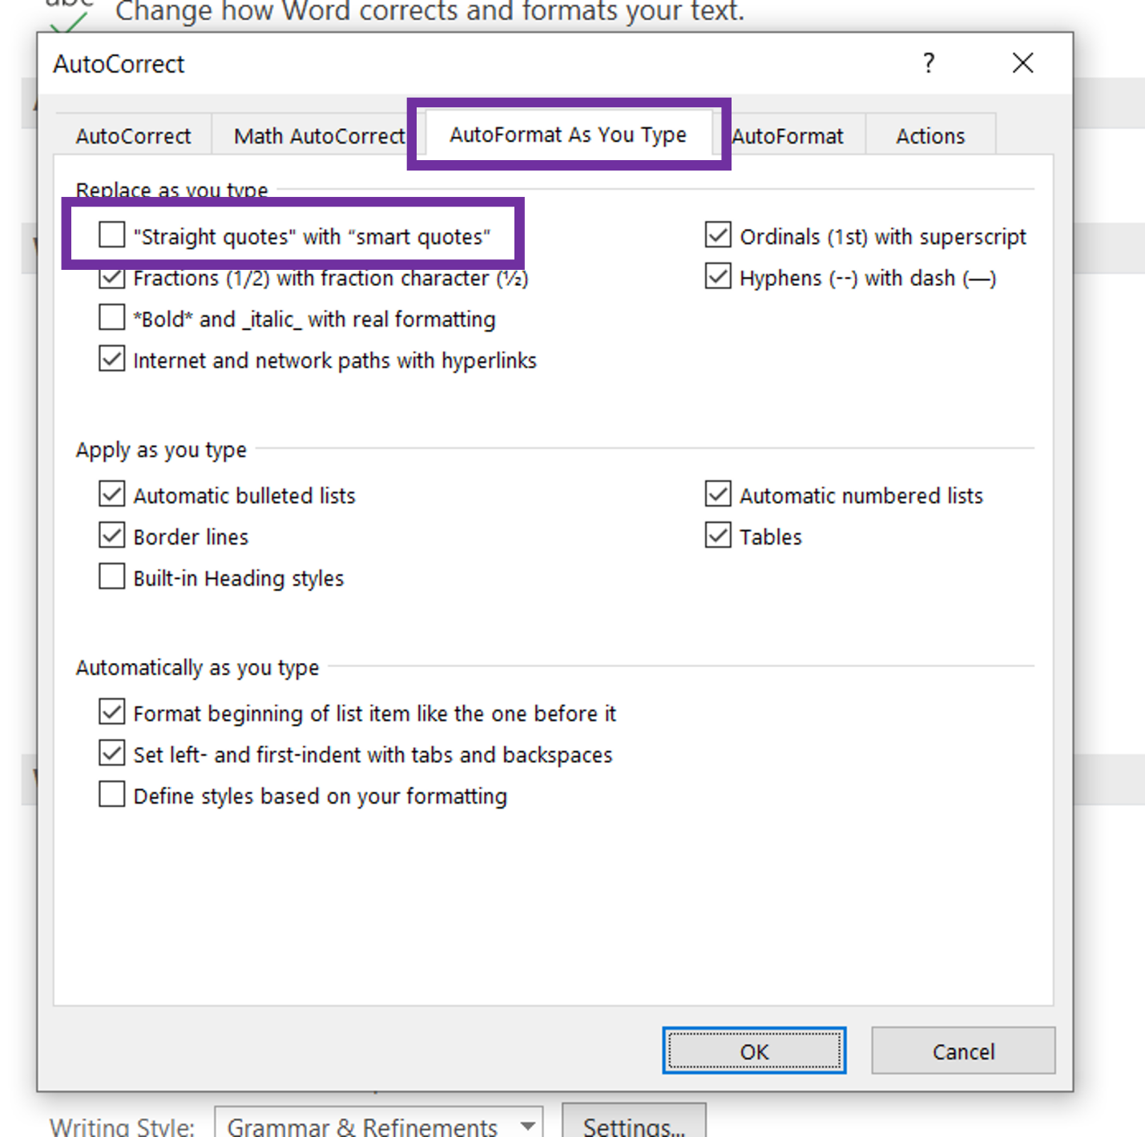

- Click the "AutoFormat" tab
- Uncheck the box next to "Straight quotes with smart quotes".
- Click "OK."
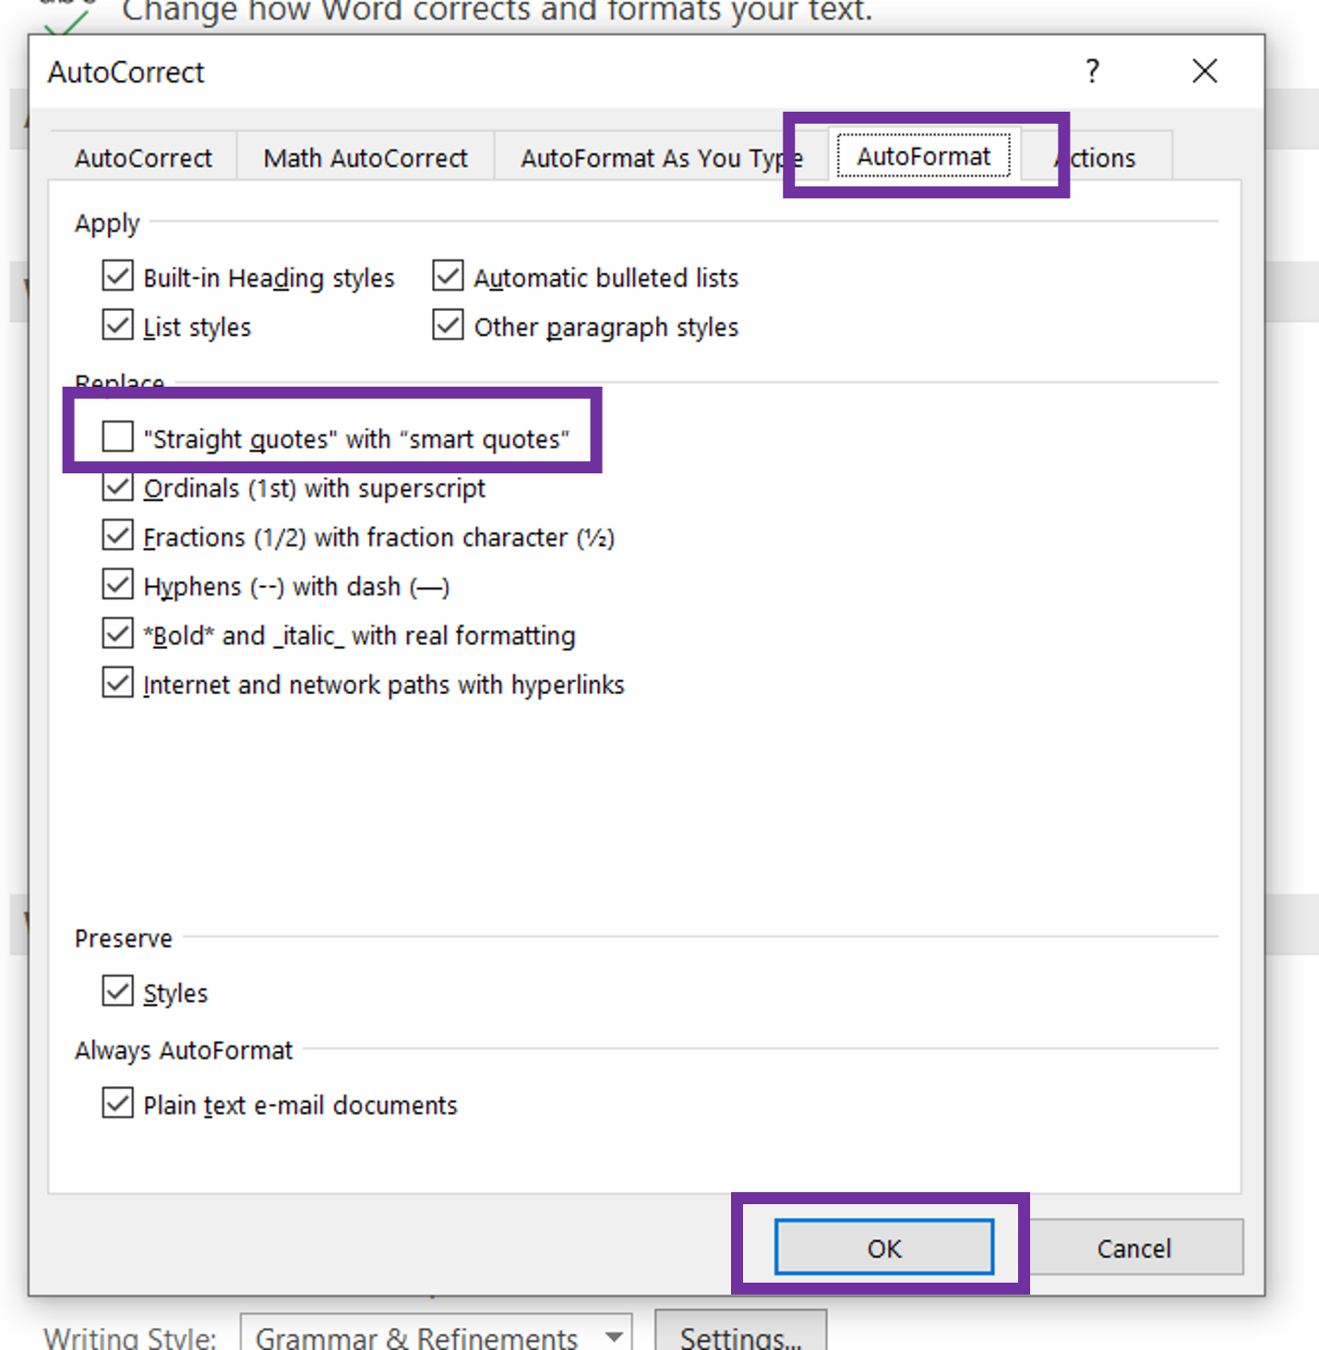

- Click "OK" again to exit out of the dialog box.
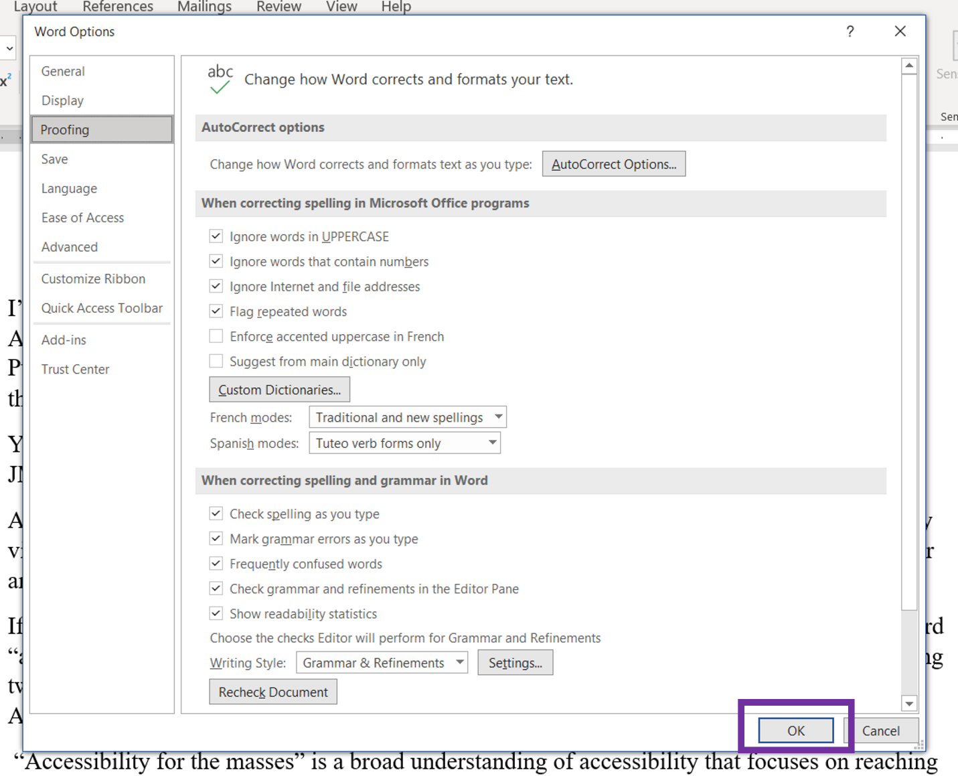
- Click "Replace" under the "Home" tab
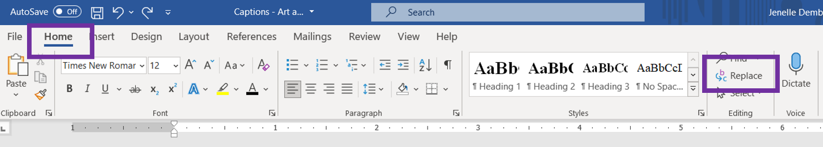

- Type in a double quotation mark (") in both the "Find what" and "Replace with" boxes
- Click "Replace All"
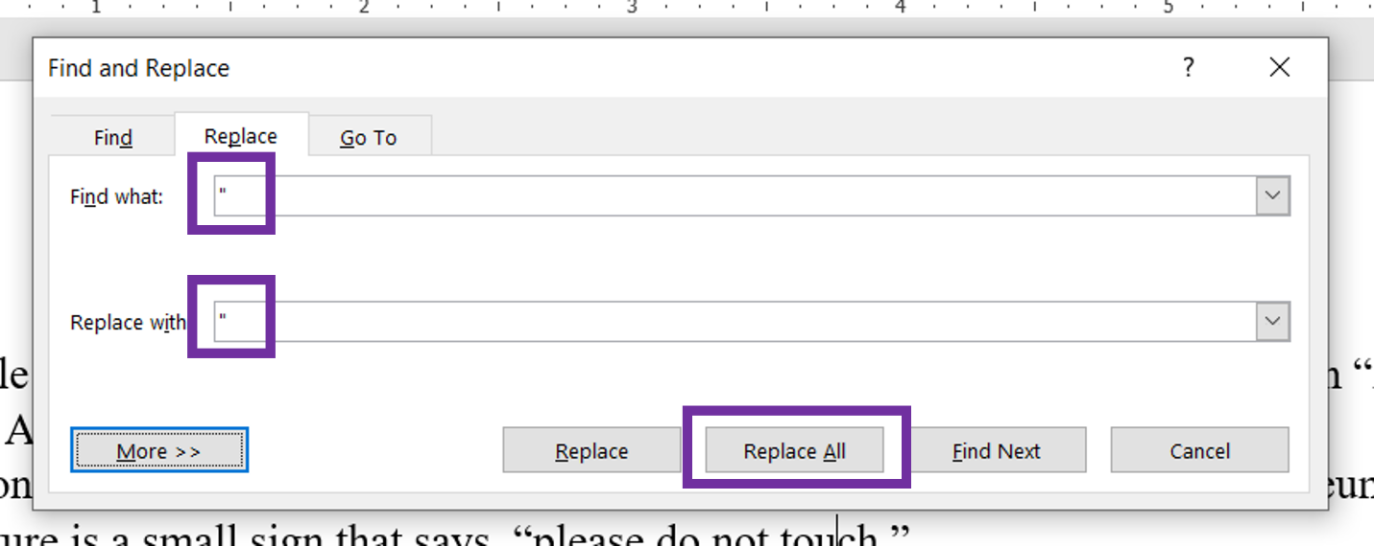
- A dialogue box will appear that confirms that Word has made the replacements. Click "OK."
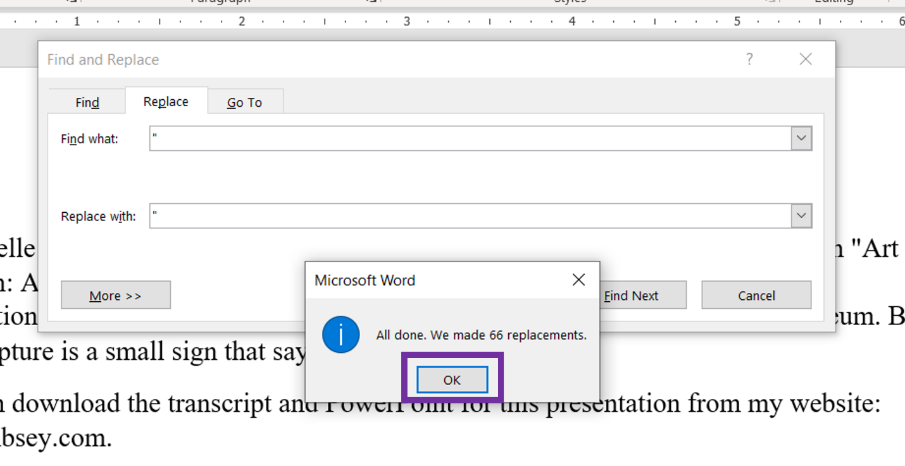

- Type in a single quotation mark (") in both the "Find what" and "Replace with" boxes
- Click "Replace All"
- A dialogue box will appear that confirms that Word has made the replacements. Click "OK."
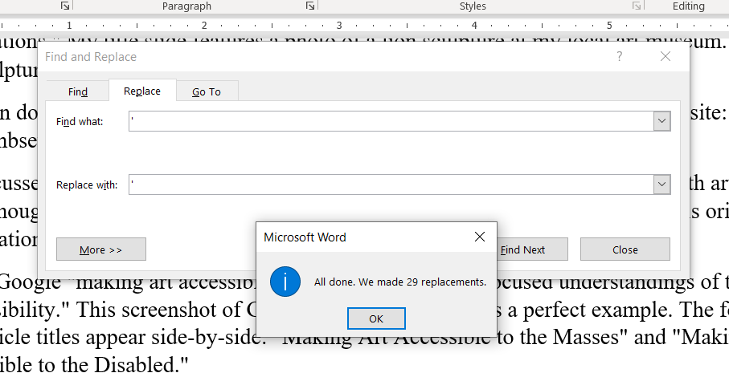

Save Your Transcript as a Plain Text File
After removing all formatting and replacing curly quotation marks, you will save your transcript as a Plain Text file. Follow these steps:
- Go to the “File” tab
- Click “Save As” in the left menu
- Select “Plain Text (.txt)” from the drop-down menu
- Click “Save”
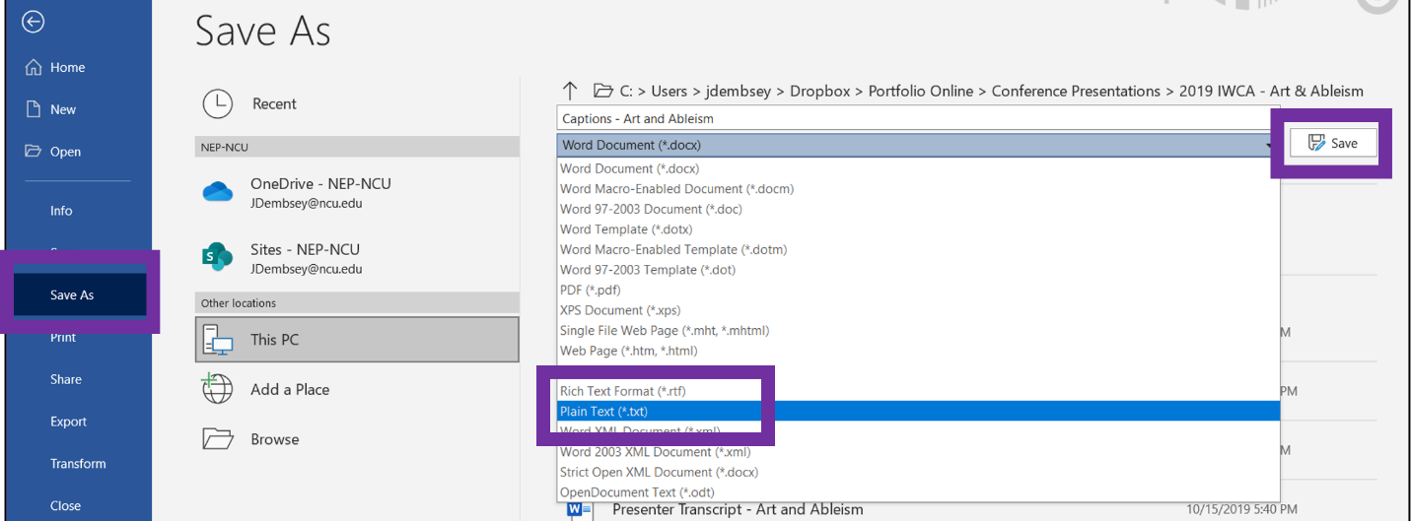
- Click “OK” in the pop-up window.
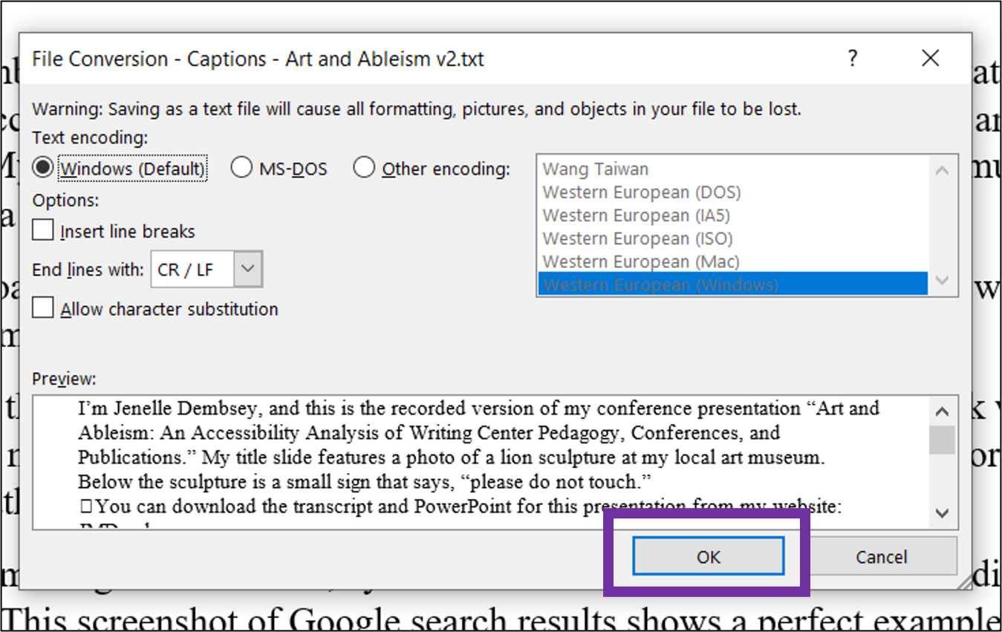
After completing these steps, you will be ready to upload your video and your transcript into YouTube.

How to Upload a Video and Transcript in YouTube
To upload your video and transcript in YouTube, follow these steps:
- Login to YouTube
- In the top right menu, click the camcorder and select “Upload video” from the drop-down menu
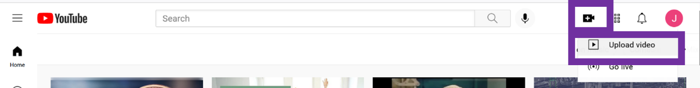
- Drag and drop your video file into the pop-up window.
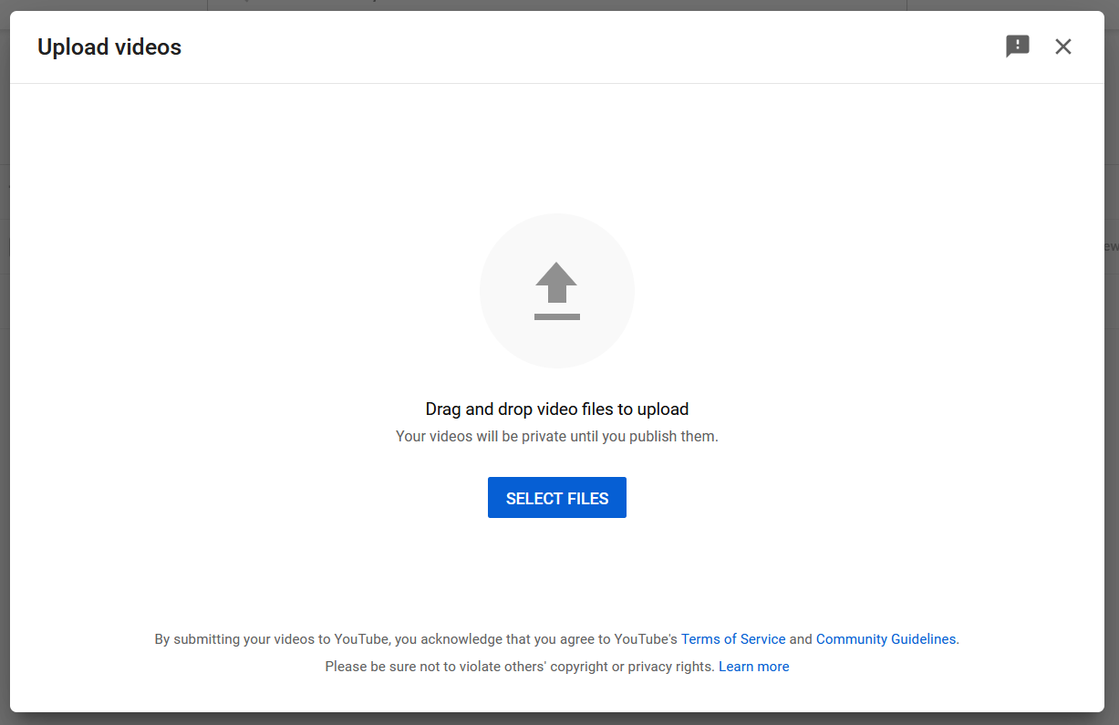

- After YouTube has accepted your video file, a pop-up window will appear. Under “Details,” type in the title of your video.
- Select “Next" in the bottom right corner.
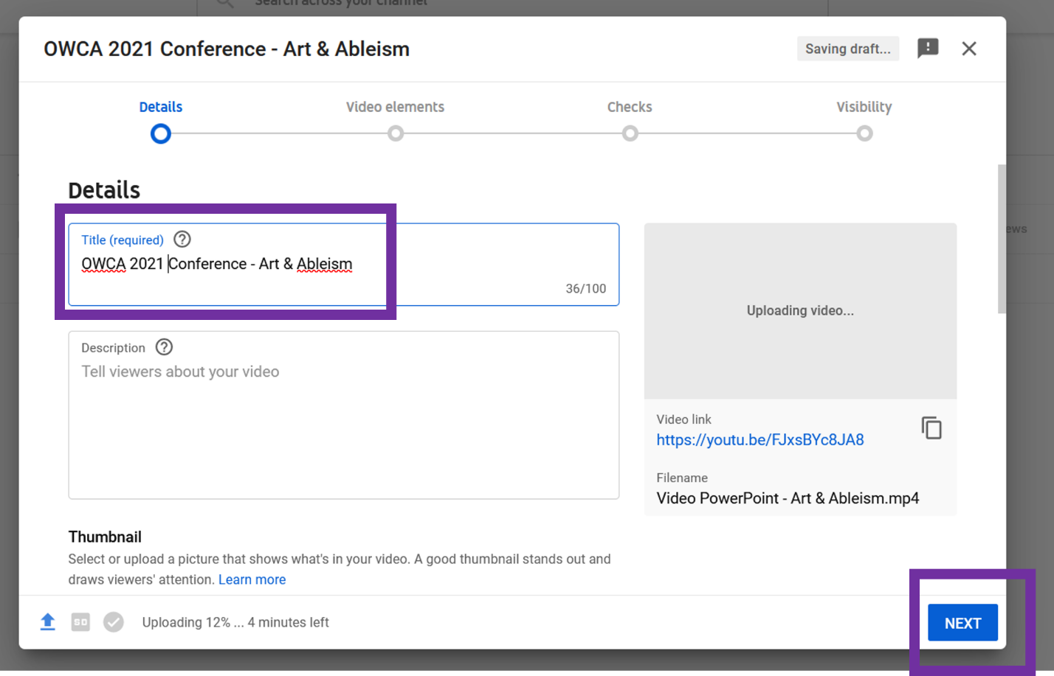

- Under “Video Elements,” find the box for “Add subtitles” and select “Add” on the right side of the box
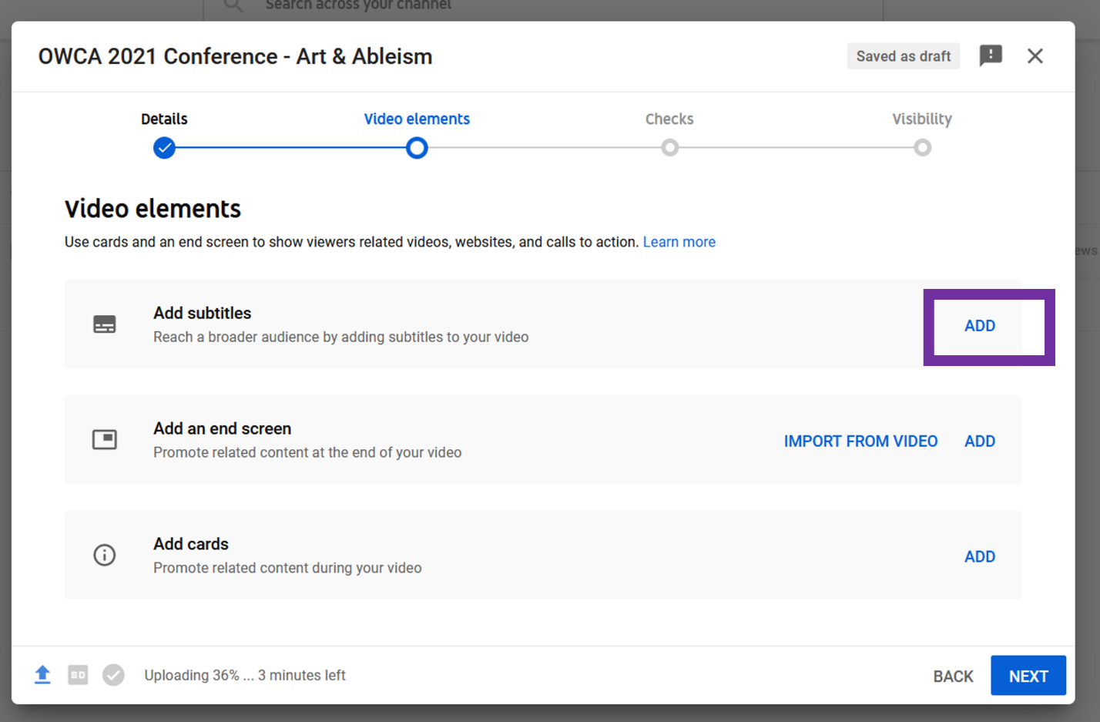
- Select “Upload file.”
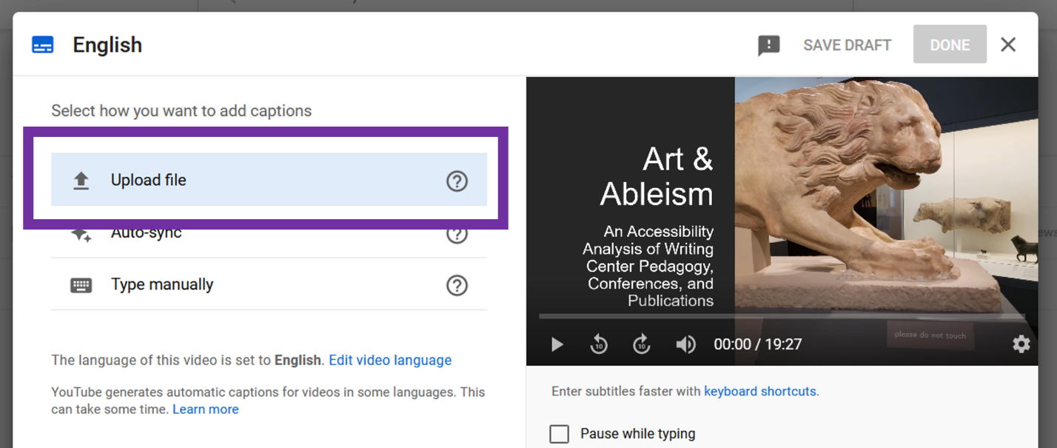

- A pop-up box will appear for your subtitle file type. Select “without timing.”
- Select “Continue.”
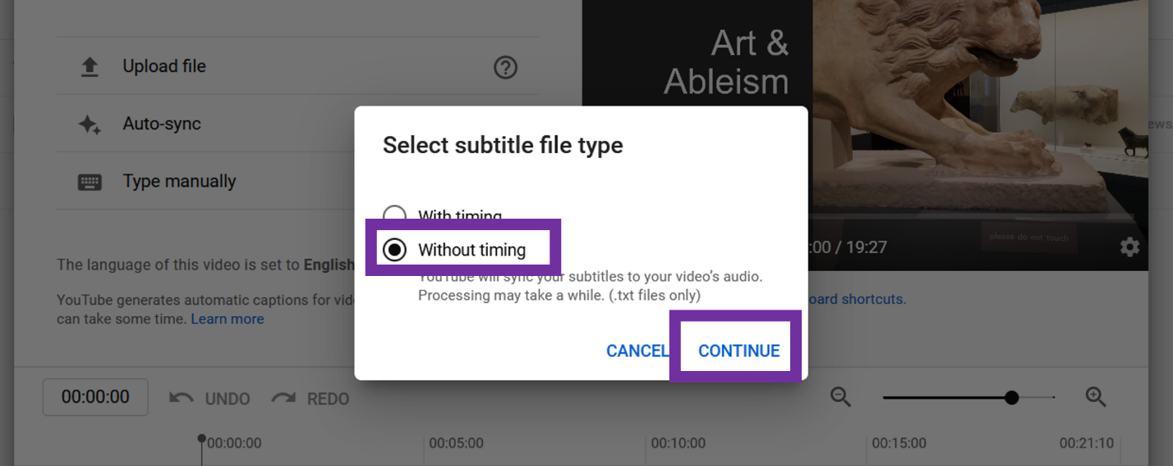
- A pop-up window will appear for you to select your file. Select the .txt file for your transcript that you created earlier.
- Click "Open."
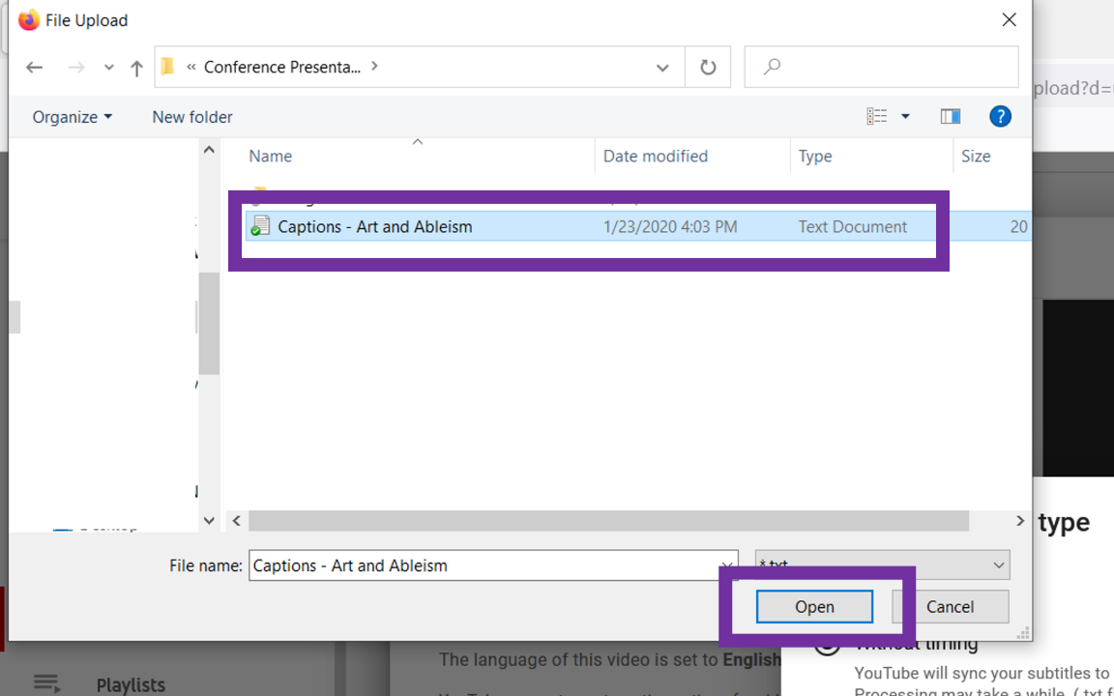

- You will be taken back to the “Video Elements” screen. Click “Next" in the bottom right corner.
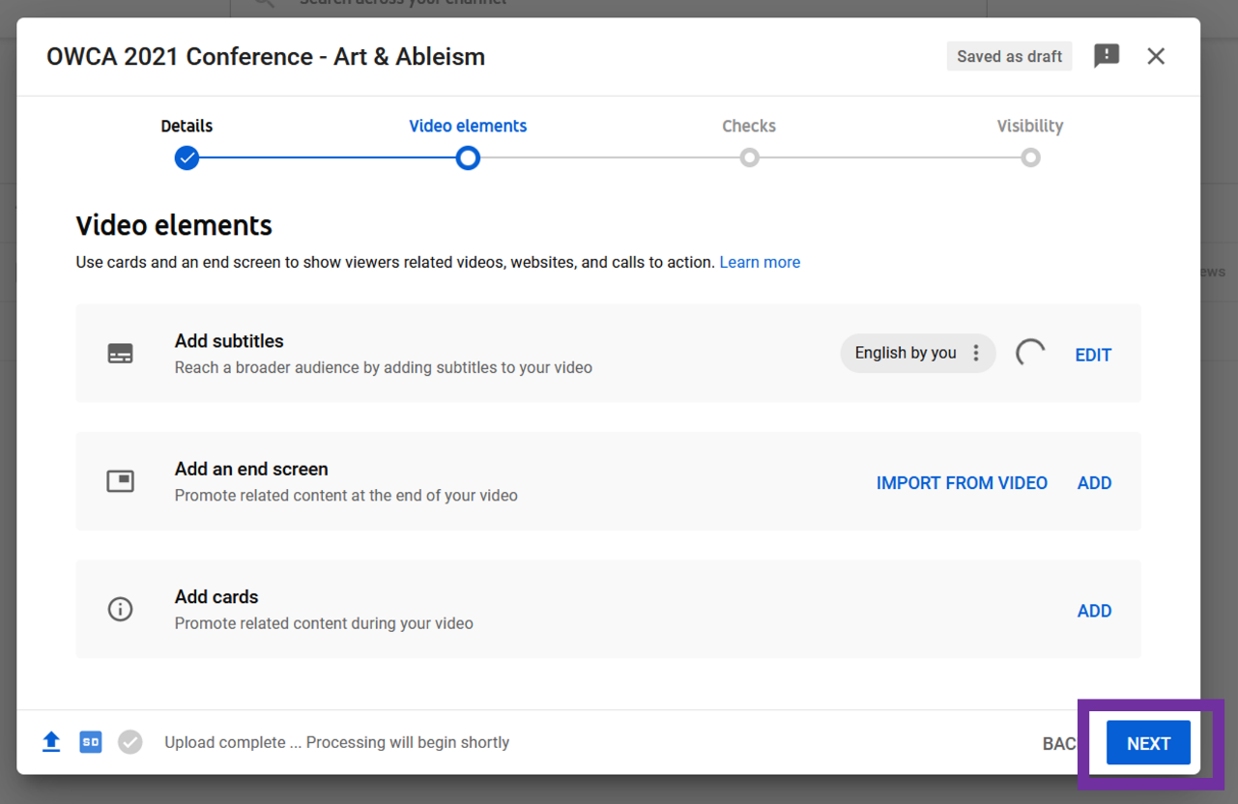
- Click “Next” again.
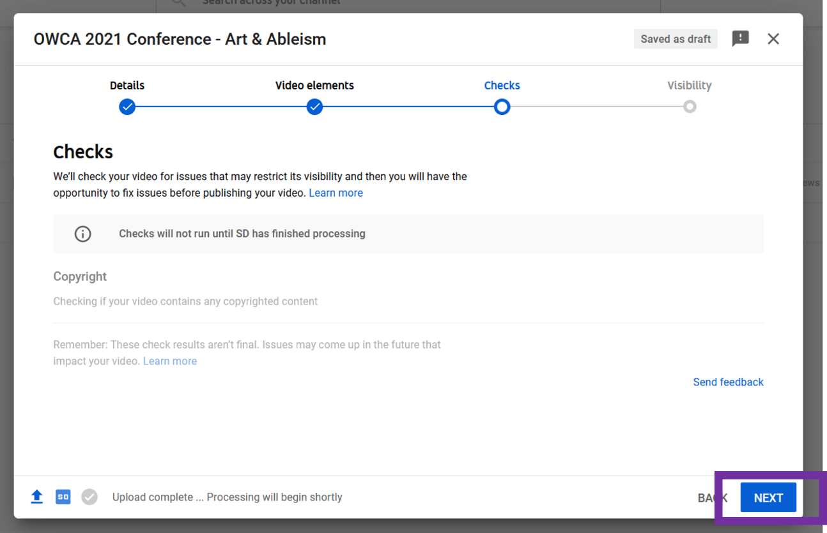
- Under “Visibility,” select “Unlisted.”
- Click “Save" in the bottom right corner.
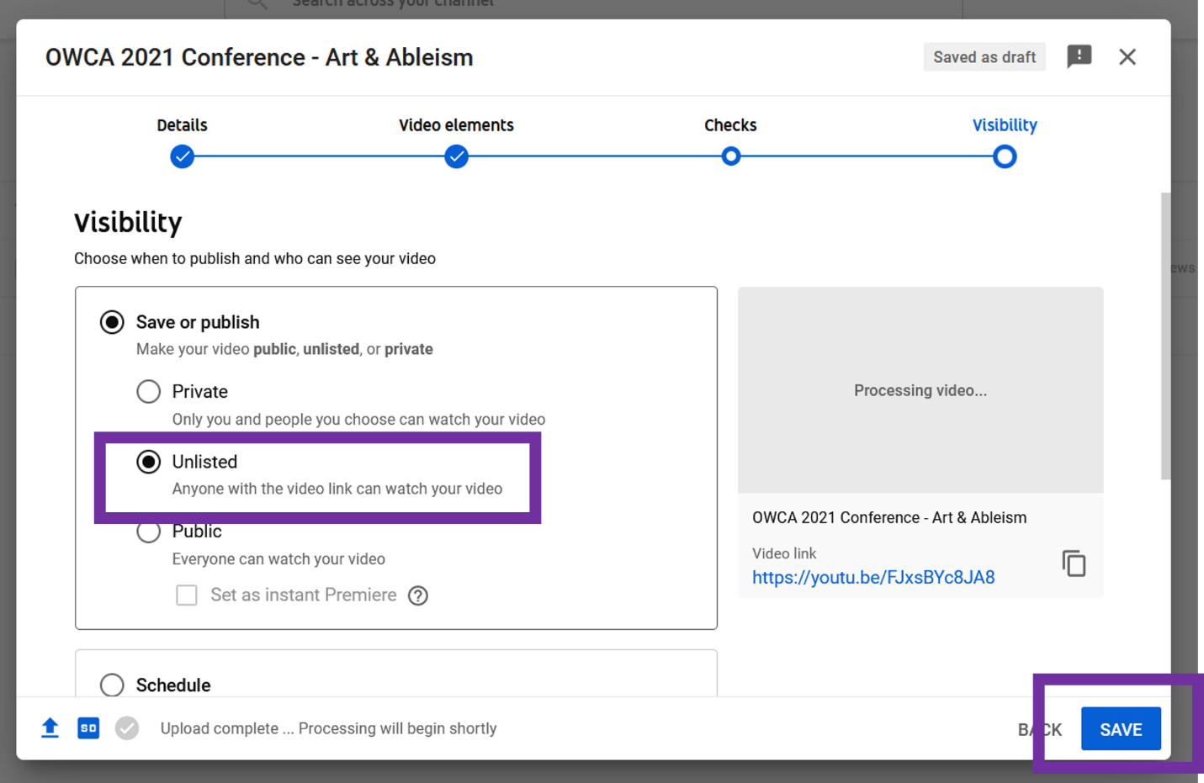
- YouTube will confirm that your video is processing. Click “Close."
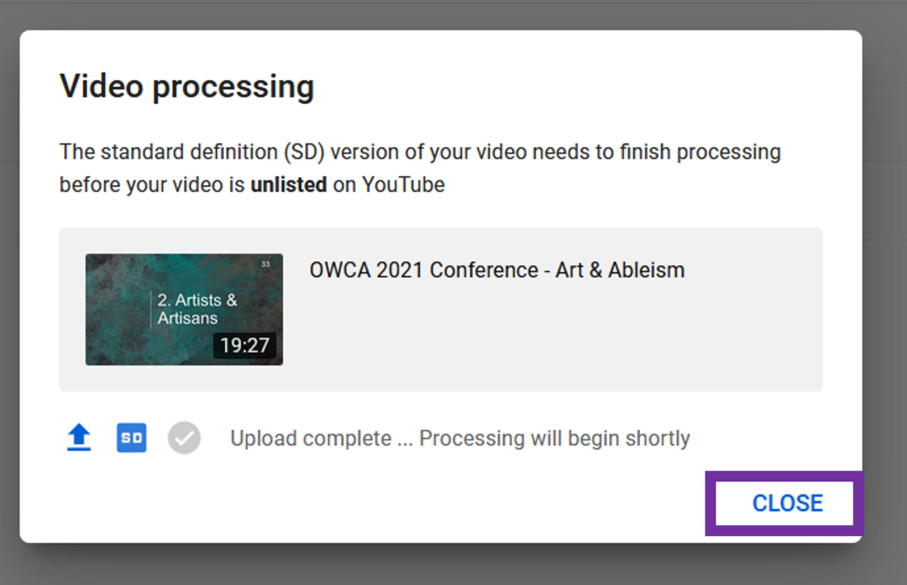

How to Check Captions for Accuracy
You should give YouTube a few hours to finish processing your video and creating captions from your transcript. Before submitting your video to the OWCA, please watch your video and double-check that the captions are correct. Follow these steps:
- Click the 3 horizontal lines in the top left corner of YouTube’s site
- Select “Your videos” from the menu.
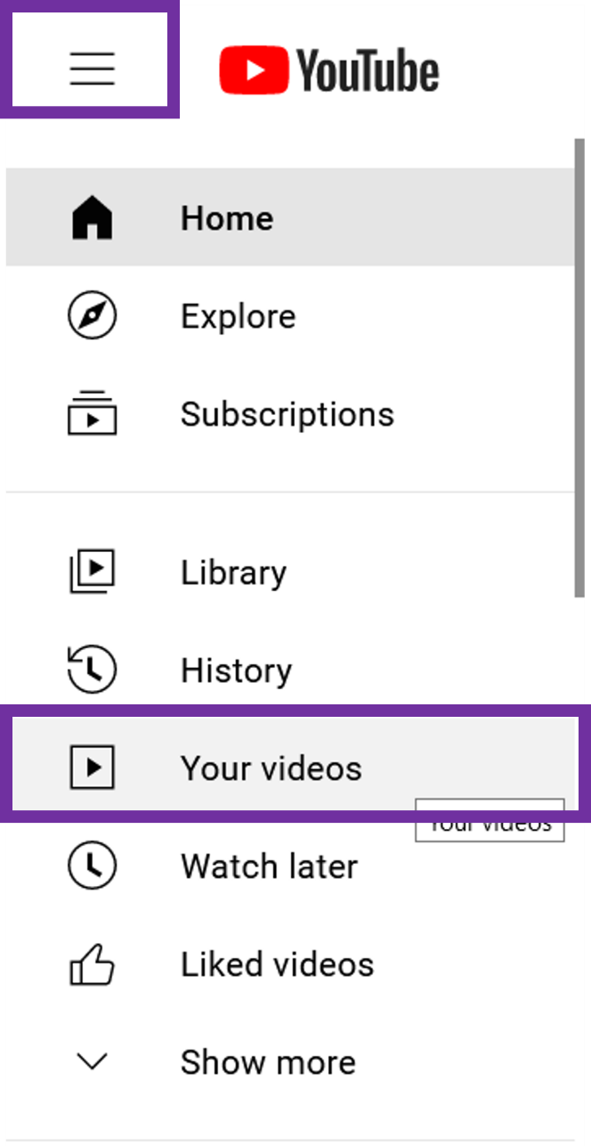
- YouTube will list all of the videos posted to your account. Hover your cursor over your conference video and click the YouTube icon.
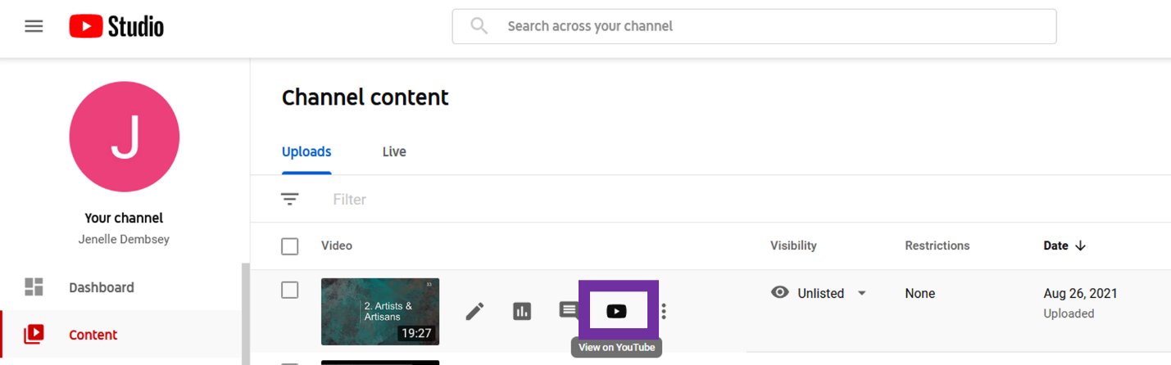
- Your YouTube video will open in a new tab. Select the “CC” icon in the play menu of your video and watch the captions at the bottom as your video plays. Please check that the wording and timing of the captions match what you are saying in your presentation.
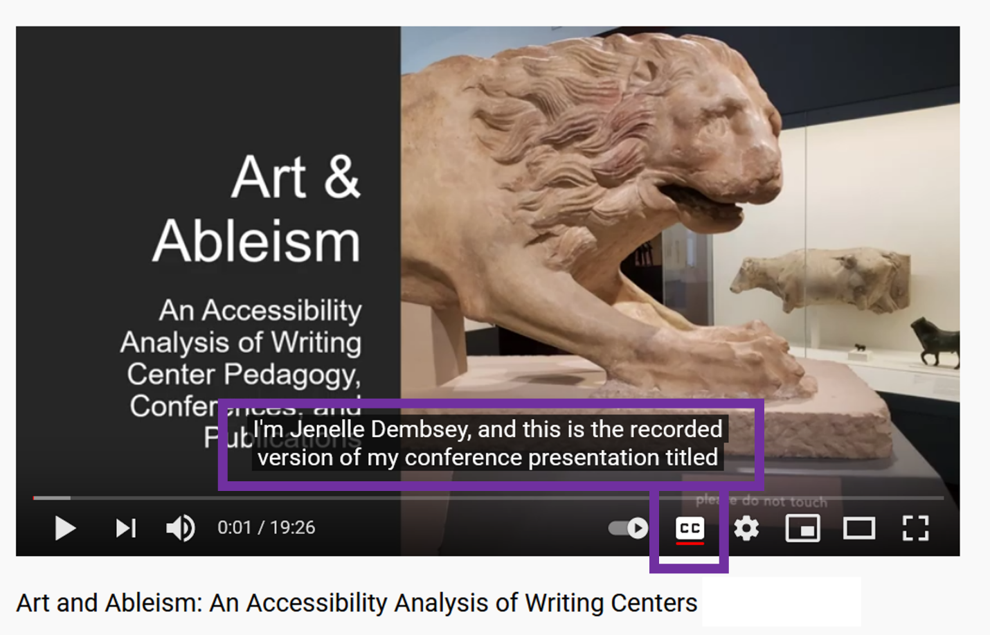

If you notice an error in the captions, you can edit them by following these steps:
- Go back to the “Your Videos” page
- Hover your cursor over your conference video and click the pencil icon for “Details.” You can edit other details about your video here as well, including the title, thumbnail, and visibility.
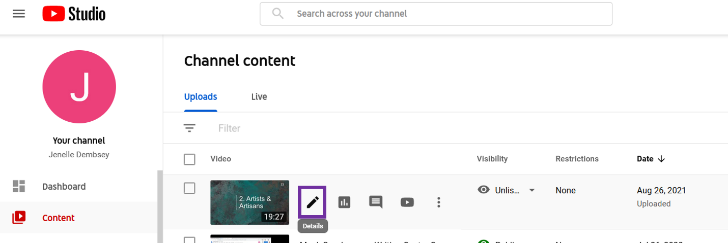
- Scroll down and click the pencil icon next to “Subtitles” on the right.
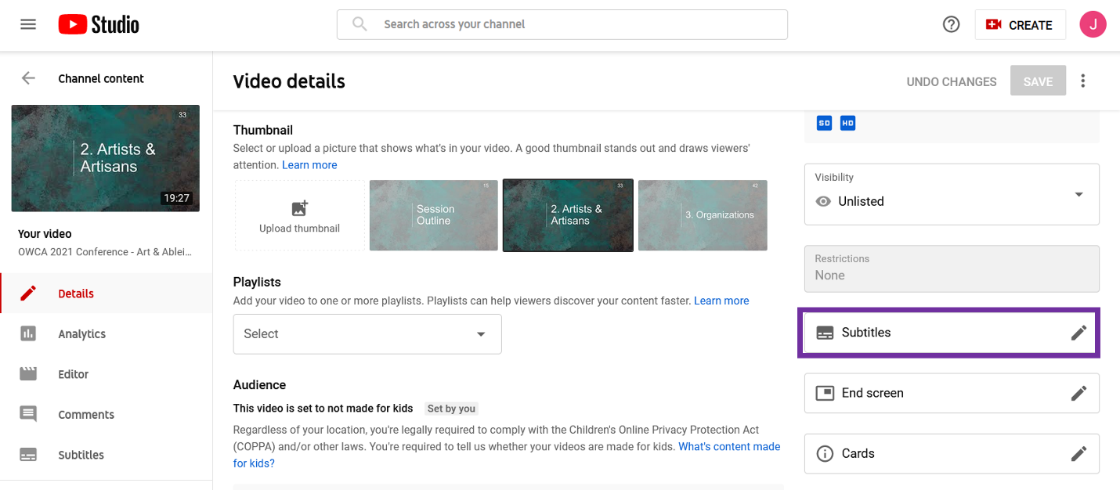

- A pop-up window will appear for the captions. From this screen, you can edit any errors in the text, add in new text for missing captions, and change the timing of the captions.
- When you’ve finished editing the captions, click “Done” in the upper right corner of the pop-up.
