Synchronous Consulting in the Writing Center

by J. M. Dembsey

Introduction [slides 1-2]
Hi, everyone! My name is Jenelle Dembsey, and I’ll be presenting on synchronous consulting in the writing center. My title slide features an open laptop with the words “Join Us Online” written in orange font on the screen.
If you’d like to follow along with me, you can download my presentation materials from my website: JMDembsey.com. You are also welcome to use the synchronous training materials on my website and modify them for your writing center.

Overview of Synchronous Consulting [slides 3-4]
In case anyone’s rusty with online consulting terms, “synchronous” refers to interactions that take place in real-time. In a synchronous consultation, the consultant and writer can communicate through video, audio, and/or text-chat. They may discuss the writing by sharing their screens or working together in a whiteboard space or text-sharing space.
When choosing a synchronous platform for your center, you can consider and balance the following:
- Institutional Context. What platforms does your institution already provide or support?
- Reliability. Is the video connection generally reliable and consistent?
- Flexibility. Are there features for varying learning and communication needs? Can writers participate through various technologies, internet browsers, or levels of internet connectivity?
- Accessibility. Can disabled writers participate with interpreters, screenreaders, text-to-speech software, keyboard keys, etc.?
- Relevance. Is this technology relevant outside of your institution? Would learning this platform benefit staff and writers in future professional contexts?
For highly interactive synchronous consultations, I suggest combining a video-meeting platform with a text-sharing platform, when possible. When I worked at a Google campus, we used Google Hangouts and Google Docs with a lot of success. I currently work at a Microsoft campus, and we use Zoom and Microsoft SharePoint with success as well.

Overview of Synchronous Training [slide 5]
The rest of my presentation will focus on how writing center administrators can train their staff for synchronous writing consultations. As with any training, you will start by determining your learning outcomes and then designing activities that help consultants to meet those outcomes.
In the synchronous training I’ve designed, consultants needed to build upon previous writing center knowledge and transfer skills from a face-to-face context to an online synchronous context. This training was also not part of a larger writing center course. With that in mind, the learning outcomes I suggest for synchronous training are:
- Demonstrate proficient use of the technology platform(s)
- Apply multimodal strategies with flexibility and creativity
- Assist with technology troubleshooting and technological literacy
- Utilize effective written feedback in text-chat consultations
- Navigate between communication methods and platforms
I’ll discuss each of these learning outcomes individually and suggest training activities for meeting these outcomes.

Learning Outcome 1: Demonstrate Proficient Use of the Technology Platform(s) [slides 6-8]
The photo on this slide shows the corners of a laptop, tablet, and smart phone on a sackcloth surface.
The best way to help consultants become proficient with your technology platforms is to immerse them in those platforms throughout training and to conduct the training itself online (which was an effective practice before COVID-19).
To train consultants online, you can:
- Pair asynchronous and synchronous activities
- Record short instructional videos (5 minutes or less) for consultants to watch on their own time
- Assign asynchronous activities to reflect upon or apply information from your videos
- Design all writing and discussion activities to be completed within your text-sharing platform
- Schedule synchronous group meetings and mock consultations in your video-meeting platforms
- Use group meetings for group discussion and group activities

LO1: Training Activities [slide 8]
In addition to using the platforms to complete training, consultants can build proficiency through the following activities:
- Watch short videos that introduce the technology platforms and their features
- Attend a synchronous consultation as a writer or observer
- Utilize features of the technology platforms in training meetings and mock consultations
- Record their own videos that explain the features of the technology platforms

Learning Outcome 2: Apply Multimodal Strategies with Flexibility and Creativity [slides 9-12]
This photo shows an open laptop and smartphone surrounded by paint tubes and a painted canvas.
Once consultants have been introduced to the basics of the technology platforms, they can begin learning how to use those platforms strategically to facilitate learning. Knowing which features and strategies to use to meet the writer’s needs requires flexibility and creativity.

Effective Multimodal Strategies [slides 10-11]
I’m going to briefly overview some effective multimodal strategies for synchronous consultations, based on the technology platforms that I’ve used. These same strategies can be transferred to face-to-face and asynchronous contexts as well.
- Writing and Revising in Real-Time. Without a consultant physically looking over their shoulder, writers often feel more comfortable writing and revising within a synchronous space. In a text-sharing space, the consultant can watch the revisions and provide feedback in real-time.
- Selecting Text with Your Cursor. In some text-sharing spaces, such as Google Docs, other users can see when you have selected text with your cursor. Selecting text is a visual way of directing the writer’s attention to a specific sentence or paragraph for discussion.
- Highlighting and Color-Coding Text. Highlighting text in color is a great way to indicate patterns for revision, such as consistent phrases that are unclear or wordy. Color can also point out areas to return for discussion or emphasize important parts of the paper, such as the thesis statement and topic sentences.
- Inserting Comments. Comment bubbles can be used to record the writer’s concerns, save notes or feedback for future reference, work on a reverse outline, or provide links to relevant resources.
- Screensharing. Screensharing is another way for consultants and writers to view a document at the same time when a text-sharing space is not available or conducive. For example, screensharing would be helpful for writers who need help formatting their dissertation. Consultants can also use screensharing to visually model tasks, such as navigating the writing center’s resources or using a library database.
- Text-Chatting. A text-chat space can be used to summarize/record your feedback in writing, suggest revisions, or share resources and documents. In group writing sessions, it’s also common for writers to leave comments in the chat while others are talking. Text-chat can also be the primary method of communicating, as we will discuss in Learning Outcome 4.
- Recording. With the writer’s permission, you can record consultations and share the video file with the writer for them to re-watch at a later time.
This screenshot of a synchronous consultation in Google Docs provides an example of what multimodal strategies can look like. In this example, the consultant has recorded the writer’s concerns in a comment bubble in the upper right corner and has inserted another comment to remind the writer to decide on word choice. The writer has highlighted the thesis of their paper in blue and has used Suggestion Mode to track the revisions they are making in the document.
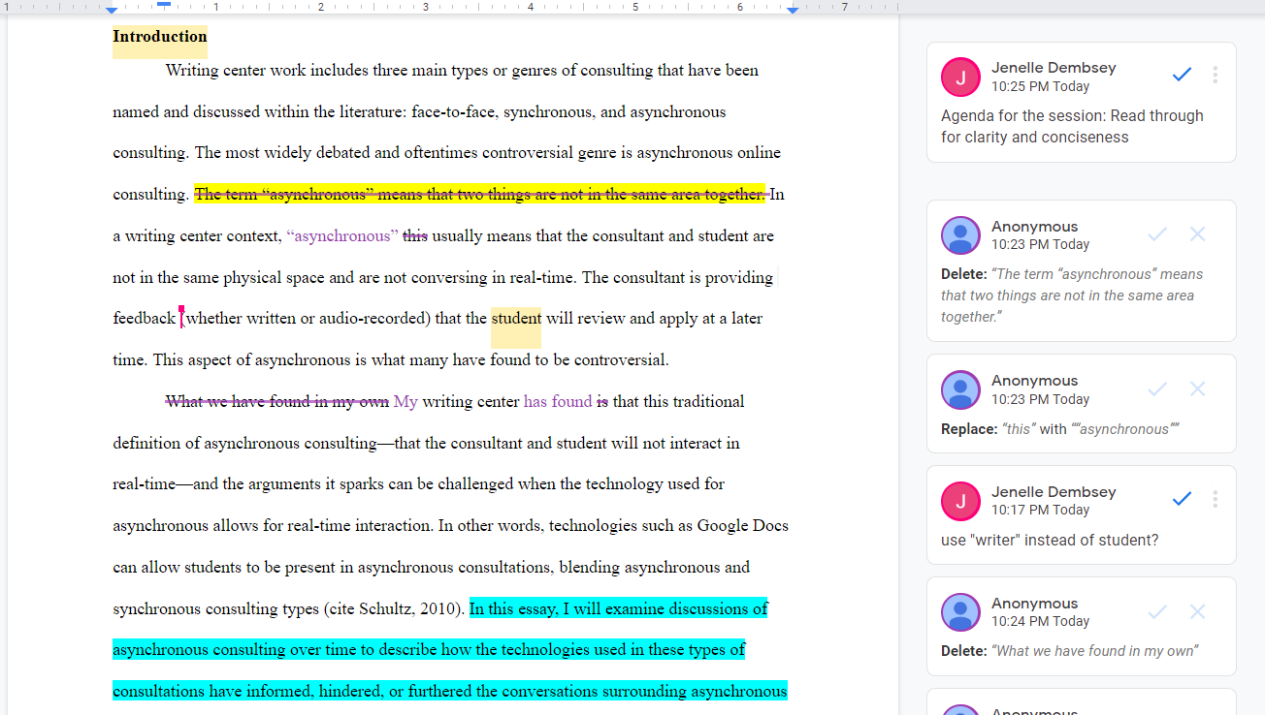

LO2: Training Activities [slide 12]
To learn multimodal strategies, consultants can:
- Watch a short video on effective multimodal strategies and a recorded synchronous consultation that models these strategies
- Reflect on the multimodal practices used in the sample consultation and how those practices are similar to or different from what they already know (face-to-face, asynchronous, peer review, etc.)
- Respond to various consulting scenarios and describe multimodal practices they might use in those scenarios
- Apply multimodal strategies in a mock synchronous consultation

Learning Outcome 3: Assist with Technology Troubleshooting and Technological Literacy [slides 13-15]
In the photo for this outcome, a hand pointer hovers over a question mark, with a keyboard in the background.
Technology issues will happen and are expected in synchronous consultations, so synchronous training can prepare consultants to troubleshoot common technology issues in the platforms they will be using. They will also likely work with writers who have not yet used the platforms before or are not comfortable with technology, so consultants may need to assist with teaching this literacy.
In a synchronous consultation, consultants may do any of the following:
- Help writers navigate to the correct location for their appointment
- Troubleshoot initial technology problems and any problem that occurs throughout the session
- Introduce or explain the features of the technology platform
- Prepare writers for what to do if they become disconnected or their video/audio fails during the session. A best practice is to tell writers to chat or email the consultant if something goes wrong.
- Suggest alternative communication methods or platforms when needed

LO3: Training Activities [slide 15]
To become comfortable with troubleshooting and teaching technological literacy, consultants can:
- Watch a recorded consultation where the consultant addresses technology issues and introduces the platform
- Respond to scenarios involving technology problems and describe solutions
- Troubleshoot a long list of technology issues in quick succession
- Practice solving technology issues, introducing the platform, and applying multimodal strategies in a mock consultation

Learning Outcome 4: Utilize Effective Written Feedback in Text-Chat Consultations [slides 16-18]
The photo on the screen is a closeup of a green keyboard key with a smiley face icon.
It’s important to remember that some writers will not have working webcams or microphones and some writers will not be verbal communicators. Synchronous training can prepare consultants to use text-chat as a primary method of communicating.

Effective Text-Chat Practices [slide 17]
Text-chat consultations pull heavily from effective practices for asynchronous written feedback. Practices to teach consultants include:
- Manage Time. Text-chat conversations will move at a slower pace than verbal conversations, so consultants need realistic expectations about what can be accomplished in a text-chat consultation.
- Clarify the moves of the session. Consultants will need to clarify what they are doing and what the writer should be doing. For instance, if it’s time to read through the document, the consultant can clarify which paragraph(s) they are going to read, invite the writer to read the same paragraph, and then let the writer know when they have finished reading.
- Break Up Text. Sending messages with huge chucks of text can be overwhelming to writers and take them awhile to read. Instead, consultants can send feedback in small chucks that are less overwhelming and give the writer time to begin reading while the consultant continues typing.
- Encourage informality. Text-chat can often reflect texting, in that writers may not use punctuation or capitalization and may use emojis to convey their reactions. Consultants should be encouraged to match the informality or formality of the writer to build rapport.

LO4: Training Activities [slide 18]
To learn text-chat consulting, consultants can:
- Analyze a sample text-chat consultation for the effective practices we just discussed. We had consultants complete this activity with a mentor so they could also learn about that mentor’s experience with text-chat consultations
- Practice just setting the agenda through text-chat. This short exercise helps consultants to alter their time expectations and receive feedback before doing a full consultation.
- Reflect upon and revise their text-chat transcript according to feedback they received
- Practice a full mock consultation through text-chat

Learning Outcome 5: Navigate Between Communication Methods and Platforms [slides 19-21]
On this slide, white hands are typing on a laptop keyboard. Above the keyboard are five icons depicting a smartphone, traditional telephone, chat bubbles, envelope, location symbol, and @ symbol.
Synchronous consultants may have to switch from audio to text-chat or vice versa within the same appointment. Consultants may also have to track down a writer via email or telephone or switch to another platform if the writer is frustrated. This is, of course, a lot to balance at one time and is why synchronous consultations require more skill and practice than face-to-face or asynchronous consultations.

LO5: Training Activities [slide 21]
The previous training activities will have helped consultants to build these skills individually: now they just need to practice bringing them all together. Consultants can:
- Practice mock consultations that require switching between multiple communication methods or platforms
- Begin consulting or co-consulting with support from a mentor and start applying their skills in real contexts. In my experience, consultants are often nervous about starting synchronous consultations with writers, even if they have a lot of writing center experience. They are worried about encountering technology issues and not remembering what to do. So I suggest scheduling them to consult at the same time as a veteran consultant or mentor who can co-consult with them, observe, or provide support throughout their first semester.

Cite This Presentation
Dembsey, J. M. (2020, July). Synchronous consulting in the writing center [webinar]. International Writing Centers Association.

