Humanizing Technology: Developing Critical Approaches to Bringing Technology into the Center

by J. M. Dembsey and Lori Rogers

Introduction [slides 1-3]
[Lori] Hello, and welcome to our workshop on “Humanizing Technology: Developing Critical Approaches to Bringing Technology into the Center.” I’m Lori Rogers, and I’m the Associate Director of the Central Michigan University Writing Center.
[Jenelle] And I’m Jenelle Dembsey, and I’m an IRB Analyst at Northcentral University.
We have passed out handouts with a transcript for the presentation portion of our workshop and for the activities. If you’d like to download this handout or our PowerPoint, you can do so on my website at JMDembsey.com.
Here is our plan for the workshop:
- Brief introduction to humanizing technology (5 minutes)
- Self-assessment on tech literacy in writing centers (3 minutes)
- Small group discussion (8 minutes)
- Large group discussion (20 minutes)
- Overview of accessibility and technology (6 minutes)
- Ending discussion (8 minutes)

Our Experience with Technological Literacy [slides 4-6]
[Jenelle] We came upon this topic while setting up a meeting to discuss conference ideas. We wanted to do a presentation together and needed to meet online, because we live in different states. I created a video meeting in Google Hangouts, sent the link to Lori, and didn’t think much about it, because I’ve used Google Handouts before.
[Lori] I had never used Google Hangouts before. So the day of the meeting, I ended up spending time trying to prepare to enter the online video space for our meeting. It was a small misunderstanding, but we realized that writing center staff represent a spectrum of tech literacy skills.
[Jenelle] I grew up with computers in my home and in public school, so I’ve developed technological literacies over my entire life. When I was a graduate student at Central Michigan University, I worked in the writing center with Lori, and I was the Online Consulting Coordinator for almost 2 years. In that position, I learned how to use technology for pedagogy and administrative tasks, and I learned that I prefer working through technology over working in face-to-face contexts. I later worked as a Coordinator for Technology and Accessibility at another writing center, where I developed an online consulting program from scratch, used technology to streamline administrative processes, and received digital accessibility training. I returned to school and received a graduate certificate through a fully online degree program. And I currently work for a fully online university, where I use technology for all work tasks and all communication with my co-workers. So needless to say, I am very comfortable with technology, but that also means that I can’t anticipate the ways that technology can frustrate, confuse, or overwhelm other people.
[Lori] I consider myself an early adopter of technology. I was using computers in the late 80s, and 90s—anyone remember Trumpet Windsock, Kermit, or DOS? In the late 90s, I assisted in the design and setup of a networked computer lab in our department specifically for writing courses. I also was able to convince our department to purchase a software license for Daedalus Integrative Writing Environment—a program that allowed students to share their writing as well as participate in synchronous discussion activities. I’m comfortable teaching online courses and using technology in the classroom; my job as Associate Director places much different demands on me for considering the role of technology in all aspects of our center. We have immediate needs to develop a pilot synchronous session component to our asynchronous online service, and we need to consider major changes to our scheduling and data collection systems. Somewhere along the line I feel like I didn’t keep up with new technologies that might support our work in the writing center.

Humanizing Technology with a Focus on Literacy [slides 7-10]
[Lori] If we feel we fall short on technical competencies or even just the time to research and learn new technologies, what strengths can we draw on (other than emailing Jenelle) to make informed decisions in our centers? My early introduction to tech literacy was focused on its application to classroom writing instruction. And there is a good body of research that supports the pedagogical value of integrating technologies into writing center sessions. But that doesn’t cover how users are tracked in data or how consultants are positioned in an online session. There is very little research to go on that helps guide technology decision-making in all phases of writing center work and operations. Taking a “go with what you know” attitude as a starting point, my background in literacy studies helps me to view technology as something more than a neutral tool, meaning it is also bound up in the workings of power. It can shape what we do in both positive and negative ways. Thinking about what people are doing with technology and how they adopt and learn it helps keep the focus on people rather than the technology. Issues associated with access are a primary example of the potential for technologies to sometimes support and sometimes work against our goals. Later in this session, Jenelle will point to ways even the less tech savvy among us can address issues of access via technology in our centers.
We will explore our own technoliteracies in a moment, but the point I want to make here is that we can apply what we know about literacy and learning—our writing center sensibilities and values—to advocate for a more inclusive approach to integrating tech in our centers. In a separate handout on page 11, I’ve listed some characteristics of what Michael Day calls the “technorehetorician” that can be applied to writing center administrators as well, along with some additional aspects of literacy learning.
Even when inclusion and best practices are foremost in our minds when making technological decisions, they are also heavily influenced by budget, available resources, individual preferences, and comfort levels. Integrating new technologies is also time-consuming with false-starts and dead-ends. It requires additional training and on-going maintenance and support. Facing these challenges without a strong technical background amplifies some of these issues. How can we leverage our backgrounds in literacy and learning to better assess and implement tech into our centers?
A good starting point is identifying what we know and what we don’t know—what we feel comfortable with and what we feel less comfortable with.

Activity 1: Technology Literacy Self-Assessment [slides 11-12]
[Jenelle] Read through each statement and score yourself on a scale of 1 to 5, with 5 being strongly agree and 1 being strongly disagree.
- Strongly Disagree
- Disagree
- Neutral
- Agree
- Strongly Agree

General Comfort
___ I feel comfortable using technology to browse the web and find information online.
___ I feel comfortable using technology to communicate or collaborate with others (i.e., email, Microsoft Word, Google Docs).
___ I feel comfortable using technology to meet with others in real-time (i.e., Skype, Zoom, Google Hangouts).
___ I feel comfortable using technology to create and maintain a digital presence for my center (e.g., website, social media, learning management systems).
___ I feel comfortable using technology to provide online services in my center (e.g., asynchronous or synchronous appointments, online class visits, online workshops).
___ I feel comfortable using technology to collect and analyze data in my center.
___ I feel comfortable using technology to problem-solve and make processes more efficient in my center.
___ I feel comfortable training others on technology.

Decision-Making
___ I can choose technology platforms that meet the needs of my local context.
___ I can decide between recommendations from other centers and the needs of my local context.
___ I listen to students or tutees when making decisions about technology in my center.
___ I listen to other staff (tutors, administrators, tech support) when making decisions about technology in my center.
___ I feel comfortable delegating technology development projects to tutors or staff.

Emotion
___ I am not hesitant to ask others for help with technology.
___ I am patient when someone is assisting me with technology.
___ I am patient with students or tutees who need assistance with technology.
___ I am patient with other staff (tutors, administrators) who need assistance with technology.
___ I have empathy for those who are less comfortable with technology than me.

Training
___ I can train myself on technologies I am unfamiliar with.
___ I know where to find technology support at my institution.
___ I can anticipate the areas of confusion/frustration that others may experience when using technology in my center.
___ I can develop training materials for others to better understand or use my center’s technology.
___ I can develop training materials for others to apply pedagogies in technological spaces.

Accessibility
___ I consider accessibility and disability in my pedagogy.
___ I consider accessibility and disability when designing teaching or training materials.
___ I consider accessibility and disability when creating resources for my center (e.g., handouts, presentations, videos, websites).
___ I try to choose technology platforms that are accessible to persons with disabilities.
___ I know where to find accessibility and disability support at my institution.

Activity 2: Small Group Discussion [slides 13-14]
[Lori] For the next 10 minutes, please discuss your self-assessment in small groups. You can stay where you are or move around the room, depending on your comfort level. Use these 3 questions to guide your discussion:
- How do you feel after completing this self-evaluation? What stories or experiences came to your mind?
- What areas did you identify as strengths? What area did you identify as needing improvement?
- What questions do you have for others in this room? Write your questions on notecards for the presenters to share.

Activity 3: Large Group Discussion [slides 15-19]
[Lori] We’ll now have a larger group discussion to share stories and strategies. We will read questions and comments off from your notecards.
If needed, here are some additional questions for discussion:

Decision-Making
- How does your comfort with technology affect the decisions you are making, not making, or avoiding?
- Who makes decisions about technology in your center and who gets to participate in those conversations?
- Who is responsible for technology-related tasks or projects (e.g., coordinating online consulting, editing the website, managing an online scheduling system)? Is this sustainable?

Emotion
- What experiences have made you patient or impatient?
- What changes can you make in your perspective or your center to increase patience and empathy?

Training
- What technology training is or is not happening in your center?
- Where can you go for technology training?

Accessibility [slides 20-37]
[Jenelle] We wanted to make sure we spend some time discussing the accessibility of technology. Disability should be at the center of any such discussion. Sushil K. Oswal (2013) explains:
Accessibility can be defined as the ability to use, enjoy, perform, work on, avail of, and participate in a resource, technology, activity, opportunity, or product at an equal or comparable level with others. Separate is not equal and before or after the fact is also not equal. In the context of technology and systems, accessibility at the interface level, not as a retrofit or add-on, is true accessibility.
In other words, technology is accessible when it can be used equally by disabled and nondisabled users. There are three common causes of inaccessible technology:
- A technology is not designed for/with disabled users, such as a technology platform that requires users to have the ability to see, hear, or use a mouse.
- Flexible options for participation are not available.
- Users are not aware of technology features that can make content more accessible.
Let’s discuss how we can address each of these issues within our centers.
The first step you can take is to prioritize accessibility when choosing technology platforms for your writing center. You can test/research accessibility by doing any of the following:
- Recruit disabled students/tutors to test the technology platform. This is the best option because it centers the advice and participation of disabled users.
- Contact your local disability support or accessibility support office. They may have recommendations for disability-friendly platforms or may have software to test programs for you.
- Use free accessibility evaluation tools. We suggest using this option only if the first two options are not available to you, as these evaluator tools apply accessibility standards that don’t always reflect the experiences of disabled people (Oswal, 2013).
If you need to use an online evaluation tool, the WAVE accessibility tool is one option that can test websites or web-based programs. WAVE will tell you how many accessibility errors are present, which you can use to compare different platforms and eliminate the most inaccessible. For example, I recently used this tool to test different survey platforms, and I chose the platform that had the fewest number of accessibility errors. This screenshot shows the WAVE test results for my survey. The test results show up in a panel on the left side of the screen. The “Summary” tab shows that this survey page has 1 error and 3 alerts, which is low compared to other platforms I tested.
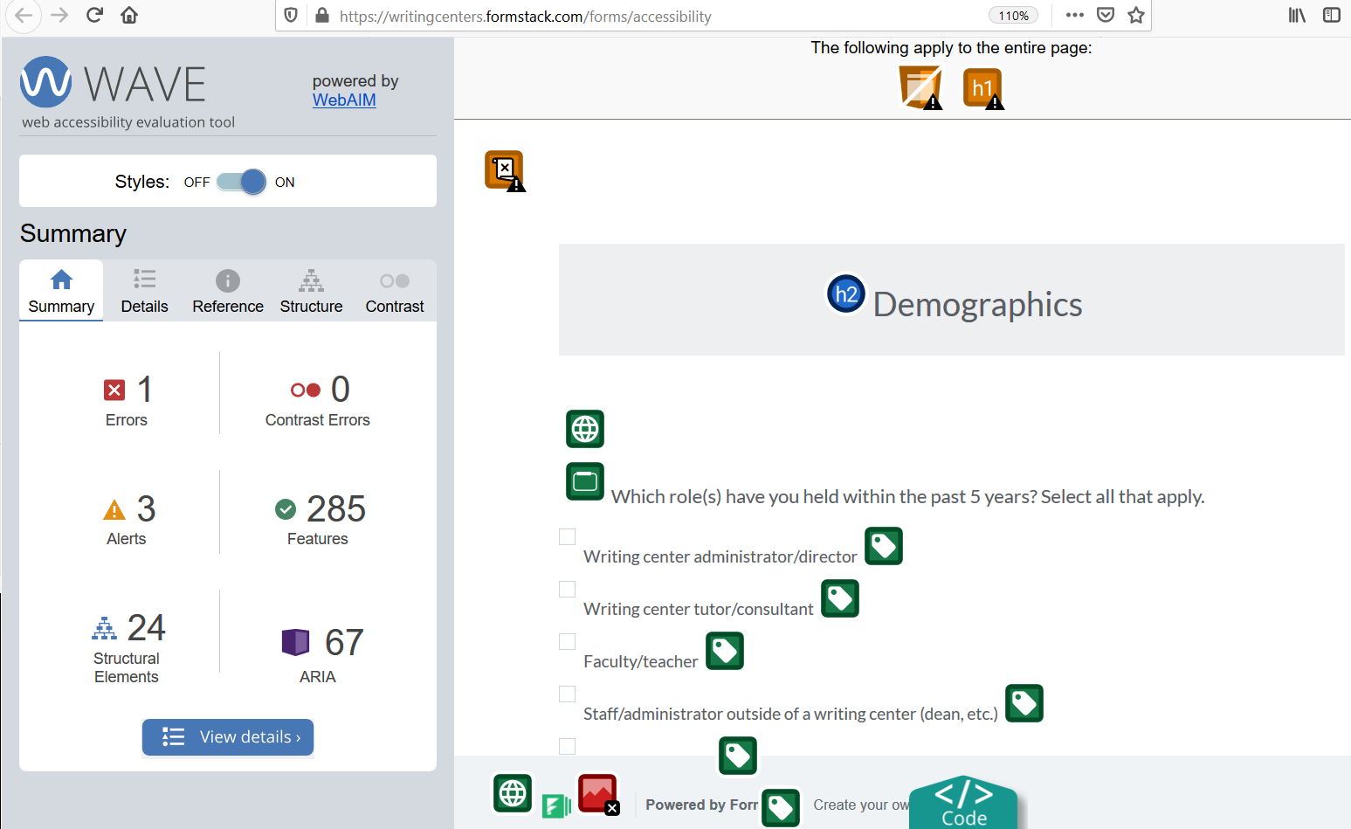
Unfortunately, many technologies, such as appointment scheduling systems, are still very inaccessible to users with disabilities, and no one can guarantee that a technology is accessible to all users. So the second step you can take is to give your users options for participation, so they aren’t forced to use a technology that is not accessible to them. For my survey, I gave users the option of taking the survey online or taking the survey over the phone. Similarly, if you have an appointment scheduling system, you can still encourage students to schedule via email or phone if that is more accessible to them.
The third step is to use the available accessibility features in technologies in your center. Three common accessibility features are (1) headings, (2) hyperlinks, and (3) alternative text. Pro tip: if the technology you’re using doesn’t offer these features, then that technology platform is likely not accessible.

Headings [slides 28-30]
The first accessibility feature is headings, which are helpful for breaking up your text into sections and labeling those sections so users can skim and find the information they are looking for. However, if you’re only bolding or increasing the size of the text, then blind users can’t tell that you have headings in your document. So most programs have a feature to label headings within your text for screenreaders.
In Microsoft Word, for example, the options for headings are located under the “Home” tab and in a section on the right called “Styles.” There are options for Heading 1, Heading 2, etc. The title of your document should always be Heading 1 and should be the only Heading 1 in your document. Your first group of sub-headings would be Heading 2 and so on. So in the example on the screen, I have an informed consent form in Microsoft Word. The title of the document is labeled as Heading 1 and the sub-headings (“Introduction” and “Activities”) are labeled as Heading 2.
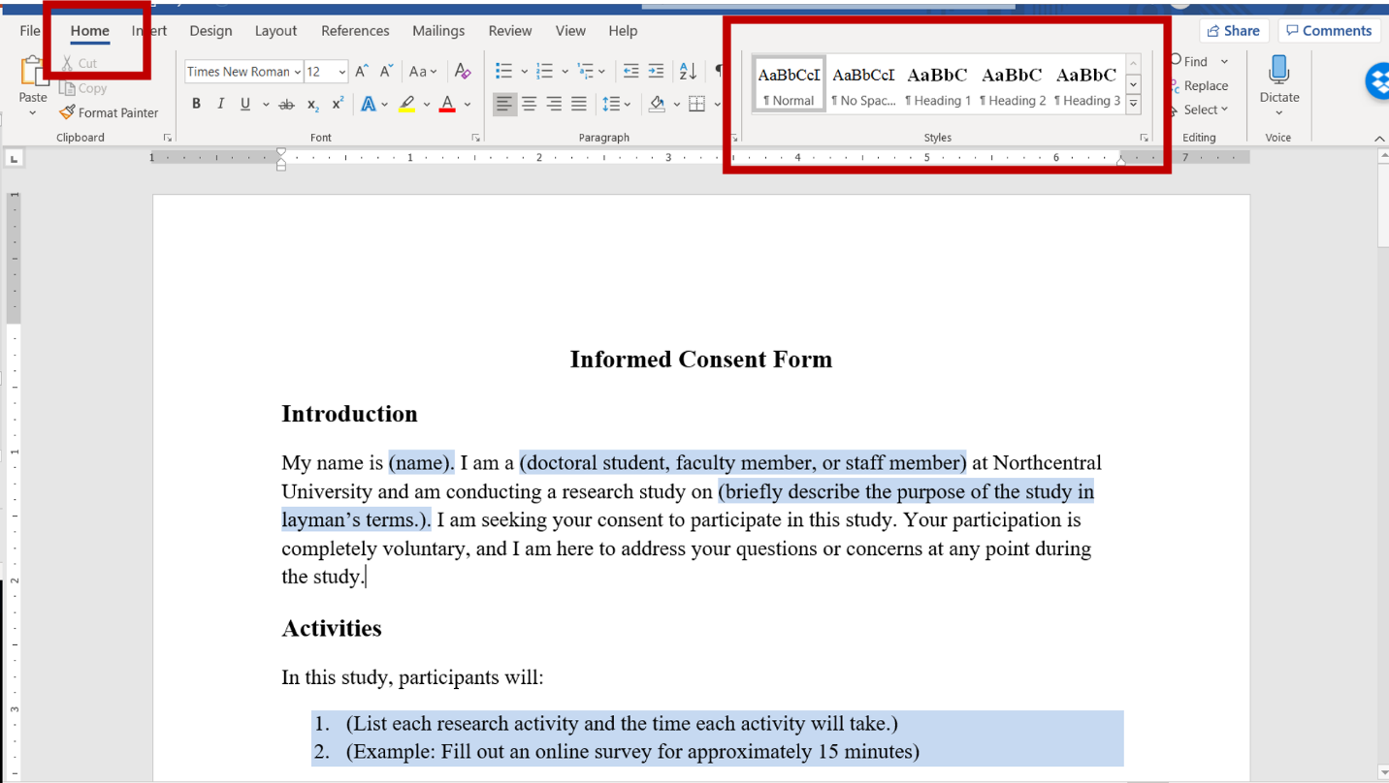
If you’re editing text online, such as your writing center’s website, headings are usually available under a drop-down menu for “paragraph.” This example shows the text editor for my Wordpress website. If you select “paragraph,” a drop-down menu appears with options to label your text as Heading 2, Heading 3, etc. Remember that the title of the page will always be Heading 1 and then headings after that will be Heading 2 and so on.
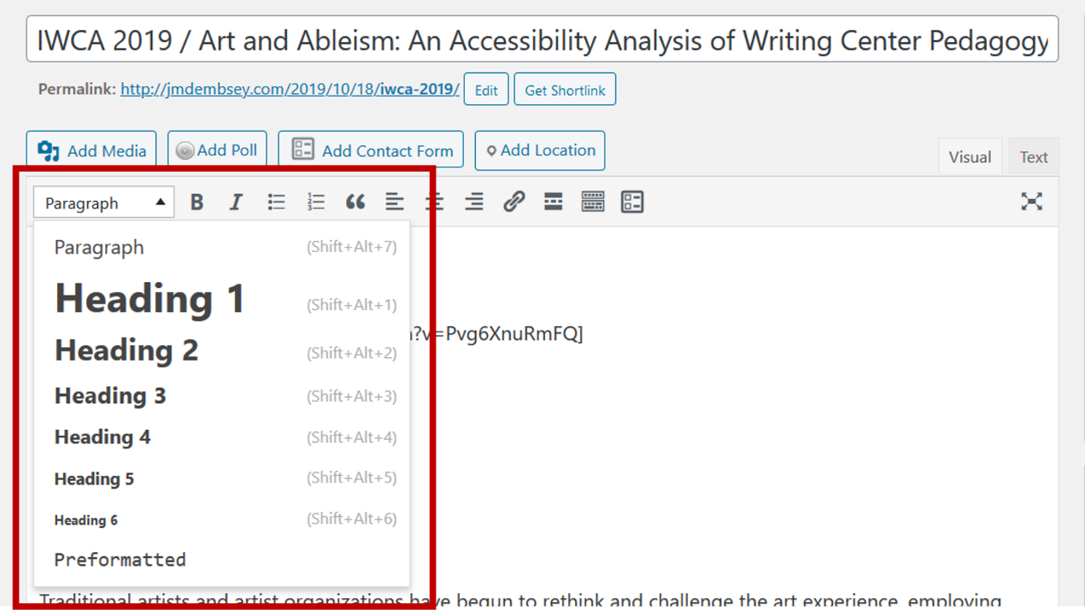

Hyperlinks [slides 31-34]
The second accessibility feature is hyperlinks. A hyperlink is a direct link that takes users to a document or webtext. Hyperlinks are most commonly distinguished in bright blue text with an underline. When sharing links, it’s common for people to just paste the entire URL for a document or webtext; however, this practice is inaccessible for screenreaders because a URL appears as one, long, complicated word, and many URLs also don’t clarify where they are taking the user.
Many programs have a hyperlink feature that lets you place a link on a specific word or phrase that tells the user where the link will take them. This word or phrase should make sense completely out of context.
In this example on the screen, I’ve drafted an email about my online survey, and I’ve hyperlinked the words “Accessibility Survey.” Out of context, users would know that this link will take them to a survey on accessibility. In my email signature, I’ve also hyperlinked my affiliations, and users can tell that the links will take them to the Online Writing Centers Community website and my personal website, respectively.
To insert a hyperlink in an email, look for an icon that resembles a link in a chain. In Gmail, this icon appears at the bottom next to the “Attachment” icon. As shown on the screen, you can select the text you want to hyperlink, select the hyperlink icon, and then paste in the URL that you want to link to.
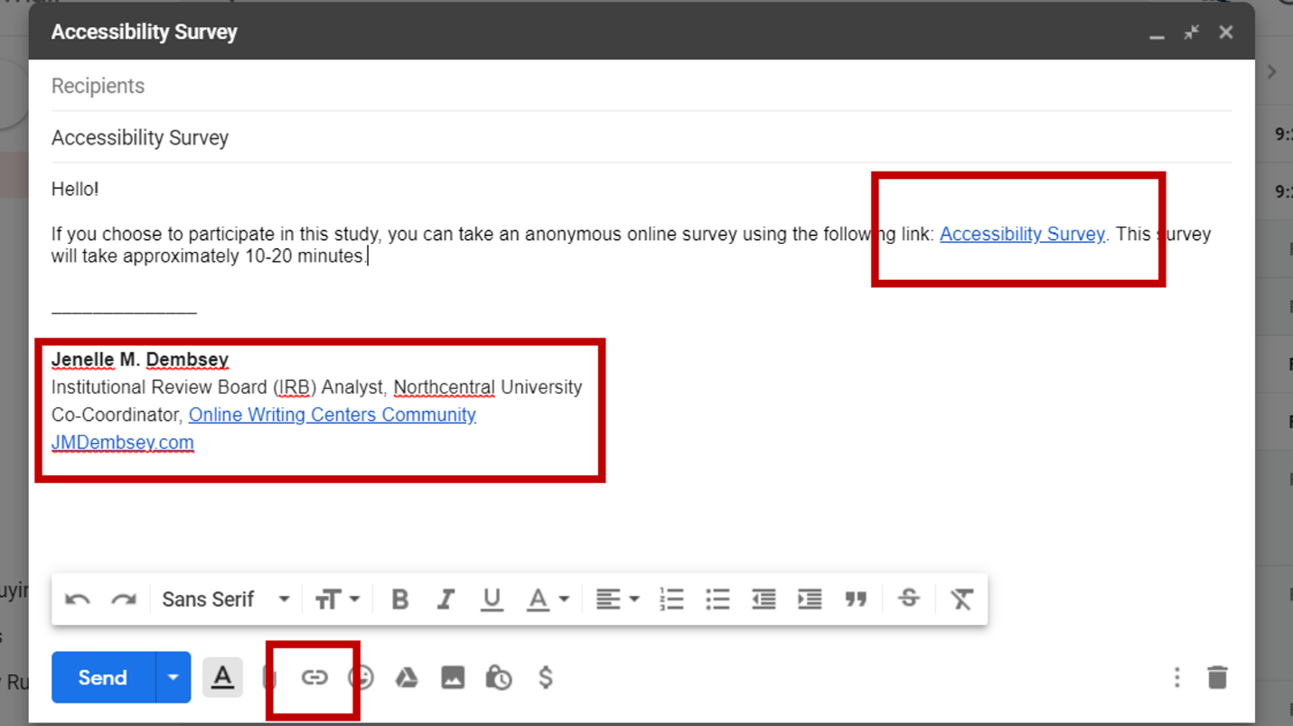
To insert a hyperlink in Microsoft Suite, select a phrase, right-click, and select “Link.” This screenshot provides an example of inserting a hyperlink into Microsoft Word.
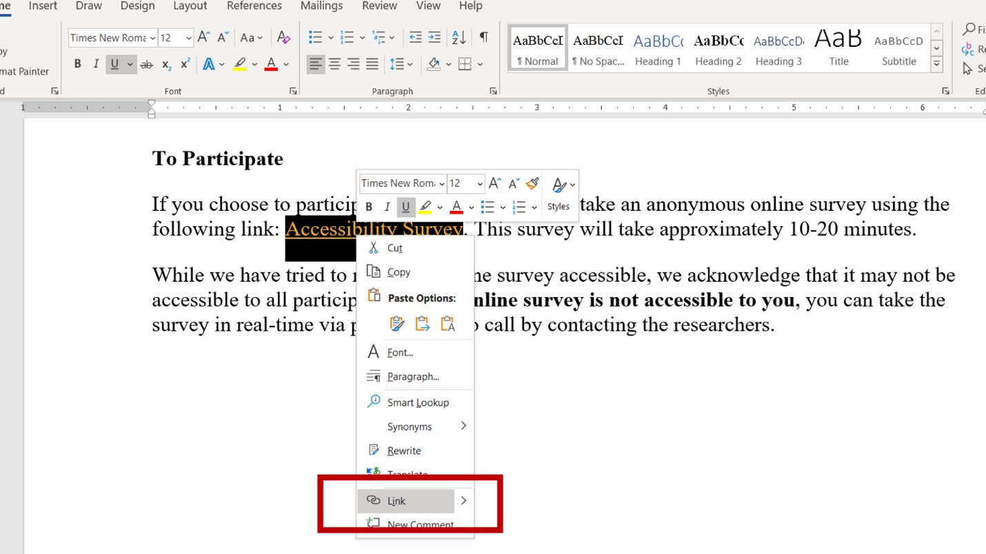

Alternative Text [slides 35-36]
The last accessibility feature we will discuss is alternative text. Alternative text lets you provide a textual description of images for users who are blind. Alternative text should describe what is in the image, including any text.
To add alternative text in Microsoft Word or PowerPoint, right-click on an image and select the option for “edit alt text.” A box will appear on the right side for you to type in a description of the image. In this example, I have an image in PowerPoint, and I’ve provided the following alternative text: “Construction sign outside of art museum. The sign states: ‘Coming Soon: Accessible Front Entrance.’”
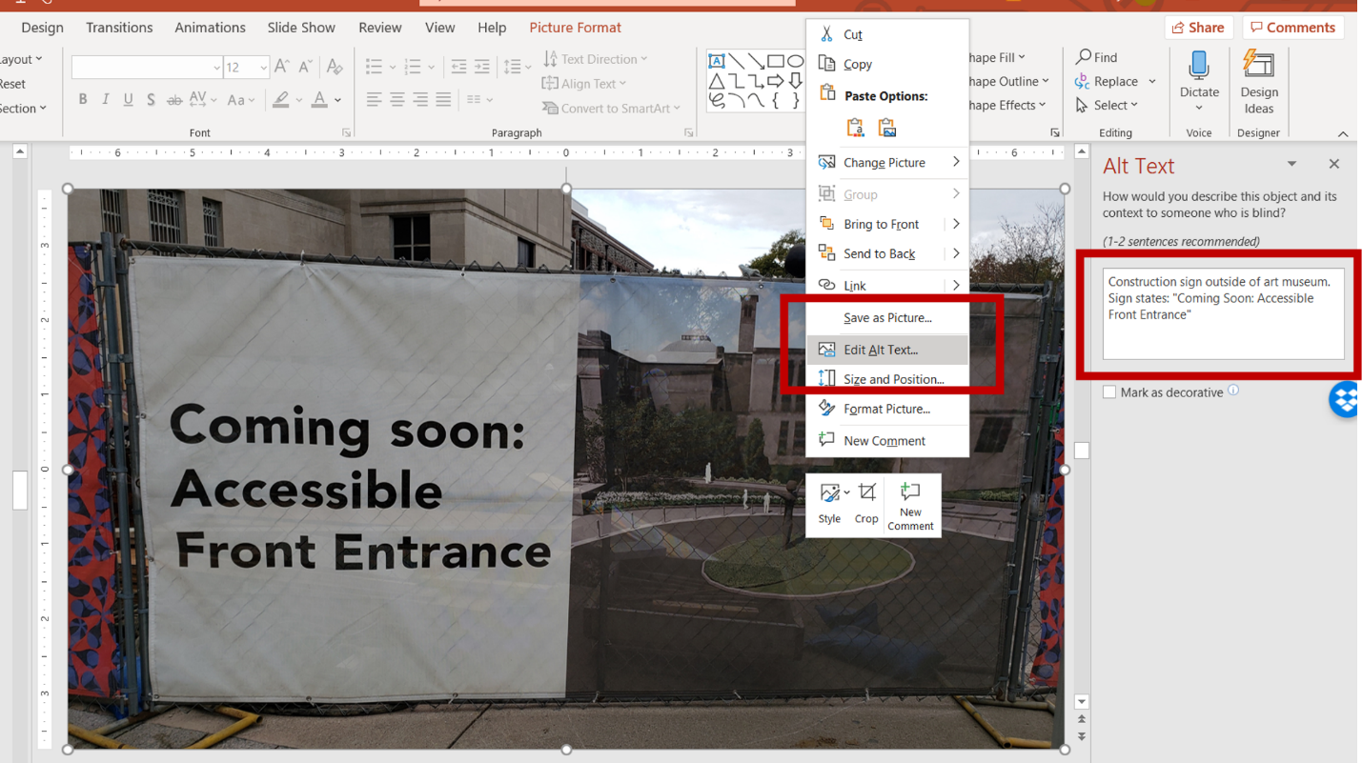

Additional Accessibility Support [slide 37]
These are just 3 examples of accessibility features. If your center uses Microsoft Suite, Microsoft has support articles for accessibility in Word documents and accessibility in PowerPoint slides. We suggest searching for accessibility guides for any technologies your center is using or considering.

Characteristics of Literacy and the Technorhetorician
Below are some aspects of literacy that can be helpful as we consider the role of technology and how it positions users in relation to our best practices.
- Literacy is best understood as a set of social practices; these can be inferred from events which are mediated by texts/symbols.
- There are different literacies associated with different domains of life.
- Literacy practices are patterned by social institutions and power relationships, and some literacies become more dominate, visible and influential than others.
- Literacy practices are purposeful and embedded in broader social goals and cultural practices.
- Literacy is historically situated.
- Literacy practices change, and new ones frequently acquired through processes of informal learning and sense-making.
(Barton & Hamilton, 1998)
Below are some of the characteristics identified by Michael Day (2009) of the administrator as technorhetorician, which can be applied more broadly to writing center programs, staff, and stakeholders:
- identifies, seeks out, and listens to stakeholders including students, colleagues, supportive staff, and higher administrators
- learns as much as possible about available technologies for teaching, but always considers technologies in terms of the program’s goals and outcomes, as well as its limitations
- shares governance and decision making in technology choices
- keeps abreast of global conversations on technology, but balances external advice about
- advocates for students, to be sure the program treats them fairly and that they have access to computers and online resources
- provides adequate technological training for graduate students, including a pedagogy class, mentoring, and workshops
- advocates for best practices in teaching with technology but does not lockstep everyone in the program to the same book, software, and syllabus

References [slides 38-39]
Barton D., & Hamilton, M. (1998). Local literacies: Reading and writing in one community. Routledge.
Day, M. (2009). The administrator as technorhetorician: Sustainable technological ecologies in Writing Programs. In D. DeVoss, H. McKee, & R. Selfe (Eds.), Technological ecologies & sustainability (Chapter 6). Computers and Composition Digital Press.
Oswal, S. K. (2013). Multimodality in motion: Ableism. Kairos, 18(1). Retrieved from http://kairos.technorhetoric.net/18.1/coverweb/yergeau-et-al/pages/ableism/index.html

Cite This Workshop [slide 40]
Dembsey, J. M., & Rogers, L. (2020, March). Humanizing technology: Developing critical approaches to bringing tech into the center. East Central Writing Centers Association. Marian University. Indianapolis, IN.

